STATE OF SOUTH CAROLINA
State Budget and Control Board
OFFICE OF GENERAL SERVICES
JIM HODGES, CHAIRMAN  GOVERNOR  GRADY L. PATTERSON, JR.  STATE TREASURER  JAMES A. LANDER  COMPTROLLER GENERAL |  |  | HUGH K. LEATHERMAN, SR.  CHAIRMAN, SENATE FINANCE COMMITTEE  ROBERT W. HARRELL, JR.  CHAIRMAN, WAYS AND MEANS COMMITTEE  RICK KELLY  EXECUTIVE DIRECTOR
GEORGE N. DORN, JR.
DIRECTOR

MATERIALS MANAGEMENT OFFICE
1201 MAIN STREET, SUITE 600
COLUMBIA, SOUTH CAROLINA 29201
(803) 737-0600
Fax (803) 737-0639

R. VOIGHT SHEALY
MATERIALS MANAGEMENT OFFICER

May 22, 2001

Mr. George Dorn, Director
Office of General Services
1201 Main Street, Suite 420
Columbia, South Carolina 29201

Dear George:

I have attached Winthrop University’s procurement audit report and recommendations made by the Office of Audit and Certification. I concur and recommend the Budget and Control Board grant the University a three-year certification as noted in the audit report.

Sincerely,

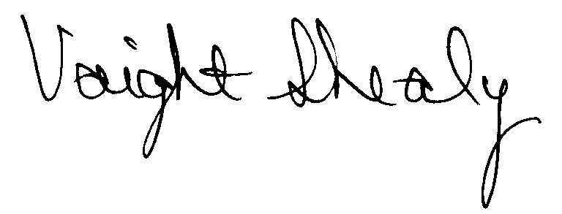
R. Voight Shealy
Materials Management Officer

/jl
WINTHROP UNIVERSITY
PROCUREMENT AUDIT REPORT
APRIL 1, 1998 - DECEMBER 31, 2000

TABLE OF CONTENTS
PAGE
Transmittal Letter 1
Scope 3
Results of Examination 4
Certification Recommendation 7
University Response 8
Follow-up Letter 9

STATE OF SOUTH CAROLINA
State Budget and Control Board
OFFICE OF GENERAL SERVICES
JIM HODGES, CHAIRMAN  GOVERNOR  GRADY L. PATTERSON, JR.  STATE TREASURER  JAMES A. LANDER  COMPTROLLER GENERAL |  |  | HUGH K. LEATHERMAN, SR.  CHAIRMAN, SENATE FINANCE COMMITTEE  ROBERT W. HARRELL, JR.  CHAIRMAN, WAYS AND MEANS COMMITTEE  RICK KELLY  EXECUTIVE DIRECTOR
GEORGE N. DORN, JR.
DIRECTOR

MATERIALS MANAGEMENT OFFICE
1201 MAIN STREET, SUITE 600
COLUMBIA, SOUTH CAROLINA 29201
(803) 737-0600
Fax (803) 737-0639

R. VOIGHT SHEALY
MATERIALS MANAGEMENT OFFICER

May 2, 2001

Mr. R. Voight Shealy
Materials Management Officer
Office of General Services
1201 Main Street, Suite 600
Columbia, South Carolina 29201

Dear Voight:
We have examined the procurement policies and procedures of Winthrop University for the period April 1, 1998 through December 31, 2000. As part of our examination, we studied and evaluated the system of internal control over procurement transactions to the extent we considered necessary.
The evaluation was to establish a basis for reliance upon the system of internal control to assure adherence to the South Carolina Consolidated Procurement Code, State regulations and the University’s procurement policy. Additionally, the evaluation was used in determining the nature, timing and extent of other auditing procedures necessary for developing an opinion on the adequacy, efficiency and effectiveness of the procurement system.
The administration of Winthrop University is responsible for establishing and maintaining a system of internal control over procurement transactions. In fulfilling this responsibility, estimates and judgments by management are required to assess the expected benefits and related
costs of control procedures. The objectives of a system are to provide management with reasonable, but not absolute, assurances of the integrity of the procurement process, that affected assets are safeguarded against loss from unauthorized use or disposition and that transactions are executed in accordance with management's authorization and are recorded properly.
Because of inherent limitations in any system of internal control, errors or irregularities may occur and not be detected. Also, projection of any evaluation of the system to future periods is subject to the risk that procedures may become inadequate because of changes in conditions or that the degree of compliance with the procedures may deteriorate.
Our study and evaluation of the system of internal control over procurement transactions, as well as our overall examination of procurement policies and procedures, were conducted with professional care. However, because of the nature of audit testing, they would not necessarily disclose all weaknesses in the system.
The examination did, however, disclose conditions enumerated in this report that we believe need correction or improvement.
Corrective action based on the recommendations described in these findings will in all material respects place Winthrop University in compliance with the Consolidated Procurement Code and ensuing regulations.

Sincerely,
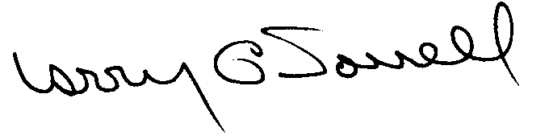
Larry G. Sorrell, Manager
Audit and Certification

SCOPE
We conducted our examination in accordance with Generally Accepted Auditing Standards as they apply to compliance audits. Our examination encompassed a detailed analysis of the internal procurement operating procedures of Winthrop University and its related policies and procedures manual to the extent we deemed necessary to formulate an opinion on the adequacy of the system to properly handle procurement transactions.
We selected a judgmental sample for the period April 1, 1998 through December 31, 2000 of procurement transactions for compliance testing and performed other audit procedures that we considered necessary to formulate this opinion. Specifically, the scope of our audit included, but was not limited to, a review of the following:
(1) All sole source, emergency and trade-in sale procurements for the period April 1, 1998 through December 31, 2000

(2) Procurement transactions for the audit period as follows:
- Ninety-one payment transactions greater than $1,500 each reviewed for
competition and compliance to the Code
b) An additional block sample of ten sealed bids
c) A block sample of four hundred purchase orders from selected vendor files reviewed for order splitting and favored vendors

(3) Five permanent improvement projects and five professional services contracts for compliance with the Manual for Planning and Execution of State Permanent Improvements

- Surplus property procedures

(5) Information technology plans and approvals

(6) Minority Business Enterprise Plan and reports

(7) Internal procurement procedures manual review

(8) Blanket purchase agreements

(9) File documentation and evidence of competition
RESULTS OF EXAMINATION
The Office of Audit and Certification performed an examination of the internal procurement operating policies and procedures and related manual of Winthrop University, hereinafter referred to as the University, for the period April 1, 1998 through December 31, 2000.
Our audit review was conducted March 19 through April 10, 2001 and was made under the authority described in Section 11-35-1230(1) of the South Carolina Consolidated Procurement Code. The audit was performed primarily because the three-year certification granted the University by the Budget and Control Board is to expire August 11, 2001. The current certification limits are as follows and no increase in certification was requested.
PROCUREMENT AREAS | CERTIFICATION LIMITS
Goods and Services | $50,000 per commitment
Consultant Services | $50,000 per commitment
Information Technology | $50,000 per commitment
Construction Services | $25,000 per commitment
Since our previous audit in 1998, the University has maintained what we consider to be a professional, efficient procurement system. However, we did note, the following points that should be addressed by management.

Request for Quotations Not Written and Advertised
The University did not prepare written solicitations of written quotations and did not advertise the following two solicitations.
PO | Date | Description | Amount
P003670 | 9/25/00 | Equipment rental | $14,790
P901115 | 9/11/98 | Software | 13,865
Since the total value was greater than $10,000 but less than $25,000, written solicitations of written quotations and advertisement in the South Carolina Business Opportunities, per Section 11-35-1550(2)(d), applied to the solicitations.
We recommend the University comply with the Code by issuing written solicitations and advertising the solicitations.

No Competition on Blanket Purchase Agreement
Purchase order P100799 for $8,000 was issued as a blanket purchase agreement for screen-printing. The maximum procurement amount per transaction on the agreement was $2,500. Voucher 1003447 was issued for $2,060 against the agreement without the solicitation of three verbal quotes, per Section 11-35-1550(2)(b).
We recommend the University comply with the Code by soliciting competition when the procurement attributed to a blanket purchase agreement exceeds $1,500.

Protest Rights on Statement of Award for Request for Quotations
The University issues statements of awards for request for quotation solicitations. The statements of awards include a bidder’s right to protest per Section 11-35-4210. The bidder’s right to protest does not apply to request for quotations per Section 11-35-1550(3).
We recommend the University not include protest rights for request for quotation solicitations.

Multi-Term Determinations Not Prepared
Multi-term determinations were not prepared for the following three multi-term contracts.
IFB | Date | Description | Total Award
R100973LC | 06/02/00 | Computer maintenance | $35,784
100712/TS | 04/28/00 | Tree service | $30,000
40511/TS | 12/09/99 | Dust mops and mats | $27,118
Section 11-35-2030 and Regulation 19-445.2135 defines the conditions for the use of multi-term contracts. One condition is that a written determination must be prepared for each multi-term contract.
We recommend the University prepare a written determination to justify each multi-term contract.

Bid Tabulation Sheets Not Signed or Witnessed
The sealed bid tabulation sheets were not signed or witnessed at the time of the opening. Section 11-35-1520(5) states in part, “Bids shall be opened publicly in the presence of one or more witnesses at the time and place designated. The amount of each bid with the name of each bidder shall be tabulated. The tabulation shall be open to public inspection at that time.”
We recommend the bid tabulation sheets be completed as required by the Code.

Time and Date Stamping of Quotations and Bids
We noted that when the Purchasing Office received responses to solicitations, neither the envelopes nor the solicitations were date and time stamped recording the date of receipt.
We recommend the Purchasing Office either time and date stamp the original envelopes when received or time and date stamp the quotes/bids of each responding bidder so that a timely receipt of responses can be verified.

State Term Contracts Not Referenced
We noted a number of purchases from state term contracts that did not reference the term contract numbers. In order to help ensure the proper contract terms and conditions and provide compliance to the Code, the term contract number should be referenced on the purchase order.
We recommend the contract number be referenced on the purchase order when applicable.

CERTIFICATION RECOMMENDATIONS
As enumerated in our transmittal letter, corrective action based on the recommendations described in this report, we believe, will in all material respects place Winthrop University in compliance with the South Carolina Consolidated Procurement Code and ensuing regulations.
Under the authority described in Section 11-35-1210 of the Procurement Code and subject to this corrective action, we will recommend the University be recertified to make direct agency procurements for three years up to the limits as follows:

PROCUREMENT AREAS |  |  | RECOMMENDED  CERTIFICATION LIMITS
 |  | Goods and Services |  |  | *$ 50,000 per commitment
 |  | Consultant Services |  |  | *$ 50,000 per commitment
 |  | Information Technology |  |  | *$ 50,000 per commitment
 | Construction Services |  |  | $ 25,000 per commitment
 | Construction Contract Change Order |  |  | $ 25,000 per change order
 | Architect/Engineer Contract Amendment |  |  | $ 5,000 per amendment
*The total potential purchase commitment whether single year or multi-term contracts are used.
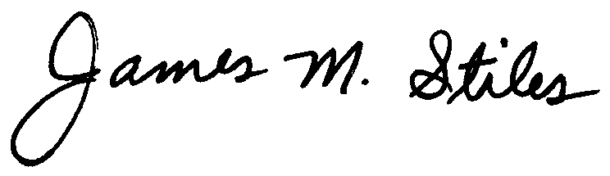
James M. Stiles, CPPB
Audit Manager

Larry G. Sorrell, Manager

Audit and Certification

STATE OF SOUTH CAROLINA
State Budget and Control Board
OFFICE OF GENERAL SERVICES
JIM HODGES, CHAIRMAN  GOVERNOR  GRADY L. PATTERSON, JR.  STATE TREASURER  JAMES A. LANDER  COMPTROLLER GENERAL |  |  | HUGH K. LEATHERMAN, SR.  CHAIRMAN, SENATE FINANCE COMMITTEE  ROBERT W. HARRELL, JR.  CHAIRMAN, WAYS AND MEANS COMMITTEE  RICK KELLY  EXECUTIVE DIRECTOR
GEORGE N. DORN, JR.
DIRECTOR

MATERIALS MANAGEMENT OFFICE
1201 MAIN STREET, SUITE 600
COLUMBIA, SOUTH CAROLINA 29201
(803) 737-0600
Fax (803) 737-0639

R. VOIGHT SHEALY
MATERIALS MANAGEMENT OFFICER

May 22, 2001

Mr. R. Voight Shealy

Materials Management Officer
Materials Management Office
1201 Main Street, Suite 600
Columbia, South Carolina 29201

Dear Voight:

We have reviewed the response from Winthrop University to our audit report for the period of April 1, 1998 – December 31, 2000. Also we have followed the University’s corrective action during and subsequent to our fieldwork. We are satisfied that the University has corrected the problem areas and the internal controls over the procurement system are adequate.

Therefore, we recommend the Budget and Control Board grant Winthrop University the certification limits noted in our report for a period of three years.

Sincerely,

Larry G. Sorrell, Manager
Audit and Certification

LGS/jl
Total Copies Printed 25
Unit Cost .20
Total Cost $5.00

