STATE OF SOUTH CAROLINA
State Budget and Control Board
OFFICE OF GENERAL SERVICES
JIM HODGES, CHAIRMAN  GOVERNOR  GRADY L. PATTERSON, JR.  STATE TREASURER  JAMES A. LANDER  COMPTROLLER GENERAL |  | HUGH K. LEATHERMAN, SR.  CHAIRMAN, SENATE FINANCE COMMITTEE  ROBERT W. HARRELL, JR.  CHAIRMAN, WAYS AND MEANS COMMITTEE  FRANK FUSCO  EXECUTIVE DIRECTOR
GEORGE N. DORN, JR.
DIRECTOR

MATERIALS MANAGEMENT OFFICE
1201 MAIN STREET, SUITE 600
COLUMBIA, SOUTH CAROLINA 29201
(803) 737-0600
Fax (803) 737-0639

R. VOIGHT SHEALY
MATERIALS MANAGEMENT OFFICER

July 23, 2001

Mr. George N. Dorn, Jr., Director
Office of General Services
1201 Main Street, Suite 420
Columbia, South Carolina 29201

Dear George:

I have attached the audit report for the Technical College of the Lowcountry. Since we are not recommending any certification above the basic $5,000 allowed by the Code, no action is required by the Budget and Control Board. Therefore, I recommend that the report be presented to the Budget and Control Board as information.

Sincerely,
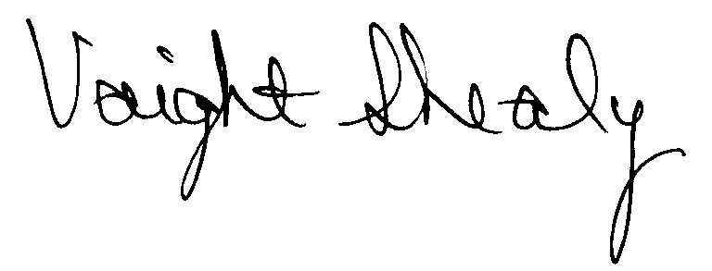
R. Voight Shealy
Materials Management Officer

/jl

TECHNICAL COLLEGE OF THE LOWCOUNTRY

PROCUREMENT AUDIT REPORT

JULY 1, 1999 - MARCH 31, 2001

TABLE OF CONTENTS

Transmittal Letter 1
Scope 3
Results of Examination 4
Conclusion 7
College Response 8
Follow-up Letter 9

STATE OF SOUTH CAROLINA
State Budget and Control Board
OFFICE OF GENERAL SERVICES
JIM HODGES, CHAIRMAN  GOVERNOR  GRADY L. PATTERSON, JR.  STATE TREASURER  JAMES A. LANDER  COMPTROLLER GENERAL |  | HUGH K. LEATHERMAN, SR.  CHAIRMAN, SENATE FINANCE COMMITTEE  ROBERT W. HARRELL, JR.  CHAIRMAN, WAYS AND MEANS COMMITTEE  FRANK FUSCO  EXECUTIVE DIRECTOR
GEORGE N. DORN, JR.
DIRECTOR

MATERIALS MANAGEMENT OFFICE
1201 MAIN STREET, SUITE 600
COLUMBIA, SOUTH CAROLINA 29201
(803) 737-0600
Fax (803) 737-0639

R. VOIGHT SHEALY
MATERIALS MANAGEMENT OFFICER

July 9, 2001

Mr. R. Voight Shealy
Materials Management Officer
Office of General Services
1201 Main Street, Suite 600
Columbia, South Carolina 29201
Dear Voight:
We have examined the procurement policies and procedures of the Technical College of the Lowcountry for the period July 1, 1999 through March 31, 2001. As part of our examination, we studied and evaluated the system of internal control over procurement transactions to the extent we considered necessary.
The evaluation was to establish a basis for reliance upon the system of internal control to assure adherence to the Consolidated Procurement Code, State regulations, and the College’s procurement policy. Additionally, the evaluation was used in determining the nature, timing and extent of other auditing procedures necessary for developing an opinion on the adequacy, efficiency and effectiveness of the procurement system.
The administration of the Technical College of the Lowcountry is responsible for establishing and maintaining a system of internal control over procurement transactions. In fulfilling this responsibility, estimates and judgments by management are required to assess the expected benefits and related costs of control procedures. The objectives of a system are to provide

management with reasonable, but not absolute, assurance of the integrity of the procurement process, that affected assets are safeguarded against loss from unauthorized use or disposition and that transactions are executed in accordance with management's authorization and are recorded properly.
Because of inherent limitations in any system of internal control, errors or irregularities may occur and not be detected. Also, projection of any evaluation of the system to future periods is subject to the risk that procedures may become inadequate because of changes in conditions or that the degree of compliance with the procedures may deteriorate.
Our study and evaluation of the system of internal control over procurement transactions, as well as our overall examination of procurement policies and procedures, were conducted with professional care. However, because of the nature of audit testing, they would not necessarily disclose all weaknesses in the system.
The examination did, however, disclose conditions enumerated in this report which we believe need correction or improvement.
Corrective action based on the recommendations described in these findings will in all material respects place the Technical College of the Lowcountry in compliance with the South Carolina Consolidated Procurement Code and ensuing regulations.

Sincerely
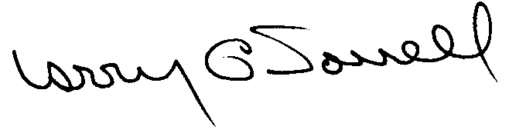

Larry G. Sorrell, Manager
Audit and Certification

SCOPE
We conducted our examination in accordance with Generally Accepted Auditing Standards as they apply to compliance audits. Our examination encompassed a detailed analysis of the internal procurement operating procedures of the Technical College of the Lowcountry and its related policies and procedures manual to the extent we deemed necessary to formulate an opinion on the adequacy of the system to properly handle procurement transactions.
We systematically selected samples for the period July 1, 1999 through March 31, 2001 of procurement transactions for compliance testing and performed other audit procedures that we considered necessary to formulate this opinion. Specifically, the scope of our audit included, but was not limited to, a review of the following:
(1) All sole source, emergency and trade-in sale procurements for the period July 1, 1999 through March 31, 2001

(2) Procurement transactions from the period July 1, 1999 through March 31, 2001 as follows:
a) Thirty-seven payment transactions exceeding $1,500 each
- A block sample of payments to thirteen vendors from the audit period reviewed for order splitting and favored vendors

(3) Two construction contracts and one professional service contract for compliance with the Manual for Planning and Execution of State Permanent Improvements

(4) Minority Business Enterprise Plan and reports
(5) Approval of most recent Information Technology Plan
(6) Internal procurement procedures manual
- Surplus property procedures
- File documentation and evidence of competition
RESULTS OF EXAMINATION
The Office of Audit and Certification performed an examination of the internal procurement policies and procedures manual of the Technical College of the Lowcountry, hereinafter referred to as the College, for the period July 1, 1999 to March 31, 2001. Our on-site review was conducted May 14 - 18, 2001 and was made under the authority described in Section 11-35-1230(1) of the South Carolina Consolidated Procurement Code and Regulation 19-445.2020.
Since our previous audit in 1994, the College has maintained what we consider to be a professional, efficient procurement system. We did note, however, the following items which should be addressed by management.

Unauthorized Procurements
We noted four unauthorized procurements.

 | Check | PO | Amount | Description
 | 30015 | B0000008 | $ 2,100 per year | Maintenance of parking lots
 | 31235 | 000444 | 72,695 | Furniture
 | 100190 | --- | 33,417 | Media consultant
 | 101920 | B0000060 | 1,000 | Printing
The procurements for items 1, 2, and 3 were unauthorized as the total value exceeded the College’s procurement authority of $5,000. On item 1, the College contracted for one year with the option to extend for two additional years thus making the total value of the contract $6,300 On item 2, the College hired an interior designer to assist in furnishing health science building. The designer developed specifications for the furniture, issued the solicitation, received the responses to the solicitation, advised the College on the vendor to receive the award. The College issued the purchase order. The College believed item 3 was exempt.
The maximum value on the purchase order for item 4 was limited to $1,000, however the printing job charged exceeded the $1,000 limit but was not authorized by someone with procurement authority.
Regulation 19-445.2015 defines an unauthorized procurement as an act obligating the State in a contract by any person without the requisite authority to do so.
We recommend the College request ratification from the Materials Management Officer for items 1 through 3 and from the College President for item 4 in accordance with Regulation 19-445.2015.
Additionally, the multi-term determination was not prepared for item 1. Section 11-35-2030 of the Code requires the written determination prior to the use of a multi-term contract.
We recommend the College prepare the written determinations when applicable.
Procurements Without Competition
The following eight procurements were not supported by solicitations of competition, sole source or emergency procurement determinations, term contract references or incorrectly classified as exempt items.
Check | PO | Amount | Description
30486/30625 | 001143 | $ 2,484 | Projectors
31270 | 001233 | 4,800 | Billboard rental
30946 | 001200/001331 | 4,162 | Workstations
29774 | 000825 | 2,140 | Office supplies
101468 | P0000449 | 3,891 | Computer accessories
100979 | P0000119 | 2,566 | Cosmetology supplies
100410 | NO PO | 2,856 | Meals for upward bound students
102230 | P0000646 | 2,703 | Upgrade electrical circuits
Section 11-35-1510 of the Code lists the methods of source selection and Section 11-35-710 lists the exemptions as well as the procedures of exempting items.
We recommend the College comply with the competitive requirements of the Code when the potential value exceeds $1,500.

Change Order Policy
The College does not have a formal change order policy. A lack of change order procedures lead to invoices being paid which did not agree with the purchase orders on the following three procurements.

Check | PO | Payment Amount | PO Amount | Description
29643 | 000700 | $3,089 | $2,700 | HVAC service
27281 | 000368 | 4,350 | 4,000 | Tree trimming and brush removal
102724 | 000751 | 4,254 | 1,470 | Printing
We recommend a formal change order procedure be implemented. A formal change order procedure will assure that payments are made based on the terms of the purchase orders.
CONCLUSION
As enumerated in our transmittal letter, corrective action based on the recommendations described in this report will in all materials respects place the Technical College of the Lowcountry in compliance with the Consolidated Procurement Code and ensuing regulations.
The College has not requested increased procurement certification above the basic limit of $5,000 allowed by the Code. Subject to corrective action listed in this report, we will recommend the College be allowed to continue procuring all goods and services, consultant services, construction services and information technology up to the basic level of $5,000 as allowed by the Consolidated Procurement Code and accompanying regulations.
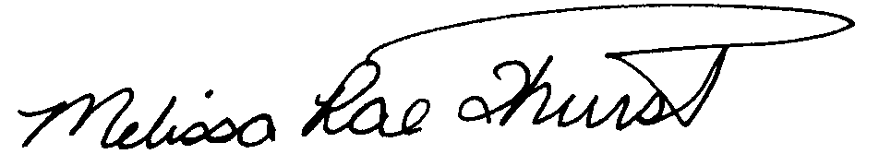
Melissa Rae Thurstin
Senior Auditor

Larry G. Sorrell, Manager
Audit and Certification

STATE OF SOUTH CAROLINA
State Budget and Control Board
OFFICE OF GENERAL SERVICES
JIM HODGES, CHAIRMAN  GOVERNOR  GRADY L. PATTERSON, JR.  STATE TREASURER  JAMES A. LANDER  COMPTROLLER GENERAL |  | HUGH K. LEATHERMAN, SR.  CHAIRMAN, SENATE FINANCE COMMITTEE  ROBERT W. HARRELL, JR.  CHAIRMAN, WAYS AND MEANS COMMITTEE  FRANK FUSCO  EXECUTIVE DIRECTOR
GEORGE N. DORN, JR.
DIRECTOR

MATERIALS MANAGEMENT OFFICE
1201 MAIN STREET, SUITE 600
COLUMBIA, SOUTH CAROLINA 29201
(803) 737-0600
Fax (803) 737-0639

R. VOIGHT SHEALY
MATERIALS MANAGEMENT OFFICER

July 23, 2000

Mr. R. Voight Shealy
Materials Management Officer
Materials Management Office
1201 Main Street, Suite 600
Columbia, South Carolina 29201

Dear Voight:

We have reviewed the Technical College of the Lowcountry’s response to our audit report for July 1, 1999 – March 31, 2001. Also, we have followed the College’s corrective action during and subsequent to our field work. We are satisfied that the College has corrected the problem areas and the internal controls over the procurement system are adequate.

Additional certification was not requested. Therefore, we recommend the College be allowed to continue procuring all goods and services, construction services, information technology and consulting services up to the basic level of outlined in the Code.

Sincerely,
Larry G. Sorrell, Manager
Audit and Certification

LGS/jl

Total Copies Printed 25
Unit Cost - .20
Total Cost - $5.00

