STATE OF SOUTH CAROLINA
State Budget and Control Board
OFFICE OF GENERAL SERVICES
JIM HODGES, CHAIRMAN  GOVERNOR  GRADY L. PATTERSON, JR.  STATE TREASURER  JAMES A. LANDER  COMPTROLLER GENERAL |  | HUGH K. LEATHERMAN, SR.  CHAIRMAN, SENATE FINANCE COMMITTEE  ROBERT W. HARRELL, JR.  CHAIRMAN, WAYS AND MEANS COMMITTEE  FRANK FUSCO  EXECUTIVE DIRECTOR
GEORGE N. DORN, JR.
DIRECTOR

MATERIALS MANAGEMENT OFFICE
1201 MAIN STREET, SUITE 600
COLUMBIA, SOUTH CAROLINA 29201
(803) 737-0600
Fax (803) 737-0639

R. VOIGHT SHEALY
MATERIALS MANAGEMENT OFFICER

July 31, 2001

Mr. George N. Dorn, Jr., Director
Office of General Services
1201 Main Street, Suite 420
Columbia, South Carolina 29201

Dear George:

I have attached the audit report for Spartanburg Technical College. Since we are not recommending any certification above the basic $5,000 allowed by the Code, no action is required by the Budget and Control Board. Therefore, I recommend that the report be presented to the Budget and Control Board as information.

Sincerely,
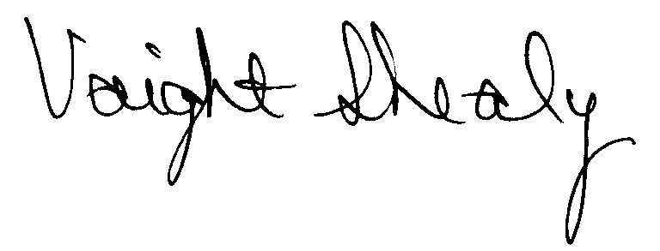
R. Voight Shealy
Materials Management Officer

/jl

SPARTANBURG TECHNICAL COLLEGE
PROCUREMENT AUDIT REPORT

JULY 1, 1999 - MARCH 31, 2001
TABLE OF CONTENTS
PAGE
Transmittal Letter 1
Introduction 3
Scope 4
Results of Examination 5

Conclusion…………………………………………………………………………… 6

College Response……………………………………………………………………… 7

Follow-up Letter……………………………………………………………………… 8

STATE OF SOUTH CAROLINA
State Budget and Control Board
OFFICE OF GENERAL SERVICES
JIM HODGES, CHAIRMAN  GOVERNOR  GRADY L. PATTERSON, JR.  STATE TREASURER  JAMES A. LANDER  COMPTROLLER GENERAL |  | HUGH K. LEATHERMAN, SR.  CHAIRMAN, SENATE FINANCE COMMITTEE  ROBERT W. HARRELL, JR.  CHAIRMAN, WAYS AND MEANS COMMITTEE  FRANK FUSCO  EXECUTIVE DIRECTOR
GEORGE N. DORN, JR.
DIRECTOR

MATERIALS MANAGEMENT OFFICE
1201 MAIN STREET, SUITE 600
COLUMBIA, SOUTH CAROLINA 29201
(803) 737-0600
Fax (803) 737-0639

R. VOIGHT SHEALY
MATERIALS MANAGEMENT OFFICER

July 15, 2001
Mr. R. Voight Shealy
Materials Management Officer
Office of General Services
1201 Main Street, Suite 600
Columbia, South Carolina 29201

Dear Voight:
We have examined the procurement policies and procedures of Spartanburg Technical College for the period July 1, 1999 through March 31, 2001. As part of our examination, we studied and evaluated the system of internal control over procurement transactions to the extent we considered necessary.
The evaluation was to establish a basis for reliance upon the system of internal control to assure adherence to the Consolidated Procurement Code, State Regulations and College’s procurement policy. Additionally, the evaluation was used in determining the nature, timing and extent of other auditing procedures necessary for developing an opinion on the adequacy, efficiency and effectiveness of the procurement system.
The administration of Spartanburg Technical College is responsible for establishing and maintaining a system of internal control over procurement transactions. In fulfilling this responsibility, estimates and judgments by management are required to assess the expected benefits and related costs of control procedures. The objectives of a system are to provide management with reasonable, but not absolute, assurance of the integrity of the procurement process, that affected assets are safeguarded against loss from unauthorized use or disposition

and that transactions are executed in accordance with management's authorization and are recorded properly.
Because of inherent limitations in any system of internal control, errors or irregularities may occur and not be detected. Also, projection of any evaluation of the system to future periods is subject to the risk that procedures may become inadequate because of changes in conditions or that the degree of compliance with the procedures may deteriorate.
Our study and evaluation of the system of internal control over procurement transactions, as well as our overall examination of procurement policies and procedures, were conducted with professional care. However, because of the nature of audit testing, they would not necessarily disclose all weaknesses in the system.
The examination did, however, disclose conditions enumerated in this report which we believe need correction or improvement.
Corrective action based on the recommendations described in these findings will in all material respects place Spartanburg Technical College in compliance with the South Carolina Consolidated Procurement Code and ensuing regulations.

Sincerely,
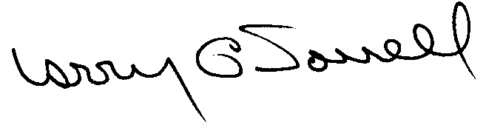
Larry G. Sorrell, Manager
Audit and Certification
INTRODUCTION
We conducted an examination of the internal procurement operating policies and procedures of Spartanburg Technical College. Our on-site review was conducted June 5-15, 2001 and was made under Section 11-35-1230 (1) of the South Carolina Consolidated Procurement Code and Section 19-445.2020 of the accompanying regulations.
The examination was directed principally to determine whether, in all material respects, the procurement system's internal controls were adequate and the procurement procedures, as outlined in the Internal Procurement Operating Procedures Manual, were in compliance with the South Carolina Consolidated Procurement Code and its ensuing regulations.
Additionally, our work was directed toward assisting the College in promoting the underlying purposes and policies of the Code as outlined in Section 11-35-20, which include:
(1) to ensure the fair and equitable treatment of all persons who deal with the procurement system of this State

(2) to provide increased economy in state procurement activities and to maximize to the fullest extent practicable the purchasing values of funds of the State

(3) to provide safeguards for the maintenance of a procurement system of quality and integrity with clearly defined rules for ethical behavior on the part of all persons engaged in the public procurement process
SCOPE
We conducted our examination in accordance with Generally Accepted Auditing Standards as they apply to compliance audits. Our examination encompassed a detailed analysis of the internal procurement operating procedures of Spartanburg Technical College and its related policies and procedures manual to the extent we deemed necessary to formulate an opinion on the adequacy of the system to properly handle procurement transactions.
We selected a systematic sample from the period July 1,1999 through March 31, 2001 of procurement transactions for compliance testing and performed other audit procedures that we considered necessary to formulate this opinion. Specifically, the scope of our audit included, but was not limited to, review of the following:
- All sole source, emergency and trade-in sale procurements from the period July 1, 1999 through March 31, 2001

(2) Procurement transactions for the audit period as follows:

a) Thirty four payments greater than $1,500 each
- A block sample of four hundred numerical purchase orders
from FY 2001 reviewed for order splitting and favored vendors
- A review of thirty six purchase transactions supported by quotations

- a) Four permanent improvement projects and one professional services contract
for compliance with the Manual for Planning and Execution of State Permanent Improvements
b) Two minor construction projects less than $25,000 approved by the State Engineer

- Surplus property procedures

- Minority Business Enterprise Plan and reports

- Internal procurement procedures manual

- File documentation and evidence of competition

RESULTS OF EXAMINATION
The Office of Audit and Certification performed an examination of the internal procurement operating policies, procedures, and related manual of Spartanburg Technical College for the period July 1, 1999 through March 31, 2001.
Since our last compliance audit, Spartanburg Technical College has maintained what we consider a professional, efficient procurement system. However, we did note the following item which should be addressed by management.

Combining Requirements for Bidding
We noted one instance where like items should have been combined and competed based on the total value.
PO | PO Date | Requisition | Amount | Description
140223 | 7/21/99 | 19625 | $ 1,417 | Audio microphones
140224 | 7/21/99 | 19626 | 1,484 | Audio mixer
 |  | Total | $ 2,901

Section 11-35-1550(2)(b) of the Code requires solicitations of verbal or written quotes from a minimum of three qualified sources for procurements between $1,500.01 and $5,000.
We recommend that the College combine and solicit competition based on the total value.

CONCLUSION
As enumerated in our transmittal letter, corrective action based on the recommendation described in this report, we believe, will in all material respects place Spartanburg Technical College in compliance with the South Carolina Consolidated Procurement Code and ensuing regulations.
The College has not requested increased procurement certification above the basic limit of $5,000 allowed by the Procurement Code. Subject to corrective action listed in this report, we recommend the College be allowed to continue procuring goods and services, consultant services, construction and information technology up to the basic level of $5,000 as allowed by the South Carolina Consolidated Procurement Code and accompanying regulations.

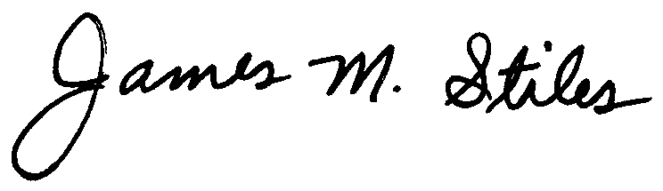
James M. Stiles, CPPB
Audit Manager

Larry G. Sorrell, Manager
Audit and Certification

STATE OF SOUTH CAROLINA
State Budget and Control Board
OFFICE OF GENERAL SERVICES
JIM HODGES, CHAIRMAN  GOVERNOR  GRADY L. PATTERSON, JR.  STATE TREASURER  JAMES A. LANDER  COMPTROLLER GENERAL |  | HUGH K. LEATHERMAN, SR.  CHAIRMAN, SENATE FINANCE COMMITTEE  ROBERT W. HARRELL, JR.  CHAIRMAN, WAYS AND MEANS COMMITTEE  FRANK FUSCO  EXECUTIVE DIRECTOR
GEORGE N. DORN, JR.
DIRECTOR

MATERIALS MANAGEMENT OFFICE
1201 MAIN STREET, SUITE 600
COLUMBIA, SOUTH CAROLINA 29201
(803) 737-0600
Fax (803) 737-0639

R. VOIGHT SHEALY
MATERIALS MANAGEMENT OFFICER

July 31, 2001

Mr. R. Voight Shealy

Materials Management Officer
Materials Management Office
1201 Main Street, Suite 600
Columbia, South Carolina 29201

Dear Voight:

We have reviewed Spartanburg Technical College’s response to our audit report for July 1, 1999 – March 31, 2001. Also, we have followed the College’s corrective action during and subsequent to our field work. We are satisfied that the College has corrected the problem area and the internal controls over the procurement system are adequate.

Additional certification was not requested. Therefore, we recommend the College be allowed to continue procuring all goods and services, construction services, information technology and consulting services up to the basic level of outlined in the Code.

Sincerely,
Larry G. Sorrell, Manager
Audit and Certification

LGS/jl

Total Copies Printed 25
Unit Cost - .18
Total Cost - $4.50

