STATE OF SOUTH CAROLINA
State Budget and Control Board
OFFICE OF GENERAL SERVICES
JIM HODGES, CHAIRMAN  GOVERNOR  GRADY L. PATTERSON, JR.  STATE TREASURER  JAMES A. LANDER  COMPTROLLER GENERAL |  | JOHN DRUMMOND  CHAIRMAN, SENATE FINANCE COMMITTEE  ROBERT W. HARRELL, JR.  CHAIRMAN, WAYS AND MEANS COMMITTEE  RICK KELLY  EXECUTIVE DIRECTOR
ROBERT W. McCLAM
DIRECTOR

MATERIALS MANAGEMENT OFFICE
1201 MAIN STREET, SUITE 600
COLUMBIA, SOUTH CAROLINA 29201
(803) 737-0600
Fax (803) 737-0639

R. VOIGHT SHEALY
ASSISTANT DIRECTOR

November 6, 2000

Mr. Robert W. McClam, Director
Office of General Services
1201 Main Street, Suite 420
Columbia, South Carolina 29201

Dear Robbie:

I have attached the South Carolina Department of Revenue’s procurement audit report and recommendations made by the Office of Audit and Certification. I concur and recommend the Budget and Control Board grant the Department a three-year certification as noted in the audit report.

Sincerely,
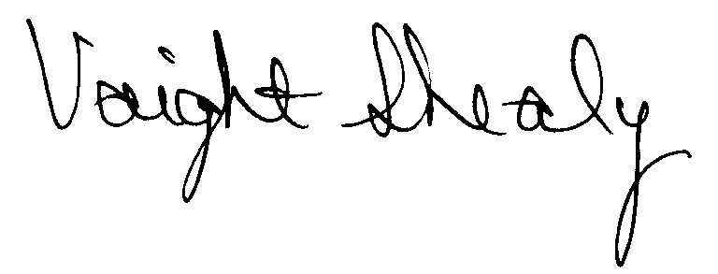
R. Voight Shealy
Materials Management Officer

/jl

SOUTH CAROLINA DEPARTMENT OF REVENUE

PROCUREMENT AUDIT REPORT

JULY 1, 1997 - JUNE 30, 2000
TABLE OF CONTENTS

PAGE

Transmittal Letter 1
Introduction 3
Background 4
Scope 5
Summary of Audit Findings 6
Results of Examination 7
Certification Recommendations 9
Follow-up Letter 10

NOTE: The Department’s responses to issues noted in this report have been inserted immediately following the items they refer to.

STATE OF SOUTH CAROLINA
State Budget and Control Board
OFFICE OF GENERAL SERVICES
JIM HODGES, CHAIRMAN  GOVERNOR  GRADY L. PATTERSON, JR.  STATE TREASURER  JAMES A. LANDER  COMPTROLLER GENERAL |  | JOHN DRUMMOND  CHAIRMAN, SENATE FINANCE COMMITTEE  ROBERT W. HARRELL, JR.  CHAIRMAN, WAYS AND MEANS COMMITTEE  RICK KELLY  EXECUTIVE DIRECTOR
ROBERT W. McCLAM
DIRECTOR

MATERIALS MANAGEMENT OFFICE
1201 MAIN STREET, SUITE 600
COLUMBIA, SOUTH CAROLINA 29201
(803) 737-0600
Fax (803) 737-0639

R. VOIGHT SHEALY
ASSISTANT DIRECTOR

October 17, 2000

Mr. R. Voight Shealy
Materials Management Officer
Office of General Services
1201 Main Street, Suite 600
Columbia, South Carolina 29201

Dear Voight:
We have examined the procurement policies and procedures of the South Carolina Department of Revenue for the period July 1, 1997 through June 30, 2000. As part of our examination, we studied and evaluated the system of internal control over procurement transactions to the extent we considered necessary.
The evaluation was to establish a basis for reliance upon the system of internal control to assure adherence to the Consolidated Procurement Code, State regulations, and the Department’s procurement policy. Additionally, the evaluation was used in determining the nature, timing and extent of other auditing procedures necessary for developing an opinion on the adequacy, efficiency and effectiveness of the procurement system.
The administration of the South Carolina Department of Revenue is responsible for establishing and maintaining a system of internal control over procurement transactions. In fulfilling this responsibility, estimates and judgments by management are required to assess the expected benefits and related costs of control procedures. The objectives of a system are to
provide management with reasonable, but not absolute, assurance of the integrity of the procurement process that affected assets are safeguarded against loss from unauthorized use or disposition and that transactions are executed in accordance with management's authorization and are recorded properly.
Because of inherent limitations in any system of internal control, errors or irregularities may occur and not be detected. Also, projection of any evaluation of the system to future periods is subject to the risk that procedures may become inadequate because of changes in conditions or that the degree of compliance with the procedures may deteriorate.
Our study and evaluation of the system of internal control over procurement transactions, as well as our overall examination of procurement policies and procedures, were conducted with professional care. However, because of the nature of audit testing, they would not necessarily disclose all weaknesses in the system.
The examination did, however, disclose conditions enumerated in this report which we believe need correction or improvement.
Corrective action based on the recommendations described in these findings will in all material respects place the South Carolina Department of Revenue in compliance with the Consolidated Procurement Code and ensuing regulations.

Sincerely,
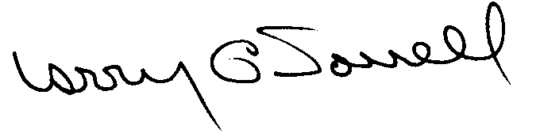
Larry G. Sorrell, Manager
Audit and Certification
INTRODUCTION

We conducted an examination of the internal procurement operating policies and procedures of the South Carolina Department of Revenue. Our on-site review was conducted June 17, 1997 through July 11, 1997 and was made under Section 11-35-1230(1) of the South Carolina Consolidated Procurement Code and Section 19-445.2020 of the accompanying regulations.
The examination was directed principally to determine whether, in all material respects, the procurement system's internal controls were adequate and the procurement procedures, as outlined in the Internal Procurement Operating Procedures Manual, were in compliance with the South Carolina Consolidated Procurement Code and its ensuing regulations.
Additionally, our work was directed toward assisting the Department in promoting the underlying purposes and policies of the Code as outlined in Section 11-35-20 which include:
(1) to ensure the fair and equitable treatment of all persons who deal with the procurement system of this State

(2) to provide increased economy in state procurement activities and to maximize to the fullest extent practicable the purchasing values of funds of the State

(3) to provide safeguards for the maintenance of a procurement system of quality and integrity with clearly defined rules for ethical behavior on the part of all persons engaged in the public procurement process

BACKGROUND

Section 11-35-1210 of the South Carolina Consolidated Procurement Code states:

The (Budget and Control) Board may assign differential dollar limits below which individual governmental bodies may make direct procurements not under term contracts. The Office of General Services shall review the respective governmental body's internal procurement operation, shall verify in writing that it is consistent with the provisions of this code and the ensuing regulations, and recommend to the Board those dollar limits for the respective governmental body's procurement not under term contract.

On February 10, 1998, the Budget and Control Board granted the South Carolina Department of Revenue the following procurement certifications:
PROCUREMENT AREAS | CERTIFICATION LIMITS
Goods and Services | $25,000 per commitment
Printing Services | $25,000 per commitment
Our audit was performed primarily to determine if recertification is warranted. The Department requested the following certification limits.
PROCUREMENT AREAS | CERTIFICATION LIMITS
Goods and Services | $25,000 per commitment
Consultant Services | $25,000 per commitment
Information Technology | $25,000 per commitment
SCOPE

We conducted our examination in accordance with Generally Accepted Auditing Standards as they apply to compliance audits. Our examination encompassed a detailed analysis of the internal procurement operating procedures of the South Carolina Department of Revenue and its related policies and procedures manual to the extent we deemed necessary to formulate an opinion on the adequacy of the system to properly handle procurement transactions.
We judgmentally selected a sample for the period July 1, 1998 through June 30, 2000 of procurement transactions for compliance testing and performed other audit procedures that we considered necessary to formulate this opinion. Specifically, the scope of our audit included, but was not limited to, a review of the following:

(1) All sole source, emergency and trade-in sale procurements for the period July 1, 1997 through June 30, 2000

(2) Procurement transactions for the period July 1, 1998 through June 30, 2000 as follows:
- One hundred and three payment transactions greater than $1,500 each reviewed for competition and compliance to the Code
- A block sample of five hundred numerical purchase orders reviewed for order splitting and favored vendors

(3) Minority Business Enterprise Plans and reports for the audit period

(4) Information technology plans for audit period

(5) Internal procurement procedures manual

- Surplus property disposal procedures

- File documentation and evidence of competition

SUMMARY OF AUDIT FINDINGS
Our audit of the procurement system of the South Carolina Department of Revenue, hereinafter referred to as the Department, produced the following findings and recommendations.
PAGE
I. Sole Source and Emergency Procurement Reporting Errors 7
During our review of sole source and emergency procurements, we noted two types of reporting errors.
- General Code Compliance
- Preferences Not Included in Solicitations 7
The Department does not include bidder’s preferences in its quotations.
- Award Based on Expired Quote 7
The quote used for an award expired prior to the date of the award.
III. General Procurement Procedures 8
Bids and quotes were not always date and time stamped when received.

RESULTS OF EXAMINATION

- Sole Source and Emergency Procurement Reporting Errors
During our review of sole source and emergency procurements, we noted two types of reporting errors. Change orders were not being reported and canceled procurements were not being deleted from reports previously filed. Section 11-35-2440 of the Code requires that governmental bodies submit a quarterly record of all sole source and emergency procurements. The Materials Management Office combines the quarterly reports and prepares an annual report to the State Budget and Control Board.
We recommend the Department revise its current procedure to include the timely reporting of change orders and cancellations to sole source and emergency procurements.
DEPARTMENT RESPONSE
We concur with the findings and have implemented procedures to include change orders and canceled procurements in the quarterly reports.

II. General Code Compliance
- Preferences Not Included in Solicitations
The Department does not provide bidder preference information in its written solicitations between $10,000 and $25,000. Section 11-35-1524 of the Code allows preferences for resident vendors and products made, manufactured, or grown in South Carolina or the United States. However, the bidders are not being informed of the availability of these preferences in the solicitations.
We recommend the preferences in Section 11-35-1524 be included in the applicable written solicitations.
DEPARTMENT RESPONSE
We respectfully disagree with the findings of the audit regarding the informing of vendors of preferences. Section 11-35-1524 does not provide a clear and concise requirement and we find no request prior to this examination to provide such information on solicitations. However, beginning this date we will comply with the request and provide notification in the applicable solicitations.

Award Based on Expired Quote
Purchase order 232 was issued on 8/11/98 for $10,668 for computer equipment. The purchase order was issued based on the awarded vendor’s quote dated 5/14/98 that was valid for 30 days. Additionally, the quote was prepared on vendor’s letterhead and not the Department’s request for quotation (RFQ) that had a return date of 8/10/98. We did not find nor could the Department provide any documentation that the RFQ was mailed to the awarded vendor or that the awarded vendor responded to the RFQ.
We recommend the Department base awards on valid responses to solicitations.
DEPARTMENT RESPONSE
We concur and all future solicitations for purchases greater than $10,000 will be written.

III. General Procurement Procedures
We noted that responses to quotes and bids have not been date and time stamped showing that they were received prior to the openings. Some bid folders contained the bid envelopes in the file but they were not time or dated stamped either.
We recommend, as a matter of internal control, that all responses to quotes and bids are date and time stamped when received to show, through an independent means, that the tabulated information was indeed received prior to the opening. If a late bid is received, the Procurement Officer should indicate on the outside of the envelope the date and time of receipt, initial the envelope, and place in the bid file. This procedure protects the Department and the Procurement Officers conducting the openings.
DEPARTMENT RESPONSE
We agree and all future quotes will be date stamped.
CERTIFICATION RECOMMENDATIONS

As enumerated in our transmittal letter, corrective action based on the recommendations, described in this report, we believe, will in all materials respects place the Department of Revenue in compliance with the South Carolina Consolidated Procurement Code and ensuing regulations.
Under the authority described in Section 11-35-1210 of the Code, subject to this corrective action, we will recommend the South Carolina Department of Revenue be recertified to make direct agency procurements for three years up to the limits as follows.
PROCUREMENT AREAS | RECOMMENDED CERTIFICATION LIMITS
Goods and Services | *$25,000 per commitment
Consultant Services | *$25,000 per commitment
Information Technology | *$25,000 per commitment

*The total potential purchase commitment whether single year or multi-term contracts are used.

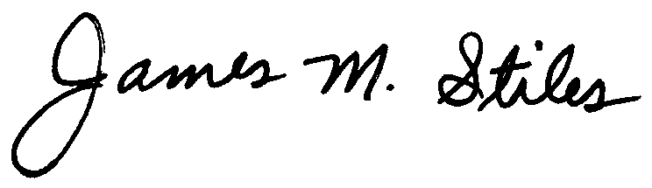
James M. Stiles, CPPB
Audit Manager

Larry G. Sorrell, Manager
Audit and Certification
STATE OF SOUTH CAROLINA
State Budget and Control Board
OFFICE OF GENERAL SERVICES
JIM HODGES, CHAIRMAN  GOVERNOR  GRADY L. PATTERSON, JR.  STATE TREASURER  JAMES A. LANDER  COMPTROLLER GENERAL |  | JOHN DRUMMOND  CHAIRMAN, SENATE FINANCE COMMITTEE  ROBERT W. HARRELL, JR.  CHAIRMAN, WAYS AND MEANS COMMITTEE  RICK KELLY  EXECUTIVE DIRECTOR
ROBERT W. McCLAM
DIRECTOR

MATERIALS MANAGEMENT OFFICE
1201 MAIN STREET, SUITE 600
COLUMBIA, SOUTH CAROLINA 29201
(803) 737-0600
Fax (803) 737-0639

R. VOIGHT SHEALY
ASSISTANT DIRECTOR

November 6, 2000

Mr. R. Voight Shealy
Materials Management Officer
Materials Management Office
1201 Main Street, Suite 600
Columbia, South Carolina 29201

Dear Voight:

We have reviewed the response from the South Carolina Department of Revenue to our audit report for the period of July 1, 1997 – June 30, 2000. Also we have followed the Department’s corrective action during and subsequent to our fieldwork. We are satisfied that the Department has corrected the problem areas and the internal controls over the procurement system are adequate.

Therefore, we recommend the Budget and Control Board grant South Carolina Department of Revenue the certification limits noted in our report for a period of three years.

Sincerely,

Larry G. Sorrell, Manager
Audit and Certification

LGS/jl
Total Copies Printed 25
Unit Cost .21
Total Cost $5.25

