STATE OF SOUTH CAROLINA
State Budget and Control Board
OFFICE OF GENERAL SERVICES
JIM HODGES, CHAIRMAN  GOVERNOR  GRADY L. PATTERSON, JR.  STATE TREASURER  JAMES A. LANDER  COMPTROLLER GENERAL |  | JOHN DRUMMOND  CHAIRMAN, SENATE FINANCE COMMITTEE  ROBERT W. HARRELL, JR.  CHAIRMAN, WAYS AND MEANS COMMITTEE  RICK KELLY  EXECUTIVE DIRECTOR
ROBERT W. McCLAM
DIRECTOR

MATERIALS MANAGEMENT OFFICE
1201 MAIN STREET, SUITE 600
COLUMBIA, SOUTH CAROLINA 29201
(803) 737-0600
Fax (803) 737-0639

R. VOIGHT SHEALY
ASSISTANT DIRECTOR

July 10, 2000

Mr. Robert W. McClam, Director
Office of General Services
1201 Main Street, Suite 420
Columbia, South Carolina 29201

Dear Robbie:

I have attached the Medical University of South Carolina’s procurement audit report and recommendations made by the Office of Audit and Certification. I concur and recommend the Budget and Control Board grants the University a three-year certification as noted in the audit report.

Sincerely,

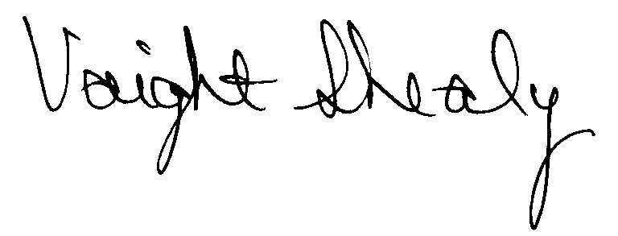
R. Voight Shealy
Materials Management Officer

MEDICAL UNIVERSITY OF SOUTH CAROLINA
PROCUREMENT AUDIT REPORT

APRIL 1, 1997 - DECEMBER 31, 1999
TABLE OF CONTENTS
PAGE

Transmittal Letter 1

Introduction 3

Background 4
Scope 6
Results of Examination 7
Certification Recommendations 9

Agency Response 10
Follow-up Letter 11
STATE OF SOUTH CAROLINA
State Budget and Control Board
OFFICE OF GENERAL SERVICES
JIM HODGES, CHAIRMAN  GOVERNOR  GRADY L. PATTERSON, JR.  STATE TREASURER  JAMES A. LANDER  COMPTROLLER GENERAL |  | JOHN DRUMMOND  CHAIRMAN, SENATE FINANCE COMMITTEE  ROBERT W. HARRELL, JR.  CHAIRMAN, WAYS AND MEANS COMMITTEE  RICK KELLY  EXECUTIVE DIRECTOR
ROBERT W. McCLAM
DIRECTOR

MATERIALS MANAGEMENT OFFICE
1201 MAIN STREET, SUITE 600
COLUMBIA, SOUTH CAROLINA 29201
(803) 737-0600
Fax (803) 737-0639

R. VOIGHT SHEALY
ASSISTANT DIRECTOR

June 23, 2000

Mr. R. Voight Shealy
Materials Management Officer
Office of General Services
1201 Main Street, Suite 600
Columbia, South Carolina 29201
Dear Voight:
We have examined the procurement policies and procedures of the Medical University of South Carolina for the period April 1, 1997 through December 31, 1999. As part of our examination, we studied and evaluated the system of internal control over procurement transactions to the extent we considered necessary.
The evaluation was to establish a basis for reliance upon the system of internal control to assure adherence to the Consolidated Procurement Code, State regulations, and the University’s procurement policy. Additionally, the evaluation was used in determining the nature, timing and extent of other auditing procedures necessary for developing an opinion on the adequacy, efficiency and effectiveness of the procurement system.
The administration of the Medical University of South Carolina is responsible for establishing and maintaining a system of internal control over procurement transactions. In fulfilling this responsibility, estimates, and judgments by management are required to assess the expected benefits and related costs of control procedures. The objectives of a system are to

provide management with reasonable, but not absolute, assurance of the integrity of the procurement process, that affected assets are safeguarded against loss from unauthorized use or disposition and that transactions are executed in accordance with management's authorization and are recorded properly.
Because of inherent limitations in any system of internal control, errors or irregularities may occur and not be detected. Also, projection of any evaluation of the system to future periods is subject to the risk that procedures may become inadequate because of changes in conditions or that the degree of compliance with the procedures may deteriorate.
Our study and evaluation of the system of internal control over procurement transactions, as well as our overall examination of procurement policies and procedures, were conducted with professional care. However, because of the nature of audit testing, they would not necessarily disclose all weaknesses in the system.
The examination did, however, disclose conditions enumerated in this report which we believe need correction or improvement.
Corrective action based on the recommendations described in these findings will in all material respects place the Medical University of South Carolina in compliance with the Consolidated Procurement Code and ensuing regulations.

Sincerely,
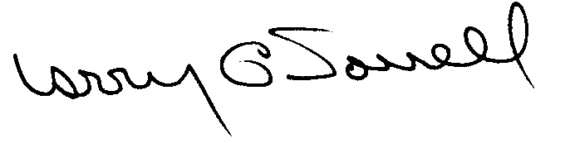
Larry G. Sorrell, Manager
Audit and Certification
INTRODUCTION
We conducted an examination of the internal procurement operating policies and procedures of the Medical University of South Carolina. Our review was conducted March 13, 2000 through April 21, 2000 and was made under Section 11-35-1230(1) of the South Carolina Consolidated Procurement Code and Section 19-445.2020 of the accompanying regulations.
The examination was directed principally to determine whether, in all material respects, the procurement system's internal controls were adequate and the procurement procedures, as outlined in the Internal Procurement Operating Procedures Manual, were in compliance with the South Carolina Consolidated Procurement Code and its ensuing regulations.
Additionally, our work was directed toward assisting the University in promoting the underlying purposes and policies of the Code as outlined in Section 11-35-20, which include:

(1) to ensure the fair and equitable treatment of all persons who deal with the procurement system of this State

(2) to provide increased economy in state procurement activities and to maximize to the fullest extent practicable the purchasing values of funds of the State

(3) to provide safeguards for the maintenance of a procurement system of quality and integrity with clearly defined rules for ethical behavior on the part of all persons engaged in the public procurement process
BACKGROUND

Section 11-35-1210 of the South Carolina Consolidated Procurement Code states:
The (Budget and Control) Board may assign differential dollar limits below which individual governmental bodies may make direct procurements not under term contracts. The Office of General Services shall review the respective governmental body's internal procurement operation, shall verify in writing that it is consistent with the provisions of this code and the ensuing regulations, and recommend to the Board those dollar limits for the respective governmental body's procurement not under term contract.
On September 16, 1997, the Budget and Control Board granted the Medical University of South Carolina the following procurement certifications:

PROCUREMENT AREAS | CERTIFICATION LIMITS
Chemical/Reagents, Injectables, Prescription Drugs, Intravenous Solutions and Sets and all other commodities defined in the Materials Management Office (MMO) Commodity Code Manual under #115-Biochemical Research and #270-Drugs, Pharmaceuticals, Biologicals-Human Use initially approved by MUSC’s Products Evaluation Committee | $6,000,000 per commitment
Medical supply items and all other commodities in the MMO Commodity Code Manual under #475-Hospital Sundries, including Linens, Gas Cylinders and Liquid Oxygen for Patient Use initially approved by MUSC’s Products Evaluation Committee | $3,000,000 per commitment
Hospital, Laboratory and Research Equipment | $ 100,000 per commitment
All Other Goods and Services | $ 50,000 per commitment
Consultant Services | $ 25,000 per commitment
Construction Services | $ 100,000 per commitment
Information Technology | $ 50,000 per commitment
Our audit was performed primarily to determine if recertification. Additionally the University requested the following certification limits.

PROCUREMENT AREAS | CERTIFICATION LIMITS
Goods and Services |  | $ 100,000 per commitment
Information Technology |  | $ 100,000 per commitment
Consultant Services |  | $ 25,000 per commitment
Construction Contract Award |  | $ 100,000 per commitment
Construction Contract Change Order |  | $ 50,000 per change order
Architect/Engineer Contract Amendment |  | $ 15,000 per change order
SCOPE
We conducted our examination in accordance with Generally Accepted Auditing Standards as they apply to compliance audits. Our examination encompassed a detailed analysis of the internal procurement operating procedures of the Medical University of South Carolina and its related policies and procedures manual to the extent we deemed necessary to formulate an opinion on the adequacy of the system to properly handle procurement transactions.
We judgmentally selected a sample for the period July 1, 1997 through December 31, 1999 of procurement transactions for compliance testing and performed other audit procedures that we considered necessary to formulate this opinion. Specifically, the scope of our audit included, but was not limited to, a review of the following:

(1) All sole source, emergency and trade-in sale procurements for the period April 1, 1997 through December 31, 1999

(2) Procurement transactions from the period July 1, 1997 through December 31, 1999 as follows:
a) One hundred thirty-three payment transactions greater than $1,500 each reviewed for competition and compliance to the Code
b) A block sample of approximately five hundred numerical purchase orders reviewed for order splitting and favored vendors
c) An additional test of thirteen sealed bids
d) One revenue generating contract

(3) Fourteen construction contracts and four professional service contracts for compliance with the Manual for Planning and Execution of State Permanent Improvements

(4) Minority Business Enterprise plans and reports for the audit period

(5) Information technology plans for the audit period

(6) Internal procurement procedures manual

- Surplus property procedures

(8) File documentation and evidence of competition

RESULTS OF EXAMINATION

Since our previous audit in 1997, the Medical University of South Carolina, hereinafter referred to as the University, has maintained what we consider a professional, efficient procurement system. We did note, however, the following points which should be addressed by management.

Various Code Violations

We reviewed solicitation 4648-6/28/99 for the purchase of foliage and foliage maintenance services for $41,513. The solicitation did not contain the award posting location as required by Section 11-35-1520(10) of the Code. The contract had a potential of five years but the written multi-term determination per Section 11-35-2030 of the Code was not prepared. The solicitation also contained the following ambiguous specifications.

3.5 – Number of people on staff who hold certificates to apply pesticides on campus and off campus in greenhouse

3.7 – Certificate of Insurance for 3 million dollars

3.8 – Required to have bid bond

Section 3.5 did not indicate the number of personnel required to have the certificates. Section 3.7 did not stipulate what type of insurance. Section 3.8 did not stipulate the amount of the bid bond.

We recommend the University comply with the provisions of the Code for award posting location and written multi-term determination. We also recommend that the requirements of a solicitation be clearly identified and communicated.

Bidder’s Preferences Not Included in Written Quotations

The University does not provide bidder preference information in its written solicitations between $10,000 and $25,000. Section 11-35-1524 of the Code allows preferences for resident vendors and end products made, manufactured or grown in South Carolina or the United States. However, the bidders are not being informed of the availability of these preferences in the quotations.

We recommend the preferences in Section 11-35-1524 be included in the applicable written solicitations.

Duplicate Order Received

Check 427492 was issued on December 8, 1997 that included a payment of $6,441 on invoice 51278309 for 82,000 pressure-sealed checks. The voucher referenced purchase order 505767 that was issued on July 7, 1997. The invoice represented a duplicate shipment of the checks. The user department received and used the checks without contacting the Procurement Department about the duplicate shipment.
We recommend that any discrepancies between the quantity ordered and quantity received be immediately reported to the Procurement Department for resolution.

Procurement Card Transactions Not Combined
We tested the procurement card transactions from October 1999 to December 1999. We noted the following purchases that should have been combined and made through the Procurement Department.

Item | Date | Amount | Description
1 | 9/30/99 | $827 | Office supplies
 | 9/30/99 | 870 | Office supplies
 | Total | $1,697
2 | 10/12/99 | $1,245 | Toner cartridges
 | 10/12/99 | 1,569 | Toner cartridges
 | Total | $2,814
Since the total of these transactions exceeded $1,500, they should have been combined and forwarded to the Procurement Department for processing.
We recommend that procurement card purchases be limited to procurements less than $1,500. We also recommend a periodic review of the procurement card transactions for compliance with the internal operating procedures and the Code.

CERTIFICATION RECOMMENDATIONS
As enumerated in our transmittal letter, corrective action based on the recommendations described in this report, we believe, will in all material respects place the Medical University of South Carolina in compliance with the Consolidated Procurement Code and ensuing regulations.
Under the authority described in Section 11-35-1210 of the Code, subject to this corrective action, we will recommend the Medical University of South Carolina be recertified to make direct agency procurements for three years up to the limits as follows:
PROCUREMENT AREAS | RECOMMENDED CERTIFICATION LIMITS
Goods and Services |  | *$ 100,000 per commitment
Information Technology |  | *$ 100,000 per commitment
Consultant Services |  | *$ 25,000 per commitment
Construction Contract Award |  | $ 100,000 per commitment
Construction Contract Change Order |  | $ 50,000 per change order
Architect/Engineer Contract Amendment |  | $ 15,000 per change order

*The total potential purchase commitment whether single year or multi-term contracts are used.

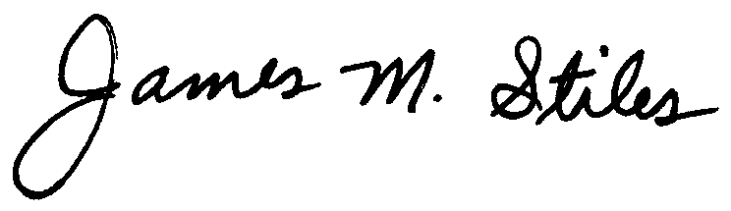

James M. Stiles, CPPB

Audit Manager

Larry G. Sorrell, Manager

Audit and Certification

/jl
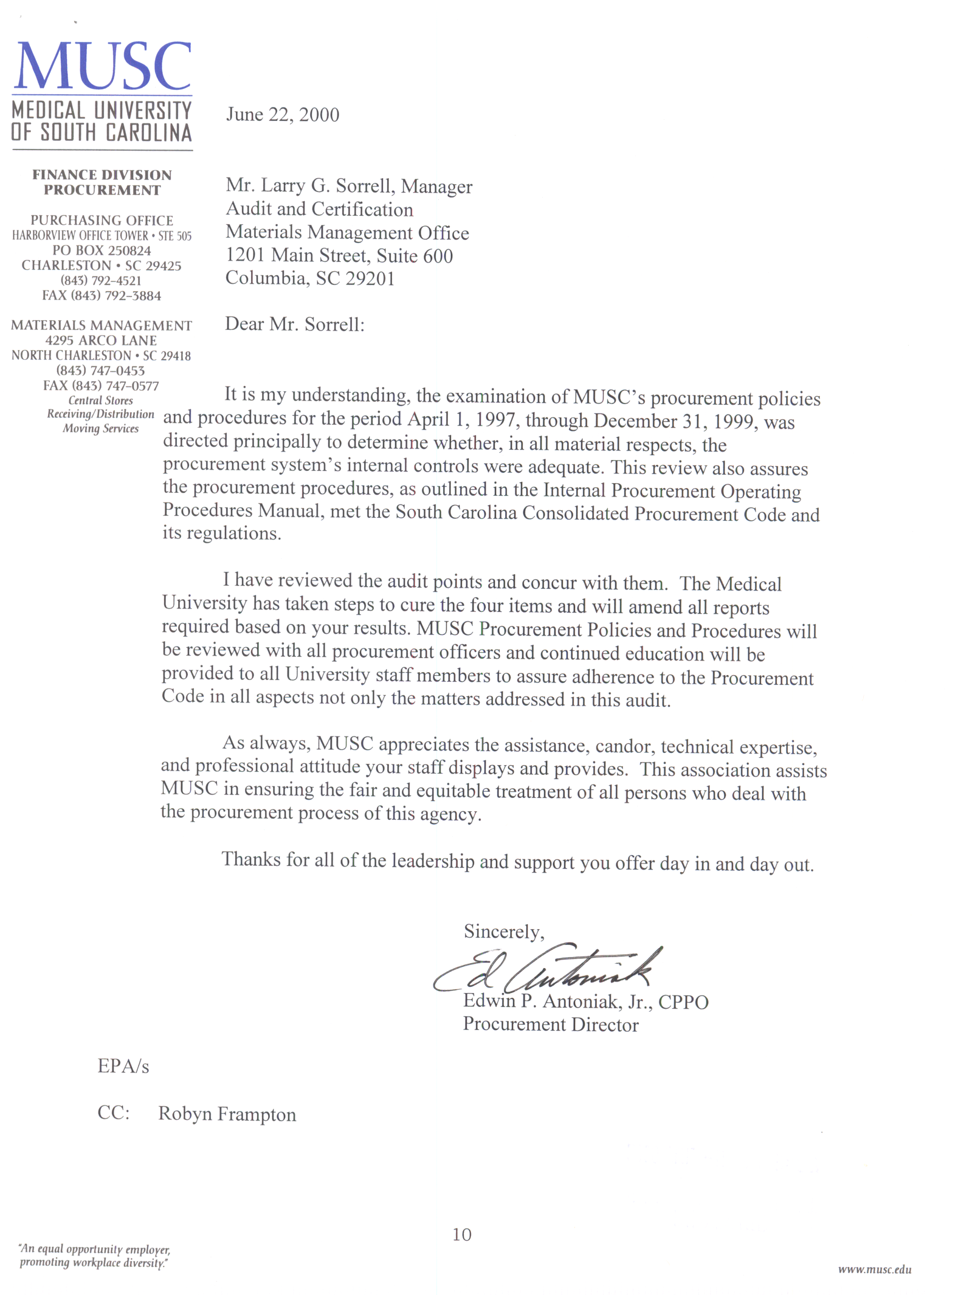

STATE OF SOUTH CAROLINA
State Budget and Control Board
OFFICE OF GENERAL SERVICES
JIM HODGES, CHAIRMAN  GOVERNOR  GRADY L. PATTERSON, JR.  STATE TREASURER  JAMES A. LANDER  COMPTROLLER GENERAL |  | JOHN DRUMMOND  CHAIRMAN, SENATE FINANCE COMMITTEE  ROBERT W. HARRELL, JR.  CHAIRMAN, WAYS AND MEANS COMMITTEE  RICK KELLY  EXECUTIVE DIRECTOR
ROBERT W. McCLAM
DIRECTOR

MATERIALS MANAGEMENT OFFICE
1201 MAIN STREET, SUITE 600
COLUMBIA, SOUTH CAROLINA 29201
(803) 737-0600
Fax (803) 737-0639

R. VOIGHT SHEALY
ASSISTANT DIRECTOR

July 10, 2000

Mr. R. Voight Shealy
Materials Management Officer
Materials Management Office
1201 Main Street, Suite 600
Columbia, South Carolina 29201

Dear Voight:

We have reviewed the response from the Medical University of South Carolina to our audit report for the period of April 1, 1997 – December 31, 1999. Also we have followed the University’s corrective action during and subsequent to our fieldwork. We are satisfied that the University has corrected the problem areas and the internal controls over the procurement system are adequate.

Therefore, we recommend the Budget and Control Board grant the Medical University of South Carolina the certification limits noted in our report for a period of three years.

Sincerely,

Larry G. Sorrell, Manager
Audit and Certification

LGS/jl
Total Copies Printed 25
Unit Cost - .23
Total Cost - $5.75

