PUBLIC MEETING NOTICE

Meeting of the Request for Proposal Evaluation Committee

Solicitation Number: 5400029264
Solicitation Description: SCSEC Post-Election Audit SaaS

A meeting of the Request for Proposal Evaluation Committee for the above-referenced solicitation will be held Tuesday, March 31, 2026 at 10:00 AM ET.

This meeting will be held at
Edisto Conference Room
1122 Lady Street, Suite 500
Columbia, SC 29201

AGENDA

Regular Session
- Open meeting
Executive Session
- Demonstrations
- Proposal discussions
Regular Session
- Demonstration scoring
Close Session

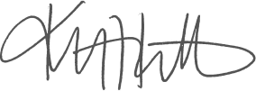
Kristen Rabon
Procurement Manager

