PUBLIC MEETING NOTICE

Meeting of the Request for Proposal Evaluation Committee

Solicitation Number: 5400029915
Solicitation Description: SCEL Computer Gaming System

Meetings of the Request for Proposal Evaluation Committee for the above-referenced solicitation will be held:
- Monday, November 2, 2026 at 9:00 a.m.
- Monday, November 9, 2026 at 9:00 a.m.
- Tuesday, November 10, 2026 at 9:00 a.m.
- Thursday, November 12, 2026 at 9:00 a.m.

These meetings will be held at:
1333 Main Street, Suite 400
Large Conference Room (427)
Columbia, SC 29201

AGENDA

Regular Session
- Open meeting
Executive Session
- Proposal discussions
Close Session

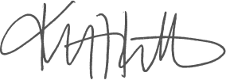
Kristen Rabon
Procurement Manager

