PUBLIC MEETING NOTICE

Meeting of the Request for Proposal Evaluation Committee

Solicitation Number: 5400029915
Solicitation Description: SCEL Computer Gaming System

The charging meeting of the Request for Proposal Evaluation Committee for the above-referenced solicitation will be held Tuesday, October 13, 2026 at 2:00 p.m.

This meeting will be held at:
1333 Main Street, Suite 400
Large Conference Room (427)
Columbia, SC 29201

AGENDA

Regular Session
- Open meeting
- Overview of process
Executive Session
- Distribution of proposals
Close Session

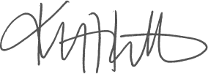
Kristen Rabon
Procurement Manager

