STATE OF SOUTH CAROLINA
State Budget and Control Board
OFFICE OF GENERAL SERVICES
JIM HODGES, CHAIRMAN  GOVERNOR  GRADY L. PATTERSON, JR.  STATE TREASURER  JAMES A. LANDER  COMPTROLLER GENERAL |  | JOHN DRUMMOND  CHAIRMAN, SENATE FINANCE COMMITTEE  ROBERT W. HARRELL, JR.  CHAIRMAN, WAYS AND MEANS COMMITTEE  RICK KELLY  EXECUTIVE DIRECTOR
ROBERT W. McCLAM
DIRECTOR

MATERIALS MANAGEMENT OFFICE
1201 MAIN STREET, SUITE 600
COLUMBIA, SOUTH CAROLINA 29201
(803) 737-0600
Fax (803) 737-0639

R. VOIGHT SHEALY
ASSISTANT DIRECTOR

July 12, 2000

Mr. Robert W. McClam, Director
Office of General Services
1201 Main Street, Suite 420
Columbia, South Carolina 29201

Dear Robbie:

I have attached the Midlands Technical College’s procurement audit report and recommendations made by the Office of Audit and Certification. I concur and recommend the Budget and Control Board grant the College a three-year certification as noted in the audit report.

Sincerely,

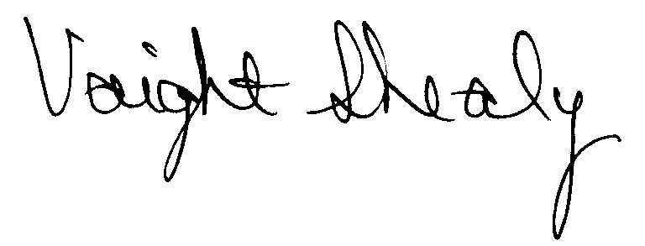
R. Voight Shealy
Materials Management Officer

/jl
MIDLANDS TECHNICAL COLLEGE
PROCUREMENT AUDIT REPORT

APRIL 1, 1997 - MARCH 31, 2000

TABLE OF CONTENTS
PAGE

Transmittal Letter 1

Introduction 3

Background 4

Scope 5
Results of Examination 6
Certification Recommendation 8
College Response 9
Follow-up Letter 10

STATE OF SOUTH CAROLINA
State Budget and Control Board
OFFICE OF GENERAL SERVICES
JIM HODGES, CHAIRMAN  GOVERNOR  GRADY L. PATTERSON, JR.  STATE TREASURER  JAMES A. LANDER  COMPTROLLER GENERAL |  | JOHN DRUMMOND  CHAIRMAN, SENATE FINANCE COMMITTEE  ROBERT W. HARRELL, JR.  CHAIRMAN, WAYS AND MEANS COMMITTEE  RICK KELLY  EXECUTIVE DIRECTOR
ROBERT W. McCLAM
DIRECTOR

MATERIALS MANAGEMENT OFFICE
1201 MAIN STREET, SUITE 600
COLUMBIA, SOUTH CAROLINA 29201
(803) 737-0600
Fax (803) 737-0639

R. VOIGHT SHEALY
ASSISTANT DIRECTOR

June 23, 2000

Mr. R. Voight Shealy
Materials Management Officer
Office of General Services
1201 Main Street, Suite 600
Columbia, South Carolina 29201

Dear Voight:
We have examined the procurement policies and procedures of Midlands Technical College for the period April 1, 1997, through March 31, 2000. As part of our examination, we studied and evaluated the system of internal control over procurement transactions to the extent we considered necessary.
The evaluation was to establish a basis for reliance upon the system of internal control to assure adherence to the Consolidated Procurement Code, State regulations, and the College’s procurement policy. Additionally, the evaluation was used in determining the nature, timing and extent of other auditing procedures necessary for developing an opinion on the adequacy, efficiency and effectiveness of the procurement system.
The administration of Midlands Technical College is responsible for establishing and maintaining a system of internal control over procurement transactions. In fulfilling this responsibility, estimates and judgments by management are required to assess the expected benefits and related costs of control procedures. The objectives of a system are to provide management with reasonable, but not absolute, assurance of the integrity of the procurement process, that affected assets are safeguarded against loss from unauthorized
use or disposition and that transactions are executed in accordance with management's authorization and are recorded properly.
Because of inherent limitations in any system of internal control, errors or irregularities may occur and not be detected. Also, projection of any evaluation of the system to future periods is subject to the risk that procedures may become inadequate because of changes in conditions or that the degree of compliance with the procedures may deteriorate.
Our study and evaluation of the system of internal control over procurement transactions, as well as our overall examination of procurement policies and procedures, were conducted with professional care. However, because of the nature of audit testing, they would not necessarily disclose all weaknesses in the system.
The examination did, however, disclose several conditions enumerated in this report which we believe need correction or improvement.
Corrective action based on the recommendations described in these findings will in all material respects place Midlands Technical College in compliance with the South Carolina Consolidated Procurement Code and ensuing regulations.

Sincerely,

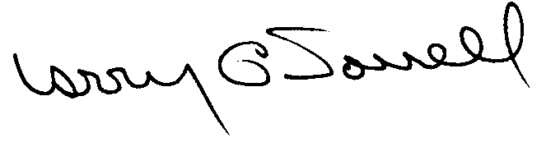

Larry G. Sorrell, Manager
Audit and Certification
INTRODUCTION
We conducted an examination of the internal procurement operating policies and procedures of Midlands Technical College. Our on-site review was conducted April 17, 2000 through May 3, 2000 and was made under Section 11-35-1230(1) of the South Carolina Consolidated Procurement Code and Section 19-445.2020 of the accompanying regulations.
The examination was directed principally to determine whether, in all material respects, the procurement system's internal controls were adequate and the procurement procedures, as outlined in the Internal Procurement Operating Procedures Manual, were in compliance with the South Carolina Consolidated Procurement Code and its ensuing regulations.
Additionally, our work was directed toward assisting the College in promoting the underlying purposes and policies of the Code as outlined in Section 11-35-20, which include:

- to ensure the fair and equitable treatment of all persons who deal with the procurement system of this State

- to provide increased economy in state procurement activities and to maximize to the fullest extent practicable the purchasing values of funds of the State

(3) to provide safeguards for the maintenance of a procurement system of quality and integrity with clearly defined rules for ethical behavior on the part of all persons engaged in the public procurement process

BACKGROUND
Section 11-35-1210 of the South Carolina Consolidated Procurement Code states:
The (Budget and Control) Board may assign differential dollar limits below which individual governmental bodies may make direct procurements not under term contracts. The Office of General Services shall review the respective governmental body’s internal procurement operation, shall verify in writing that it is consistent with the provisions of this code and the ensuing regulations, and recommend to the Board those dollar limits for the respective governmental body’s procurement not under term contract.

On September 16, 1997, the Budget and Control Board granted the College the following procurement certification:
PROCUREMENT AREAS | CERTIFICATION LIMITS
Goods and Services (Local Funds Only) | $25,000 per commitment
Consultant Services (Local Funds Only)  Information Technology (Local Funds Only) | $25,000 per commitment  $25,000 per commitment
Construction Contract Award (Local Funds Only) | $25,000 per commitment
Our audit was performed primarily to determine if recertification is warranted. No additional certification was requested.
SCOPE
We conducted our examination in accordance with Generally Accepted Auditing Standards as they apply to compliance audits. Our examination encompassed a detailed analysis of the internal procurement operating procedures of Midlands Technical College and its related policies and procedures manual to the extent we deemed necessary to formulate an opinion on the adequacy of the system to properly handle procurement transactions.
We selected judgmental samples from the period April 1, 1997 through March 31, 2000 of procurement transactions for compliance testing and performed other audit procedures we considered necessary to formulate this opinion. Specifically, the scope of our audit included, but was not limited to, a review of the following:
(1) All sole source, emergency and trade-in sale procurements for the period April 1, 1997 through March 31, 2000

(2) Procurement transactions from the period April 1, 1997 through
March 31, 2000 as follows:
a) Seventy payment transactions greater than $1,500 each reviewed for competition and compliance to the Code
- A block sample of three hundred procurement transactions from the audit period reviewed for order splitting and favored vendors

- Five construction contracts and twelve professional services contract for
compliance with the Manual for Planning and Execution of State
Permanent Improvements

(4) Minority Business Enterprise Plan and reports for the audit period
(5) Information technology plans for audit period
(6) Internal procurement procedures manual review
(7) Surplus property procedures
- File documentation and evidence of competition
RESULTS OF EXAMINATION
Since our previous audit in 1997, Midlands Technical College, hereinafter referred to as the College, has maintained what we consider a professional, efficient procurement system. However, we did note the following items which should be addressed by management.

Mult-term Determination Not Prepared and Estimated Quantity Understated
Quotation R00297 was issued on 11/1/99 for eight different models of telephones with an estimated quantity of thirty-five telephones. The quotation was for one year with an option to extend for two additional years but the written multi-term determination required by Section 11-35-2030 of the Code was not prepared. Purchase order C22061 was issued on 11/29/99 as a blanket order listing the eight models, price per model, and the multi-term provisions. Check 07-191492 was issued on 2/29/00 for $11,523 for the payment of forty-one telephones which exceeded the estimated quantity of thirty-five noted in the solicitation for the entire period of three years. Since the multi-term determination was not prepared the extension options cannot be exercised.
We recommend the College cancel the purchase order as the estimated quantity noted in the solicitation has been exceeded. Additional telephones should be procured in compliance with the Code. The College should estimate quantities more accurately based on the anticipated needs for the period. The written multi-term determination must be prepared if the contract exceeds one year.
Unauthorized Sole Source Procurement
The justification for the following sole source procurement was approved after the requesting department ordered the software.
PO | PO Date | Approval Date | Invoice Date | Description | Amount
93940 | 5/27/99 | 5/27/99 | 5/24/99 | Computer software | $9,435
Section 11-35-1560 of the Code requires that the head of the agency or a designee above the level of the procurement officer determine, in writing, that only one source exists for a needed supply or service. The determination must be authorized prior to the procurement. Regulation 19-445.2015 defines an unauthorized procurement as an act obligating the State in a contract by any person without requisite authority. Since the software was ordered prior to the proper approval, it is unauthorized.
We recommend ratification of the unauthorized procurement be requested from the College President in accordance with Regulation 19-445.2015.

Inappropriate Sole Sources
The following two sole source procurements were inappropriate.
PO | Date | Description | Amount
82683 | 1/28/98 | Consultant | $ 3,000
81378 | 9/29/97 | Consultant | 11,895
The consultant on purchase order 82683 was hired to facilitate a three-day planning session on problem solving for business and industry. Other qualified consulting firms are available and have the necessary experience. The justification on purchase order 81378 was based, in part, on the consultant being the only one in the South Carolina area that was qualified. The College should not limit the area when considering consultant services. Section 11-35-1560 of the Code requires that only one source exist for sole source to be valid.
We recommend the College comply with the Code for each sole source procurement.

Trade-in Sale Not Approved or Reported
Purchase order 81304 was issued for $13,545 on 1/22/98 to upgrade the equipment for the Distance Learning Area. When the equipment was installed, the College returned the equipment that was originally purchased on purchase order 63417 dated 5/2/96 for $58,310. The College was unable to furnish what equipment was returned, the original purchase price of the returned equipment, and the trade-in allowance. Regulation 19-445.2150(G) states:
Governmental bodies may trade-in property, whose original unit purchase price did not exceed $5,000, the trade-in value of which must be applied to the purchase of new items. When the original unit purchase price exceeds $5,000, the governmental body shall refer the matter to the Materials Management Officer, the ITMO, or the designee of either, for disposition.

We recommend the College adhere to the trade-in approval procedures as required in Regulation 19-445.2150(G) and the reporting requirements as required in Section 11-35-3830(C) of the Code.
CERTIFICATION RECOMMENDATION
As enumerated in our transmittal letter, corrective action based on the recommendations described in this report will in all material respects place Midlands Technical College in compliance with the Consolidated Procurement Code and ensuing regulations.
Under the authority described in Section 11-35-1210 of the Procurement Code, subject to this corrective action, we will recommend Midlands Technical College be recertified to make direct agency procurements for three years up to the limit as follows:

PROCUREMENT AREAS | RECOMMENDED CERTIFICATION LIMITS
Goods and Service (Local Funds Only) | *$25,000 per commitment
Consultant Services (Local Funds Only) | *$25,000 per commitment
Information Technology (Local Funds Only) | *$25,000 per commitment
Construction Services (Local Funds Only) | $25,000 per commitment
Construction Contract Change Order (Local Funds Only) | $25,000 per change order
Architect/Engineer Contract Amendment (Local Funds Only) | $ 5,000 per amendment

*The total potential purchase commitment whether single year or multi-term contracts are used.

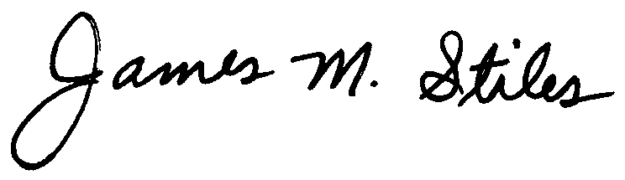
James M. Stiles, CPPB

Audit Manager

Larry G. Sorrell, Manager

Audit and Certification

STATE OF SOUTH CAROLINA
State Budget and Control Board
OFFICE OF GENERAL SERVICES
JIM HODGES, CHAIRMAN  GOVERNOR  GRADY L. PATTERSON, JR.  STATE TREASURER  JAMES A. LANDER  COMPTROLLER GENERAL |  | JOHN DRUMMOND  CHAIRMAN, SENATE FINANCE COMMITTEE  ROBERT W. HARRELL, JR.  CHAIRMAN, WAYS AND MEANS COMMITTEE  RICK KELLY  EXECUTIVE DIRECTOR
ROBERT W. McCLAM
DIRECTOR

MATERIALS MANAGEMENT OFFICE
1201 MAIN STREET, SUITE 600
COLUMBIA, SOUTH CAROLINA 29201
(803) 737-0600
Fax (803) 737-0639

R. VOIGHT SHEALY
ASSISTANT DIRECTOR

July 12, 2000

Mr. R. Voight Shealy

Materials Management Officer
Materials Management Office
1201 Main Street, Suite 600
Columbia, South Carolina 29201

Dear Voight:

We have reviewed the response from Midlands Technical College to our audit report for the period of April 1, 1997 – March 31, 2000. Also we have followed the College’s corrective action during and subsequent to our fieldwork. We are satisfied that the College has corrected the problem areas and the internal controls over the procurement system are adequate.

Therefore, we recommend the Budget and Control Board grant Midlands Technical College the certification limits noted in our report for a period of three years.

Sincerely,

Larry G. Sorrell, Manager
Audit and Certification

LGS/jl
Total Copies Printed 25
Unit Cost .21
Total Cost $5.25

