STATE OF SOUTH CAROLINA
State Budget and Control Board
OFFICE OF GENERAL SERVICES
JIM HODGES, CHAIRMAN  GOVERNOR  GRADY L. PATTERSON, JR.  STATE TREASURER  JAMES A. LANDER  COMPTROLLER GENERAL |  |  | HUGH K. LEATHERMAN, SR.  CHAIRMAN, SENATE FINANCE COMMITTEE  ROBERT W. HARRELL, JR.  CHAIRMAN, WAYS AND MEANS COMMITTEE  RICK KELLY  EXECUTIVE DIRECTOR
GEORGE N. DORN, JR.
DIRECTOR

MATERIALS MANAGEMENT OFFICE
1201 MAIN STREET, SUITE 600
COLUMBIA, SOUTH CAROLINA 29201
(803) 737-0600
Fax (803) 737-0639

R. VOIGHT SHEALY
MATERIALS MANAGEMENT OFFICER

May 12, 2001

Mr. George N. Dorn, Jr., Director
Office of General Services
1201 Main Street, Suite 420
Columbia, South Carolina 29201

Dear George:

I have attached the South Carolina Department of Labor, Licensing and Regulations’ procurement audit report and recommendations made by the Office of Audit and Certification. I concur and recommend the Budget and Control Board grant the Department a three-year certification as noted in the audit report.

Sincerely,
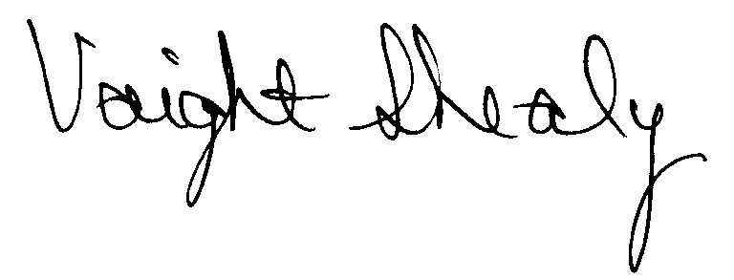
R. Voight Shealy
Materials Management Officer

/jl
SOUTH CAROLINA

DEPARTMENT OF LABOR, LICENSING AND REGULATION

PROCUREMENT AUDIT REPORT

JANUARY 1, 1998 - DECEMBER 31, 2000

TABLE OF CONTENTS
PAGE
Transmittal Letter 1
Scope. 3
Results of Examination 4
Certification Recommendation 6

Department Response 7

Follow-up Letter 8

STATE OF SOUTH CAROLINA
State Budget and Control Board
OFFICE OF GENERAL SERVICES
JIM HODGES, CHAIRMAN  GOVERNOR  GRADY L. PATTERSON, JR.  STATE TREASURER  JAMES A. LANDER  COMPTROLLER GENERAL |  |  | HUGH K. LEATHERMAN, SR.  CHAIRMAN, SENATE FINANCE COMMITTEE  ROBERT W. HARRELL, JR.  CHAIRMAN, WAYS AND MEANS COMMITTEE  RICK KELLY  EXECUTIVE DIRECTOR
GEORGE N. DORN, JR.
DIRECTOR

MATERIALS MANAGEMENT OFFICE
1201 MAIN STREET, SUITE 600
COLUMBIA, SOUTH CAROLINA 29201
(803) 737-0600
Fax (803) 737-0639

R. VOIGHT SHEALY
MATERIALS MANAGEMENT OFFICER

March 27, 2001

Mr. R. Voight Shealy
Materials Management Officer
Office of General Services
1201 Main Street, Suite 600
Columbia, South Carolina 29201
Dear Voight:
We have examined the procurement policies and procedures of the South Carolina Department of Labor, Licensing and Regulation for the period January 1, 1998 through December 31, 2000. As part of our examination, we studied and evaluated the system of internal control over procurement transactions to the extent we considered necessary.
The evaluation was to establish a basis for reliance upon the system of internal control to ensure adherence to the Consolidated Procurement Code, State regulations and the Department’s procurement policy. Additionally, the evaluation was used in determining the nature, timing and extent of other auditing procedures necessary for developing an opinion on the adequacy, efficiency and effectiveness of the procurement system.
The administration of the Department is responsible for establishing and maintaining a
system of internal control over procurement transactions. In fulfilling this responsibility, estimates and judgments by management are required to assess the expected benefits and related costs of control procedures. The objectives of a system are to provide management with reasonable, but not absolute, assurances of the integrity of the procurement process, that affected assets are safeguarded against loss from unauthorized use or disposition and that transactions are executed in accordance with management's authorization and are recorded properly. Because of inherent limitations in any system of internal control, errors or irregularities may occur and not be detected. Also, projection of any evaluation of the system to future periods is subject to the risk that procedures may become inadequate because of changes in conditions or that the degree of compliance with the procedures may deteriorate.
Our study and evaluation of the system of internal control over procurement transactions, as well as our overall examination of procurement policies and procedures, were conducted with professional care. However, because of the nature of audit testing, they would not necessarily disclose all weaknesses in the system.
The examination did, however, disclose conditions enumerated in this report that we believe need correction or improvement.
Corrective action based on the recommendations described in these findings will in all material respects place the South Carolina Department of Labor, Licensing and Regulation in compliance with the Consolidated Procurement Code and ensuing regulations.

Sincerely,
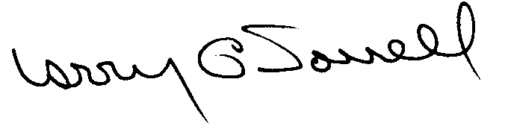

Larry G. Sorrell, Manager
Audit and Certification
SCOPE
We conducted our examination in accordance with Generally Accepted Auditing Standards as they apply to compliance audits. Our examination encompassed a detailed analysis of the internal procurement operating procedures of the South Carolina Department of Labor, Licensing and Regulation and its related policies and procedures manual to the extent we deemed necessary to formulate an opinion on the adequacy of the system to properly handle procurement transactions.
We selected a judgmental sample for the period July 1, 1998 through December 31, 2000 of procurement transactions for compliance testing and performed other audit procedures that we considered necessary to formulate this opinion. Specifically, the scope of our audit included, but was not limited to, a review of the following:

(1) All sole source, emergency and trade-in sale procurements for the period January 1, 1998 through December 31, 2000

(2) Procurement transactions from the period July 1, 1998 through December 31, 2000 as follows:
a) Ninety-six payment transactions greater than $1,500 each reviewed for competition and compliance to the Code
b) A block sample of five hundred numerical purchase orders reviewed for order splitting, favored vendors and competition
(3) Surplus property procedures
(4) Minority Business Enterprise Plan and reports
(5) Information technology plans and approvals
(6) Internal procurement procedures manual
(7) File documentation and evidence of competition
RESULTS OF EXAMINATION
The Office of Audit and Certification performed an examination of the internal procurement operating policies and procedures and related manual of the South Carolina Department of Labor, Licensing and Regulation, hereinafter referred to as the Department, for the period January 1, 1998 through December 31, 2000. Our on-site review was conducted February 20, 2001 through March 9, 2000 and was made under the authority as described in Section 11-35-1230(1) of the South Carolina Consolidated Procurement Code and Regulation 19-445.2020.
On May 12, 1998, the Budget and Control Board granted the Department the following certification:
PROCUREMENT AREAS | CERTIFICATION LIMITS
Goods and Services | $25,000 per commitment
Consultant Services | $25,000 per commitment
Information Technology | $25,000 per commitment

Our audit was performed primarily to determine if recertification is warranted. Since our previous audit in 1998, the Department has maintained what we consider a professional and efficient procurement system. We did note the following items which should be addressed by management.

Sole Source Reporting
The Department over reported the total value of four sole source procurements.
PO | Date | Description | Reported amount | Total expenditures
990360 | 7/1/98 | Tec Flame- smokeless gasoline | $125,000 | $108,472
990505 | 7/2/98 | Micro Blaze- bacteria eating foam | 50,000 | 31,274
200375 | 7/1/99 | Tec Fame- smokeless gasoline | 125,000 | 46,445
200517 | 7/1/99 | Micro Blaze- bacteria eating foam | 50,000 | 35,060
The Department issued blanket sole source purchase orders to satisfy the annual fire fighting training material requirements. The purchase orders were issued in the first quarter of the fiscal year and reported to Materials Management Office as required. However, the amount reported was not totally expended. Since an amended report was never filed, the sole source totals for the two fiscal years were overstated by $128,749.
We recommend amended reports be filed for the fiscal years to reflect the actual expenditures. If the Department is going to report projected sole source expenditures at the beginning of the fiscal year, amended reports should be filed, if applicable, at the end of the fiscal year when the projected expenditures and actual expenditures have a material difference.

Combining Requirements
We noted two instances where like items should have been combined and competed based on the combined values. The Department procured two similar printing jobs for two offices and considered each procurement separately.
PO | Amount | Description
200823 | $ 5,786 | Renewal forms and pocket cards
200822 | 5,582 | Renewal forms and pocket cards
Total | $ 11,368
The Department procured monitoring equipment and solicited competition based on the value of each type of pump.
PO | Amount | Description
200864 | $ 5,282 | Low flow sampling pumps with chargers
200863 | 7,801 | High flow sampling pumps with chargers
Total | $13,083
The office that initiated the requisition specified name brand pumps. According to office personnel, the brands could not be bought from the same vendor. However, one of the vendors solicited provided quotes for each type of pump.
Section 11-35-1550(2)(d) of the Code requires that procurements between $10,000.01 and $25,000 have written solicitations of written quotes and be advertised. Since the combined total exceeded $10,000.01, a more formal quotation method was required.
We recommend the Department combine and compete like items.

CERTIFICATION RECOMMENDATIONS
As enumerated in our transmittal letter, corrective action based on the recommendations described in this report, we believe, will in all material respects place the South Carolina Department of Labor, Licensing and Regulation in compliance with the Consolidated Procurement Code and ensuing regulations.
Under the authority described in section 11-35-1210 of the Procurement Code, subject to this corrective action, we will recommend the Department be recertified to make direct agency procurements for three years up to the limits as follows:
PROCUREMENT AREAS | RECOMMEND CERTIFICATION LIMITS
Goods and Services | *$25,000 per commitment
Consultant Services | *$25,000 per commitment
Information Technology | *$25,000 per commitment
*The total potential purchase commitment whether single year or multi-term contracts are used.

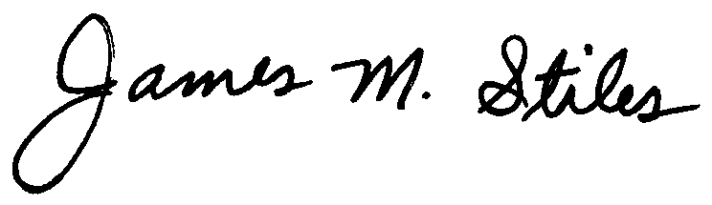
James M. Stiles, CPPB
Audit Manager

Larry G. Sorrell, Manager
Audit and Certification
STATE OF SOUTH CAROLINA
State Budget and Control Board
OFFICE OF GENERAL SERVICES
JIM HODGES, CHAIRMAN  GOVERNOR  GRADY L. PATTERSON, JR.  STATE TREASURER  JAMES A. LANDER  COMPTROLLER GENERAL |  |  | HUGH K. LEATHERMAN, SR.  CHAIRMAN, SENATE FINANCE COMMITTEE  ROBERT W. HARRELL, JR.  CHAIRMAN, WAYS AND MEANS COMMITTEE  RICK KELLY  EXECUTIVE DIRECTOR
GEORGE N. DORN, JR.
DIRECTOR

MATERIALS MANAGEMENT OFFICE
1201 MAIN STREET, SUITE 600
COLUMBIA, SOUTH CAROLINA 29201
(803) 737-0600
Fax (803) 737-0639

R. VOIGHT SHEALY
MATERIALS MANAGEMENT OFFICER

May 12, 2001

Mr. R. Voight Shealy

Materials Management Officer

Materials Management Office
1201 Main Street, Suite 600
Columbia, South Carolina 29201

Dear Voight:

We have reviewed the response from the South Carolina Department of Labor, Licensing and Regulations to our audit report for the period of January 1, 1998 – December 31, 2000. Also we have followed the Department’s corrective action during and subsequent to our fieldwork. We are satisfied that the Department has corrected the problem areas and the internal controls over the procurement system are adequate.

Therefore, we recommend the Budget and Control Board grant South Carolina Department of Labor, Licensing and Regulations the certification limits noted in our report for a period of three years.

Sincerely,
Larry G. Sorrell, Manager
Audit and Certification

LGS/jl
Total Copies Printed 25
Unit Cost .18
Total Cost $4.50

