STATE OF SOUTH CAROLINA
State Budget and Control Board
OFFICE OF GENERAL SERVICES
JIM HODGES, CHAIRMAN  GOVERNOR  GRADY L. PATTERSON, JR.  STATE TREASURER  JAMES A. LANDER  COMPTROLLER GENERAL |  |  | HUGH K. LEATHERMAN, SR.  CHAIRMAN, SENATE FINANCE COMMITTEE  ROBERT W. HARRELL, JR.  CHAIRMAN, WAYS AND MEANS COMMITTEE  RICK KELLY  EXECUTIVE DIRECTOR
GEORGE N. DORN, JR.
DIRECTOR

MATERIALS MANAGEMENT OFFICE
1201 MAIN STREET, SUITE 600
COLUMBIA, SOUTH CAROLINA 29201
(803) 737-0600
Fax (803) 737-0639

R. VOIGHT SHEALY
MATERIALS MANAGEMENT OFFICER

August 31, 2001

Mr. George N. Dorn, Jr., Director
Office of General Services
1201 Main Street, Suite 420
Columbia, South Carolina 29201

Dear George:

I have attached the audit report for the South Carolina Judicial Department. Since we are not recommending any certification above the basic $5,000 allowed by the Code, no action is required by the Budget and Control Board. Therefore, I recommend that the report be presented to the Budget and Control Board as information.

Sincerely,

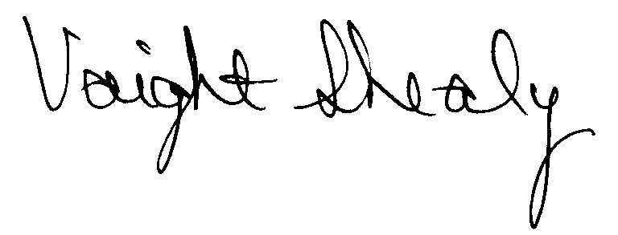
R. Voight Shealy
Materials Management Officer

/jl

SOUTH CAROLINA JUDICIAL DEPARTMENT

PROCUREMENT AUDIT REPORT

JULY 1, 1999 - JUNE 30, 2001

TABLE OF CONTENTS
PAGE

Transmittal Letter 1
Scope 3
Results of Examination 4
Conclusion 5

STATE OF SOUTH CAROLINA
State Budget and Control Board
OFFICE OF GENERAL SERVICES
JIM HODGES, CHAIRMAN  GOVERNOR  GRADY L. PATTERSON, JR.  STATE TREASURER  JAMES A. LANDER  COMPTROLLER GENERAL |  | HUGH K. LEATHERMAN, SR.  CHAIRMAN, SENATE FINANCE COMMITTEE  ROBERT W. HARRELL, JR.  CHAIRMAN, WAYS AND MEANS COMMITTEE  FRANK FUSCO  EXECUTIVE DIRECTOR
GEORGE N. DORN, JR.
DIRECTOR

MATERIALS MANAGEMENT OFFICE
1201 MAIN STREET, SUITE 600
COLUMBIA, SOUTH CAROLINA 29201
(803) 737-0600
Fax (803) 737-0639

R. VOIGHT SHEALY
MATERIALS MANAGEMENT OFFICER

August 10, 2001
Mr. R. Voight Shealy
Materials Management Officer
Office of General Services
1201 Main Street, Suite 600
Columbia, South Carolina 29201
Dear Voight:
We have examined the procurement policies and procedures of South Carolina Judicial Department for the period July 1, 1999 through June 30, 2001. As part of our examination, we studied and evaluated the system of internal control over procurement transactions to the extent we considered necessary.
The evaluation was to establish a basis for reliance upon the system of internal control to assure adherence to the Consolidated Procurement Code, State regulations, and the Department’s procurement policy. Additionally, the evaluation was used in determining the nature, timing and extent of other auditing procedures necessary for developing an opinion on the adequacy, efficiency and effectiveness of the procurement system.
The administration of the South Carolina Judicial Department is responsible for establishing and maintaining a system of internal control over procurement transactions. In fulfilling this responsibility, estimates and judgments by management are required to assess the expected benefits and related costs of control procedures. The objectives of a system are to provide

management with reasonable, but not absolute, assurance of the integrity of the procurement process, that affected assets are safeguarded against loss from unauthorized use or disposition and that transactions are executed in accordance with management's authorization and are recorded properly.
Because of inherent limitations in any system of internal control, errors or irregularities may occur and not be detected. Also, projection of any evaluation of the system to future periods is subject to the risk that procedures may become inadequate because of changes in conditions or that the degree of compliance with the procedures may deteriorate.
Our study and evaluation of the system of internal control over procurement transactions, as well as our overall examination of procurement policies and procedures, were conducted with professional care. However, because of the nature of audit testing, they would not necessarily disclose all weaknesses in the system.

Sincerely
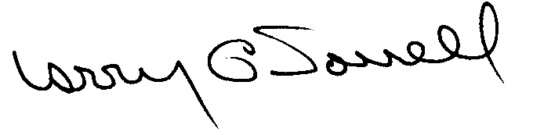

Larry G. Sorrell, Manager
Audit and Certification

SCOPE
We conducted our examination in accordance with Generally Accepted Auditing Standards as they apply to compliance audits. Our examination encompassed a detailed analysis of the internal procurement operating procedures of the South Carolina Judicial Department and its related policies and procedures manual to the extent we deemed necessary to formulate an opinion on the adequacy of the system to properly handle procurement transactions.
We judgmentally selected samples for the period July 1, 1999 through March 31, 2001 of procurement transactions for compliance testing and performed other audit procedures that we considered necessary to formulate this opinion. Specifically, the scope of our audit included, but was not limited to, a review of the following:
(1) All sole source, emergency and trade-in sale procurements for the period July 1, 1999 through March 31, 2001

(2) Procurement transactions from the period July 1, 1999 through March 31, 2001 as follows:
a) Twenty-seven payments greater than $1,500 each reviewed for competition and compliance to the Code
- A block sample of three hundred purchase orders reviewed for order splitting and favored vendors

(4) Minority Business Enterprise Plan and reports
(5) Information technology plans
(6) Internal procurement procedures manual
- Surplus property procedures
- File documentation and evidence of competition
RESULTS OF EXAMINATION
The Office of Audit and Certification performed an examination of the internal procurement policies and procedures manual of South Carolina Judicial Department. Our on-site review was conducted July 31 through August 6, 2001 and was made under the authority described in Section 11-35-1230(1) of the South Carolina Consolidated Procurement Code and Regulation 19-334.2020.
Since our previous audit in 1997, the Department has maintained what we consider to be a professional, efficient procurement system. We noted no material exceptions.
CONCLUSION
The Department has not requested increased procurement certification above the basic limit of $5,000 allowed by the Code. We recommend the Department be allowed to continue procuring all goods and services, consultant services, construction services and information technology up to the basic level of $5,000 as allowed by the South Carolina Consolidated Procurement Code and accompanying regulations.
David E Rawl, CPPB
Senior Auditor

Larry G. Sorrell, Manager
Audit and Certification

Total Copies Printed 25

Unite Cost .13

Total Cost $3.25

