STATE OF SOUTH CAROLINA
State Budget and Control Board
OFFICE OF GENERAL SERVICES
JIM HODGES, CHAIRMAN  GOVERNOR  GRADY L. PATTERSON, JR.  STATE TREASURER  JAMES A. LANDER  COMPTROLLER GENERAL |  | HUGH K. LEATHERMAN, SR.  CHAIRMAN, SENATE FINANCE COMMITTEE  ROBERT W. HARRELL, JR.  CHAIRMAN, WAYS AND MEANS COMMITTEE  FRANK FUSCO  EXECUTIVE DIRECTOR
GEORGE N. DORN, JR.
DIRECTOR

MATERIALS MANAGEMENT OFFICE
1201 MAIN STREET, SUITE 600
COLUMBIA, SOUTH CAROLINA 29201
(803) 737-0600
Fax (803) 737-0639

R. VOIGHT SHEALY
MATERIALS MANAGEMENT OFFICER

August 31, 2001

Mr. George N. Dorn, Jr., Director
Office of General Services
1201 Main Street, Suite 420
Columbia, South Carolina 29201

Dear George:

I have attached the audit report for the South Carolina State Finance and Development Authority. Since we are not recommending any certification above the basic $5,000 allowed by the Code, no action is required by the Budget and Control Board. Therefore, I recommend that the report be presented to the Budget and Control Board as information.

Sincerely,
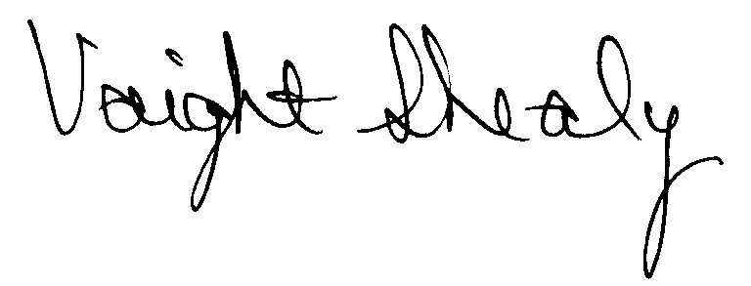
R. Voight Shealy
Materials Management Officer

/jl

STATE HOUSING FINANCE AND DEVELOPMENT AUTHORITY

PROCUREMENT AUDIT REPORT

JULY 1, 1999 – JUNE 30, 2001
TABLE OF CONTENTS
PAGE

Transmittal Letter 1

Introduction 3
Scope 4
Results of Examination 5
Conclusion 7
Follow-up Letter 8
NOTE: The Authority’s responses to issues noted in this report have been inserted immediately following the items they refer to.

STATE OF SOUTH CAROLINA
State Budget and Control Board
OFFICE OF GENERAL SERVICES
JIM HODGES, CHAIRMAN  GOVERNOR  GRADY L. PATTERSON, JR.  STATE TREASURER  JAMES A. LANDER  COMPTROLLER GENERAL |  | HUGH K. LEATHERMAN, SR.  CHAIRMAN, SENATE FINANCE COMMITTEE  ROBERT W. HARRELL, JR.  CHAIRMAN, WAYS AND MEANS COMMITTEE  FRANK FUSCO  EXECUTIVE DIRECTOR
GEORGE N. DORN, JR.
DIRECTOR

MATERIALS MANAGEMENT OFFICE
1201 MAIN STREET, SUITE 600
COLUMBIA, SOUTH CAROLINA 29201
(803) 737-0600
Fax (803) 737-0639

R. VOIGHT SHEALY
MATERIALS MANAGEMENT OFFICER

August 1, 2001

Mr. R. Voight Shealy
Materials Management Officer
Office of General Services
1201 Main Street, Suite 600
Columbia, South Carolina 29201
Dear Voight:
We have examined the procurement policies and procedures of the State Housing Finance and Development Authority for the period July 1, 1999 through June 30, 2001. As part of our examination, we studied and evaluated the system of internal control over procurement transactions to the extent we considered necessary.
The evaluation was to establish a basis for reliance upon the system of internal control to assure adherence to the Consolidated Procurement Code, State regulations and the Authority’s procurement policy. Additionally, the evaluation was used in determining the nature, timing and extent of other auditing procedures necessary for developing an opinion on the adequacy, efficiency and effectiveness of the procurement system.
The administration of the State Housing Finance and Development Authority is responsible for establishing and maintaining a system of internal control over procurement transactions. In fulfilling this responsibility, estimates and judgments by management are required to assess the

expected benefits and related costs of control procedures. The objectives of a system are to provide management with reasonable, but not absolute, assurance of the integrity of the procurement process, that affected assets are safeguarded against loss from unauthorized use or disposition and that transactions are executed in accordance with management's authorization and are recorded properly.
Because of inherent limitations in any system of internal control, errors or irregularities may occur and not be detected. Also, projection of any evaluation of the system to future periods is subject to the risk that procedures may become inadequate because of changes in conditions or that the degree of compliance with the procedures may deteriorate.
Our study and evaluation of the system of internal control over procurement transactions, as well as our overall examination of procurement policies and procedures, were conducted with professional care. However, because of the nature of audit testing, they would not necessarily disclose all weaknesses in the system.
The examination did, however, disclose conditions enumerated in this report which we believe need correction or improvement.
Corrective action based on the recommendations described in these findings will in all material respects place the State Housing Finance and Development Authority in compliance with the South Carolina Consolidated Procurement Code and ensuing regulations.

Sincerely,
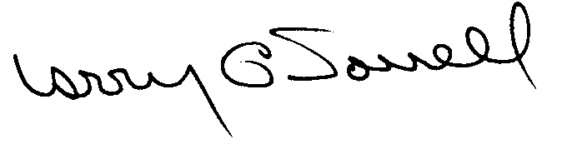
Larry G. Sorrell, Manager
Audit and Certification
INTRODUCTION
We conducted an examination of the internal procurement operating policies and procedures of the State Housing Finance and Development Authority, hereafter referred to as the Authority. Our on-site review was conducted July 9-16, 2001, and was made under Section 11-35-1230(1) of the South Carolina Consolidated Procurement Code and Section 19-445.2020 of the accompanying regulations.
The examination was directed principally to determine whether, in all material respects, the procurement system's internal controls were adequate and the procurement procedures, as outlined in the Internal Procurement Operating Procedures Manual, were in compliance with the South Carolina Consolidated Procurement Code and its ensuing regulations.
Additionally, our work was directed toward assisting the Authority in promoting the underlying purposes and policies of the Code as outlined in Section 11-35-20, which includes:

(1) to ensure the fair and equitable treatment of all persons who deal with the procurement system of this State

(2) to provide increased economy in state procurement activities and to maximize to the fullest extent practicable the purchasing values of funds of the State

(3) to provide safeguards for the maintenance of a procurement system of quality and integrity with clearly defined rules for ethical behavior on the part of all persons engaged in the public procurement process

SCOPE
We conducted our examination in accordance with Generally Accepted Auditing Standards as they apply to compliance audits. Our examination encompassed a detailed analysis of the internal procurement operating procedures of the State Housing Finance and Development Authority and its related policies and procedures manual to the extent we deemed necessary to formulate an opinion on the adequacy of the system to properly handle procurement transactions.
We selected a judgmental sample from the period July 1, 1999 through June 30, 2001 of procurement transactions for compliance testing and performed other audit procedures that we considered necessary to formulate this opinion. Specifically, the scope of our audit included, but was not limited to a review of the following:

(1) All sole source, emergency and trade-in sale procurements from the period July 1, 1999 through June 30, 2001

(2 Procurement transactions for the period July 1, 1999 through June 30, 2001 as follows:
a) Thirty-five payments each exceeding $1,500
b) A block sample of one hundred eighty-five numerical purchase orders from FY 2001 reviewed for order splitting and favored vendors

(3) Surplus property procedures

(4) Minority Business Enterprise Plans and report

(5) Information Technology Plans for Fiscal Years 1999-2003

(6) Internal procurement procedures manual

- Real property lease procedures

(8) File documentation for evidence of competition
RESULTS OF EXAMINATION

The Office of Audit and Certification performed an examination of the internal procurement operating policies, procedures and related manual for the period July 1, 1999 through June 30, 2001. Since our last compliance audit, the Authority has maintained what we consider to be a professional, efficient procurement system. However, we did note the following items which should be addressed by management:

Unauthorized Purchase
The Authority solicited three written quotes and issued purchase order 8619 on June 10, 1999 for $7,414 for a projector and monitor. The procurement exceeded the Authority’s procurement authority of $5,000 thus resulting in an unauthorized procurement as defined in Regulation 19-445.2015.
We recommend the Authority request ratification of the unauthorized procurement from the Materials Management Officer in accordance with Regulation 19-445.2015.
AUTHORITY RESPONSE
The Authority has requested ratification of the unauthorized procurement on purchase order 8619. The processing of that purchase order was an anomaly; our standard procedures require that orders in excess of $5,000 be submitted to MMO, and we will ensure that staff adheres to procedures.

Information Technology Plans Not Submitted Timely
According to the Office of the State Chief Information Officer (CIO), the Authority failed to file the required Information Technology Plans (IT Plans) for the three consecutive fiscal years 2000, 2001 and 2002. The Authority has been making information technology purchases on the basis of “ad hoc” requests as needs arise.
The IT Plans are an essential tool in carrying out the Budget and Control Board’s responsibilities with regard to the management of the State’s information technology. Full and timely participation by agencies in the planning process is necessary if the CIO is to present an accurate and comprehensive picture to the Governor and the State Legislature regarding the status of information technology utilization within state government.
We recommend the Authority develop and implement internal procedures to ensure that the Authority’s IT Plans are filed annually and in the time frame as required by the CIO.
AUTHORITY RESPONSE
The Authority will ensure that IT Plans are prepared in a timely manner and that the Procurement Officer has a copy on file. Further, the Procurement Officer will not process any IT procurements requests unless a current IT Plan is on file.

Sole Source Reporting
We noted the following exempt software licenses/maintenance renewals were unnecessarily justified and reported as sole source procurements.

Purchase Order | Amount
9011 | $ 2,373
9129 | 4,840
9613 | 42,000
9818 | 13,285
9874 | 12,276
9952 | 2,430
10060 | 9,380
10446 | 14,158
Total | $100,472
On April 22, 1986, the South Carolina Budget and Control Board approved an exemption for software license renewals after such software had been competitively bid as required by the Code.
We recommend the Authority discontinue the sole sourcing of exempt procurements.

AUTHORITY RESPONSE
It is our understanding that the purchase orders indicated as sole source have been appropriately identified and removed from the sole source report. The procurement staff will be cognizant of exempt software licenses/maintenance renewals and refrain from sole sourcing exempt procurements.
CONCLUSION
As enumerated in our transmittal letter, corrective action based on the recommendations described in this report, we believe, will in all material respects place the State Housing Finance and Development Authority in compliance with the South Carolina Consolidated Procurement Code and ensuing regulations.
The Authority has not requested increased procurement certification above the basic limit of $5,000 allowed by the Code. Subject to corrective action listed in this report, we recommend the State Housing Finance and Development Authority be allowed to continue procuring goods and services, consultant services, construction and information technology up to the basic level of $5,000 as allowed by the South Carolina Consolidated Procurement Code and accompanying regulations.

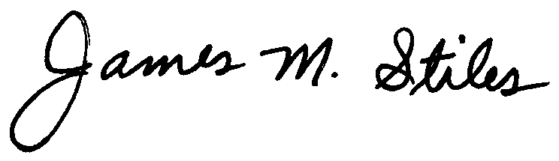
James M. Stiles, CPPB
Audit Manager

Larry G. Sorrell, Manager

Audit and Certification
STATE OF SOUTH CAROLINA
State Budget and Control Board
OFFICE OF GENERAL SERVICES
JIM HODGES, CHAIRMAN  GOVERNOR  GRADY L. PATTERSON, JR.  STATE TREASURER  JAMES A. LANDER  COMPTROLLER GENERAL |  | HUGH K. LEATHERMAN, SR.  CHAIRMAN, SENATE FINANCE COMMITTEE  ROBERT W. HARRELL, JR.  CHAIRMAN, WAYS AND MEANS COMMITTEE  FRANK FUSCO  EXECUTIVE DIRECTOR
GEORGE N. DORN, JR.
DIRECTOR

MATERIALS MANAGEMENT OFFICE
1201 MAIN STREET, SUITE 600
COLUMBIA, SOUTH CAROLINA 29201
(803) 737-0600
Fax (803) 737-0639

R. VOIGHT SHEALY
MATERIALS MANAGEMENT OFFICER

August 31, 2001

Mr. R. Voight Shealy
Materials Management Officer
Materials Management Office
1201 Main Street, Suite 600
Columbia, South Carolina 29201

Dear Voight:

We have reviewed the South Carolina State Housing Finance and Development Authority’s response to our audit report for July 1, 1999 – June 30, 2001. Also, we have followed the Authority’s corrective action during and subsequent to our field work. We are satisfied that the Authority has corrected the problem areas and the internal controls over the procurement system are adequate.

Additional certification was not requested. Therefore, we recommend the Authority be allowed to continue procuring all goods and services, construction services, information technology and consulting services up to the basic level of outlined in the Code.

Sincerely,
Larry G. Sorrell, Manager
Audit and Certification

LGS/jl

Total Copies Printed 25
Unit Cost - . .18
Total Cost - $4.50

