STATE OF SOUTH CAROLINA
State Budget and Control Board
OFFICE OF GENERAL SERVICES
JIM HODGES, CHAIRMAN  GOVERNOR  GRADY L. PATTERSON, JR.  STATE TREASURER  JAMES A. LANDER  COMPTROLLER GENERAL |  | JOHN DRUMMOND  CHAIRMAN, SENATE FINANCE COMMITTEE  ROBERT W. HARRELL, JR.  CHAIRMAN, WAYS AND MEANS COMMITTEE  RICK KELLY  EXECUTIVE DIRECTOR
ROBERT W. McCLAM
DIRECTOR

MATERIALS MANAGEMENT OFFICE
1201 MAIN STREET, SUITE 600
COLUMBIA, SOUTH CAROLINA 29201
(803) 737-0600
Fax (803) 737-0639

R. VOIGHT SHEALY
ASSISTANT DIRECTOR

November 6, 2000

Mr. Robert W. McClam, Director
Office of General Services
1201 Main Street, Suite 420
Columbia, South Carolina 29201

Dear Robbie:

I have attached the South Carolina Employment Security Commission’s procurement audit report and recommendations made by the Office of Audit and Certification. I concur and recommend the Budget and Control Board grant the Commission a three-year certification as noted in the audit report.

Sincerely,

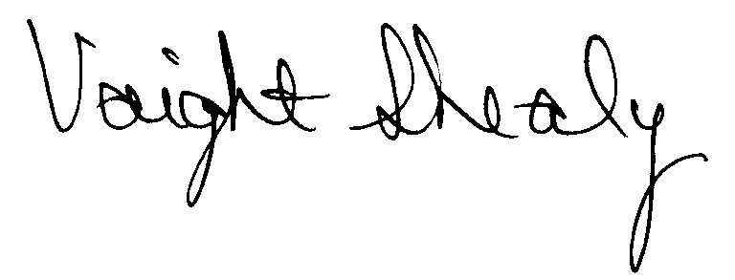
R. Voight Shealy
Materials Management Officer

/jl
SOUTH CAROLINA EMPLOYMENT SECURITY COMMISSION
PROCUREMENT AUDIT REPORT

JULY 1, 1997 - JUNE 30, 2000

TABLE OF CONTENTS
PAGE
Transmittal Letter 1
Introduction 3
Background 4
Scope 5
Summary of Audit Findings 6
Results of Examination 7
Certification Recommendations 10
Commission Response 11
Follow-up Letter 12

STATE OF SOUTH CAROLINA
State Budget and Control Board
OFFICE OF GENERAL SERVICES
JIM HODGES, CHAIRMAN  GOVERNOR  GRADY L. PATTERSON, JR.  STATE TREASURER  JAMES A. LANDER  COMPTROLLER GENERAL |  | JOHN DRUMMOND  CHAIRMAN, SENATE FINANCE COMMITTEE  ROBERT W. HARRELL, JR.  CHAIRMAN, WAYS AND MEANS COMMITTEE  RICK KELLY  EXECUTIVE DIRECTOR
ROBERT W. McCLAM
DIRECTOR

MATERIALS MANAGEMENT OFFICE
1201 MAIN STREET, SUITE 600
COLUMBIA, SOUTH CAROLINA 29201
(803) 737-0600
Fax (803) 737-0639

R. VOIGHT SHEALY
ASSISTANT DIRECTOR

October 12, 2000

Mr. R. Voight Shealy

Materials Management Officer
Office of General Services
1201 Main Street, Suite 600
Columbia, South Carolina 29201

Dear Voight:
We have examined the procurement policies and procedures of the South Carolina Employment Security Commission for the period July 1, 1997 through June 30, 2000. As part of our examination, we studied and evaluated the system of internal control over procurement transactions to the extent we considered necessary.
The evaluation was to establish a basis for reliance upon the system of internal control to assure adherence to the Consolidated Procurement Code, State regulations and the Commission’s procurement policy. Additionally, the evaluation was used in determining the nature, timing and extent of other auditing procedures necessary for developing an opinion on the adequacy, efficiency and effectiveness of the procurement system.
The administration of the South Carolina Employment Security Commission is responsible for establishing and maintaining a system of internal control over procurement transactions. In fulfilling this responsibility, estimates and judgments by management are required to assess the expected benefits and related costs of control procedures. The objectives of a system are to provide
management with reasonable, but not absolute, assurance of the integrity of the procurement process, that affected assets are safeguarded against loss from unauthorized use or disposition and that transactions are executed in accordance with management's authorization and are recorded properly.
Because of inherent limitations in any system of internal control, errors or irregularities may occur and not be detected. Also, projection of any evaluation of the system to future periods is subject to the risk that procedures may become inadequate because of changes in conditions or that the degree of compliance with the procedures may deteriorate.
Our study and evaluation of the system of internal control over procurement transactions, as well as our overall examination of procurement policies and procedures, were conducted with professional care. However, because of the nature of audit testing, they would not necessarily disclose all weaknesses in the system.
The examination did, however, disclose conditions enumerated in this report which we believe need correction or improvement.
Corrective action based on the recommendations described in these findings will in all material respects place the South Carolina Employment Security Commission in compliance with the Consolidated Procurement Code and ensuing regulations.

Sincerely,
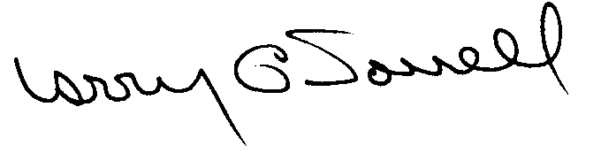
Larry G. Sorrell, Manager

Audit and Certification
INTRODUCTION
We conducted an examination of the internal procurement operating policies and procedures of the South Carolina Employment Security Commission. Our on-site review was conducted June 6, 2000 through June 23, 2000 and was made under Section 11-35-1230(1) of the South Carolina Consolidated Procurement Code and Section 19-445.2020 of the accompanying regulations.
The examination was directed principally to determine whether, in all material respects, the procurement system's internal controls were adequate and the procurement procedures, as outlined in the Internal Procurement Operating Procedures Manual, were in compliance with the South Carolina Consolidated Procurement Code and its ensuing regulations.
Additionally, our work was directed toward assisting the Commission in promoting the underlying purposes and policies of the Code as outlined in Section 11-35-20, which include:
- to ensure the fair and equitable treatment of all persons who deal with the procurement system of this State

- to provide increased economy in state procurement activities and to maximize to the fullest extent practicable the purchasing values of funds of the State

(3) to provide safeguards for the maintenance of a procurement system of quality and integrity with clearly defined rules for ethical behavior on the part of all persons engaged in the public procurement process

BACKGROUND
Section 11-35-1210 of the South Carolina Consolidated Procurement Code states:

The Budget and Control Board may assign differential dollar limits below which individual governmental bodies may make direct procurements not under term contracts. The Office of General Services shall review the respective governmental body's internal procurement operation, shall verify in writing that it is consistent with the provisions of this code and the ensuing regulations, and recommend to the Board those dollar limits for the respective governmental body's procurement not under term contract.

On December 9, 1997 the Budget and Control Board granted the Commission the following procurement certifications:
PROCUREMENT AREAS |  | CERTIFICATION LIMITS
Goods and Services | $ 25,000 per commitment
Information Technology | $ 25,000 per commitment
Consultant Services | $ 25,000 per commitment
Our audit was performed primarily to determine if recertification is warranted. The Commission did not request an increase in certification.
SCOPE
We conducted our examination in accordance with Generally Accepted Auditing Standards as they apply to compliance audits. Our examination encompassed a detailed analysis of the internal procurement operating procedures of the South Carolina Employment Security Commission and its related policies and procedures manual to the extent we deemed necessary to formulate an opinion on the adequacy of the system to properly handle procurement transactions.
We judgmentally selected a sample for the period July 1, 1997 through June 30, 2000 of procurement transactions for compliance testing and performed other audit procedures that we considered necessary to formulate this opinion. Specifically, the scope of our audit included, but was not limited to, a review of the following:
(1) All sole source, emergency and trade-in sale procurements for the period June 1, 1997 through March 31, 2000

(2) Procurement transactions for the period July 1, 1997 through June 30, 2000 as follows:
a) One hundred and three payment transactions greater than $1,500 each reviewed for competition and compliance to the Code
- A block sample of three hundred numerical purchase orders reviewed for order splitting and favored vendors

(3) Five construction contracts and three professional services contracts for compliance with the Manual for Planning and Execution of State Permanent Improvements

(4) Minority Business Enterprise Plans and reports for the audit period

- Information technology plans for the audit period

(6) Internal procurement procedures manual review

(7) Procurement file documentation and evidence of competition

- Surplus property procedures
SUMMARY OF AUDIT FINDINGS
Our audit of the procurement system of the South Carolina Employment Security Commission, hereinafter referred to as the Commission, produced the following findings and recommendations.
PAGE

- Missing Construction Documents 7
The Commission could not furnish nor could we locate the contractor’s
certificates of insurance on two procurements and the performance bond
and labor/material payment bond for one procurement.
- Sole Source Procurements
- Unauthorized Sole Source Procurements 7
The justifications to support thirteen sole source procurements were not dated.
Therefore we could not determine if the justifications were approved prior to the
procurements.
- Sole Source Reporting Errors 8
The Commission did not report three procurements and incorrectly reported one
procurement.
- General Procurement Exceptions
- Procurements Without Competition 8
We noted two procurements without competition.
- Inadequate Solicitations 9
We noted two solicitations where the competition was inadequate.
RESULTS OF EXAMINATION

- Missing Construction Documents
The Commission could not furnish nor could we locate the following construction documents.
Project Description Amount Missing Documents
Modular office Hartsville-PO97000554 $157,696 Contractor’s certificate of insurance
Landscape Hartsville-PO97000745 37,756 Contractor’s certificate of insurance
Modular office Hartsville-PO97000554 157,696 Performance bond
Modular office Hartsville-PO97000554 157,696 Labor/material payment bond
The documents are required per Chapter 6 of the Manual for Planning and Execution of State Permanent Improvement, Part II.
We recommend the Commission insures that contractor’s certificate of insurance and the bonding requirements are obtained on construction projects. These instruments could prove vital to protect the Commission if problems occur during the life of the contracts.

- Sole Source Procurements
- Unauthorized Sole Source Procurements
The Commission failed to date the written determinations on the following thirteen sole source procurements.
Purchase Order | Date | Description | Amount
98000005 | 07/1/98 | Software enhancement | $16,270
98000484 | 10/8/98 | Dry ink | 10,647
98000820 | 01/8/99 | Dry ink | 14,212
98000596 | 10/27/98 | Software | 19,455
98001534 | 05/17/99 | Elevator repair | 2,600
97001148 | 03/10/98 | Equipment rental | 11,915
97000715 | 12/08/97 | Equipment rental | 11,914
98001256 | 03/22/99 | Equipment rental | 11,970
98000794 | 01/05/99 | Equipment rental | 11,968
99000262 | 09/01/99 | Equipment rental | 12,559
99000144 | 08/04/99 | Test forms | 5,670
98001504 | 05/12/99 | Assessment tests | 13,918
97000152 | 07/24/97 | Equipment rental | 11,914

Section 11-35-1560 of the Code requires that the head of the agency or a designee above the level of the procurement officer determines in writing that only one source exists for a needed supply or service. The determinations must be authorized prior to the sole source procurements. Regulation 19-445.2015 defines an unauthorized procurement as an act obligating the State in a contract by any person without requisite authority.
We recommend the Commission develop and implement procedures insuring the approvals of the determinations are completed prior to each sole source procurement. Ratification must be requested from the Commission’s Director or his designee in accordance with Regulation 19-445.2015 for each of the unauthorized sole source procurements.

Sole Source Reporting Errors
The Commission did not report three sole source procurements.
Purchase Order | Date | Description | Amount
98001769 | 1/11/00 | Dry ink | $12,776
97000152 | 7/24/97 | Equipment rental | 11,914
98000719 | 12/3/98 | Service agreement | 2,890
In addition, the Commission reported purchase order 99000969 for hardware maintenance on the quarterly report for the period ending 3/31/00 as $5,667 rather than $56,673, an underreporting of $51,006. Section 11-35-2440 of the Code requires that governmental bodies submit a quarterly record of all contracts made as sole source procurements. The Materials Management Office combines the quarterly reports and prepares an annual report to the State Budget and Control Board. Therefore, the amounts reported by agencies must be correct to ensure proper reporting to the Board.
We recommend the Commission review its current procedure for recording sole source procurements to identify weaknesses that contributed to the reporting errors. We also recommend amended reports be submitted to reflect the four sole source procurements.

General Procurement Exceptions

Procurements Without Competition
Two procurements were not supported by evidence of solicitations of competition, sole source or emergency procurement determinations.
Reference | Description | Amount
PO 98001806 | HVAC System | $ 4,578
Contract 9CE02ALM | Analyst training | 22,850
The procurement of the analyst training was made by the Commission on behalf of a consortium of which they are a member. The Commission considered the contract exempt from the Code. However, this type of procurement is subject to the provisions of the Code.
We recommend the Commission adhere to the competitive requirements of the Code.

Inadequate Solicitations
We noted the following two inadequate solicitations.
Solicitation | Purchase Order | Date | Description | Amount
B05560 | 97001338 | 4/15/98 | Network equipment | $21,141
R06140 | 97001129 | 3/16/98 | Printed forms | 10,659

We found no evidence that written solicitations were mailed to prospective bidders as required by Section 11-35-1550(2)(d) of the Code. Additionally, the Commission does not provide preference information in its written solicitations. Section 11-35-1524 of the Code allows preferences for resident vendors and products made, manufactured or grown in South Carolina or the United States. However, bidders are not being informed of the availability of these preferences.
We recommend the Commission meet the competitive requirements by issuing written solicitations of written quotations. Further, the preferences found in Section 11-35-1524 must be included in the written solicitations.
CERTIFICATION RECOMMENDATIONS
As enumerated in our transmittal letter, corrective action based on the recommendations described in this report will in all material respects place the South Carolina Employment Security Commission in compliance with the Consolidated Procurement Code and ensuing Regulations.
Under the authority described in Section 11-35-1210 of the Procurement Code, subject to this corrective action, we will recommend the South Carolina Employment Security Commission be recertified to make direct agency procurements for three years up to the limits as follows:
PROCUREMENT AREAS |  | RECOMMENDED CERTIFICATION LIMITS
Goods and Services | *$ 25,000 per commitment
Information Technology | *$ 25,000 per commitment
Consultant Services | *$ 25,000 per commitment

*The total potential purchase commitment whether single year or multi-term contracts are used.

David E. Rawl, CPPB

Senior Auditor
Larry G. Sorrell, Manager

Audit and Certification
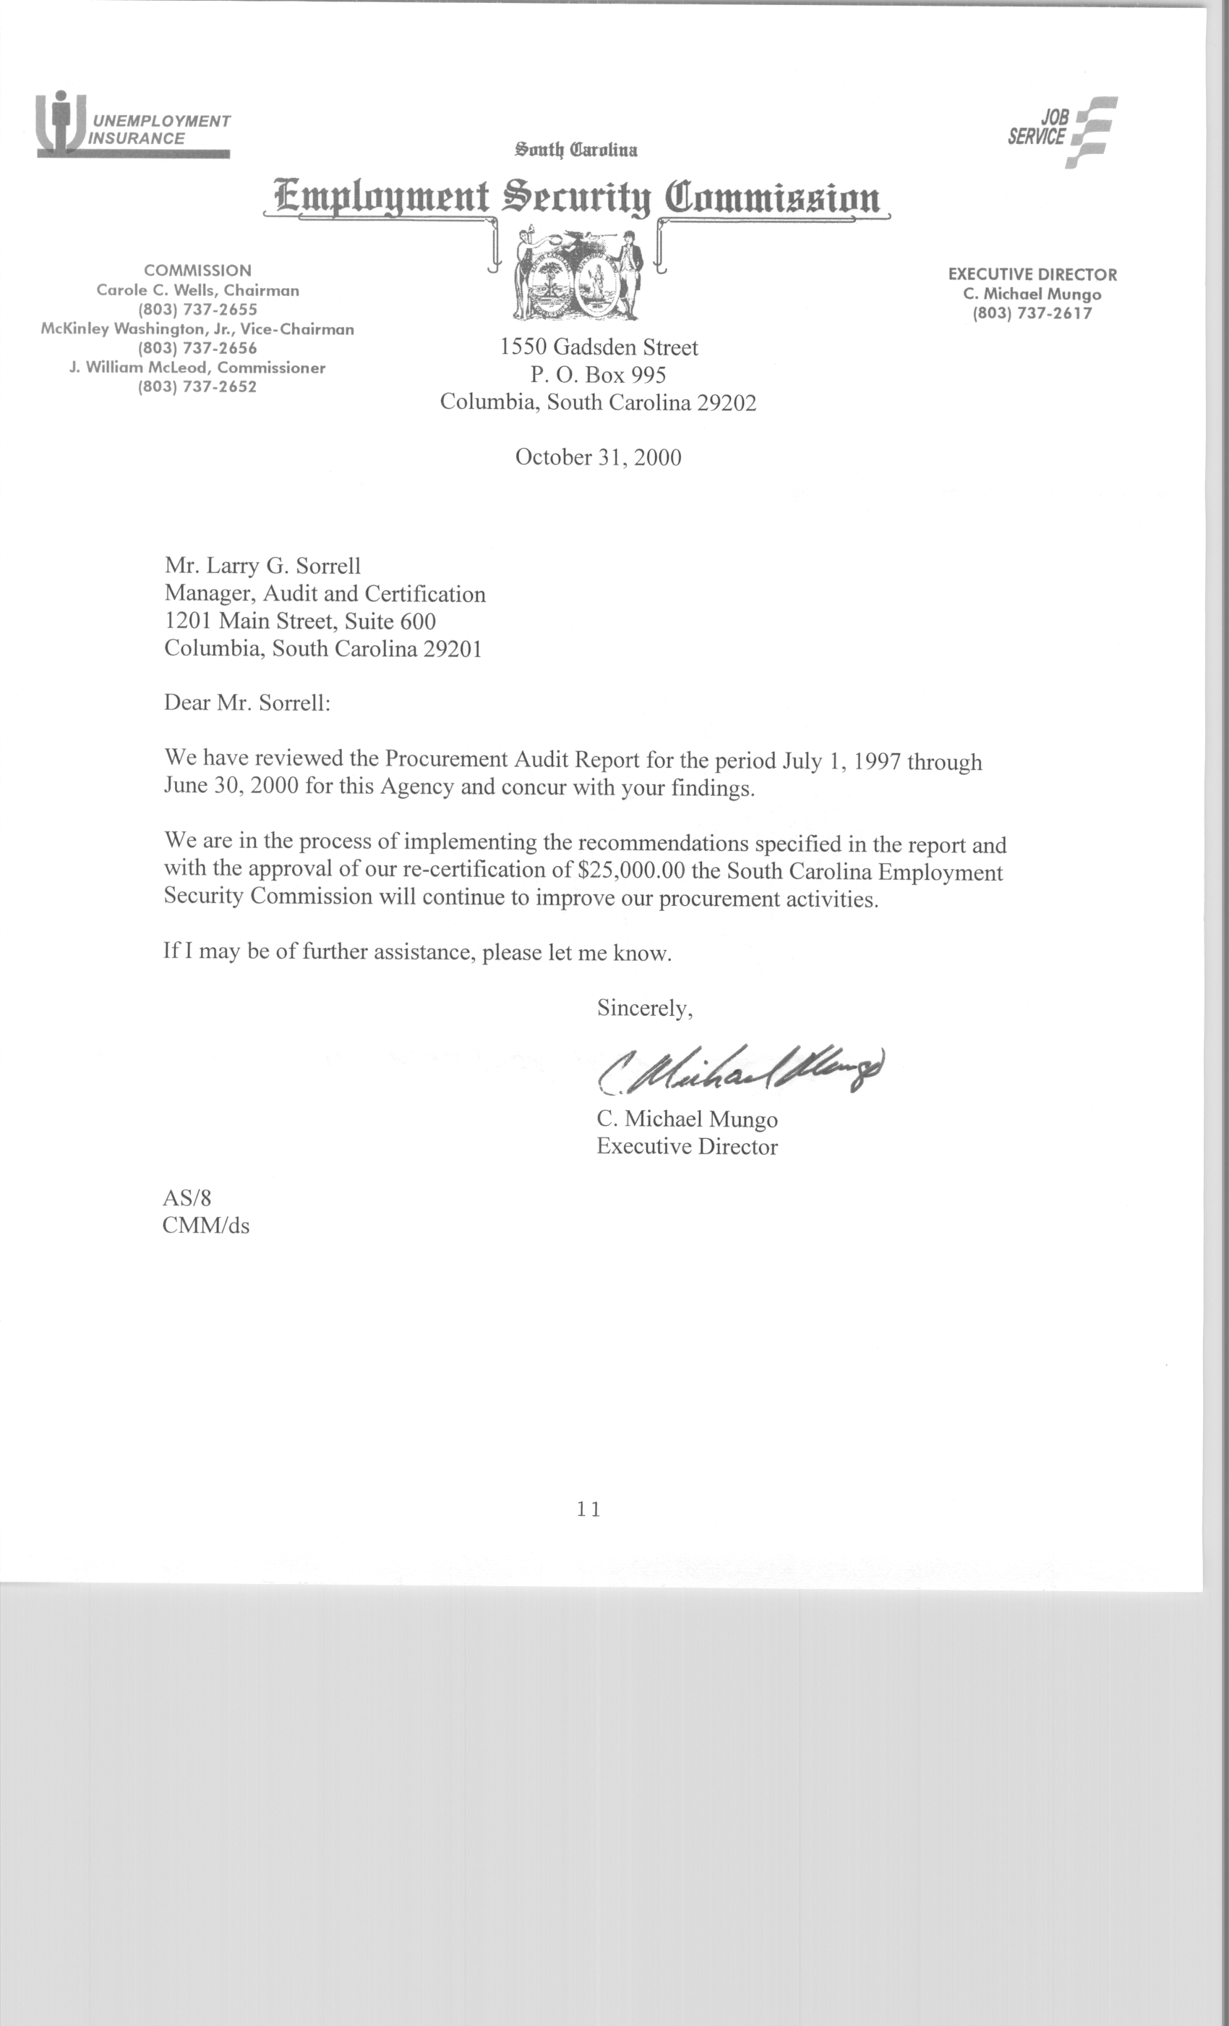
STATE OF SOUTH CAROLINA
State Budget and Control Board
OFFICE OF GENERAL SERVICES
JIM HODGES, CHAIRMAN  GOVERNOR  GRADY L. PATTERSON, JR.  STATE TREASURER  JAMES A. LANDER  COMPTROLLER GENERAL |  | JOHN DRUMMOND  CHAIRMAN, SENATE FINANCE COMMITTEE  ROBERT W. HARRELL, JR.  CHAIRMAN, WAYS AND MEANS COMMITTEE  RICK KELLY  EXECUTIVE DIRECTOR
ROBERT W. McCLAM
DIRECTOR

MATERIALS MANAGEMENT OFFICE
1201 MAIN STREET, SUITE 600
COLUMBIA, SOUTH CAROLINA 29201
(803) 737-0600
Fax (803) 737-0639

R. VOIGHT SHEALY
ASSISTANT DIRECTOR

November 6, 2000

Mr. R. Voight Shealy

Materials Management Officer
Materials Management Office
1201 Main Street, Suite 600
Columbia, South Carolina 29201

Dear Voight:

We have reviewed the response from the South Carolina Employment Security Commission to our audit report for the period of July 1, 1997 – June 30, 2000. Also we have followed the Commission’s corrective action during and subsequent to our fieldwork. We are satisfied that the Commission has corrected the problem areas and the internal controls over the procurement system are adequate.

Therefore, we recommend the Budget and Control Board grant South Carolina Employment Security Commission the certification limits noted in our report for a period of three years.

Sincerely,

Larry G. Sorrell, Manager
Audit and Certification

LGS/jl
Total Copies Printed 25
Unit Cost .24
Total Cost $6.00

