STATE OF SOUTH CAROLINA
State Budget and Control Board
OFFICE OF GENERAL SERVICES
JIM HODGES, CHAIRMAN  GOVERNOR  GRADY L. PATTERSON, JR.  STATE TREASURER  JAMES A. LANDER  COMPTROLLER GENERAL |  | HUGH K. LEATHERMAN, SR.  CHAIRMAN, SENATE FINANCE COMMITTEE  ROBERT W. HARRELL, JR.  CHAIRMAN, WAYS AND MEANS COMMITTEE  FRANK FUSCO  EXECUTIVE DIRECTOR
GEORGE N. DORN, JR.
DIRECTOR

MATERIALS MANAGEMENT OFFICE
1201 MAIN STREET, SUITE 600
COLUMBIA, SOUTH CAROLINA 29201
(803) 737-0600
Fax (803) 737-0639

R. VOIGHT SHEALY
MATERIALS MANAGEMENT OFFICER

July 12, 2001

Mr. George N. Dorn, Jr., Director
Office of General Services
1201 Main Street, Suite 420

Columbia, South Carolina 29201

Dear George:

I have attached the South Carolina Department of Education’s procurement audit report and recommendations made by the Office of Audit and Certification. I concur and recommend the Budget and Control Board grant the Department a three-year certification as noted in the audit report.

Sincerely,
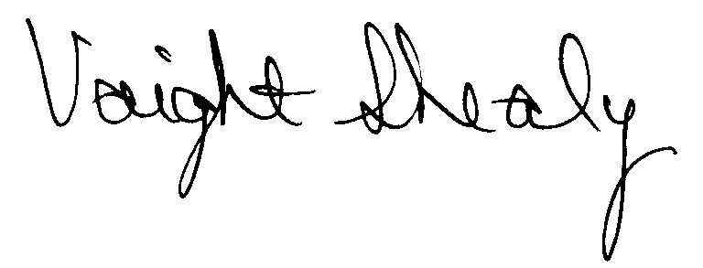
R. Voight Shealy
Materials Management Officer

/jl

SOUTH CAROLINA DEPARTMENT OF EDUCATION

PROCUREMENT AUDIT REPORT

APRIL 1, 1998 - MARCH 31, 2001
TABLE OF CONTENTS

PAGE

Transmittal Letter 1

Introduction 3

Background 4

Scope 5

Summary of Audit Findings 6

Results of Examination 7

Certification Recommendations 10

Agency Response 11

Follow-up Letter 12

STATE OF SOUTH CAROLINA
State Budget and Control Board
OFFICE OF GENERAL SERVICES
JIM HODGES, CHAIRMAN  GOVERNOR  GRADY L. PATTERSON, JR.  STATE TREASURER  JAMES A. LANDER  COMPTROLLER GENERAL |  | HUGH K. LEATHERMAN, SR.  CHAIRMAN, SENATE FINANCE COMMITTEE  ROBERT W. HARRELL, JR.  CHAIRMAN, WAYS AND MEANS COMMITTEE  FRANK FUSCO  EXECUTIVE DIRECTOR
GEORGE N. DORN, JR.
DIRECTOR

MATERIALS MANAGEMENT OFFICE
1201 MAIN STREET, SUITE 600
COLUMBIA, SOUTH CAROLINA 29201
(803) 737-0600
Fax (803) 737-0639

R. VOIGHT SHEALY
MATERIALS MANAGEMENT OFFICER

July 28, 2026

Mr. R. Voight Shealy
Materials Management Officer
Office of General Services
1201 Main Street, Suite 600
Columbia, South Carolina 29201
Dear Voight:
We have examined the procurement policies and procedures of the South Carolina Department of Education for the period April 1, 1998 through March 31, 2001. As part of our examination, we studied and evaluated the system of internal control over procurement transactions to the extent we considered necessary.
The evaluation was to establish a basis for reliance upon the system of internal control to assure adherence to the Consolidated Procurement Code, State regulations and the Department’s procurement policy. Additionally, the evaluation was used in determining the nature, timing and extent of other auditing procedures necessary for developing an opinion on the adequacy, efficiency and effectiveness of the procurement system.
The administration of the South Carolina Department of Education is responsible for establishing and maintaining a system of internal control over procurement transactions. In fulfilling this responsibility, estimates and judgments by management are required to assess the expected benefits and related costs of control procedures. The objectives of a system are to

provide management with reasonable, but not absolute, assurances of the integrity of the procurement process, that affected assets are safeguarded against loss from unauthorized use or disposition and that transactions are executed in accordance with management's authorization and are recorded properly.
Because of inherent limitations in any system of internal control, errors or irregularities may occur and not be detected. Also, projection of any evaluation of the system to future periods is subject to the risk that procedures may become inadequate because of changes in conditions or that the degree of compliance with the procedures may deteriorate.
Our study and evaluation of the system of internal control over procurement transactions, as well as our overall examination of procurement policies and procedures, were conducted with professional care. However, because of the nature of audit testing, they would not necessarily disclose all weaknesses in the system.
The examination did, however, disclose conditions enumerated in this report that we believe need correction or improvement. Corrective action based on the recommendations described in these findings will in all material respects place the South Carolina Department of Education in compliance with the Consolidated Procurement Code and ensuing regulations.

Sincerely,
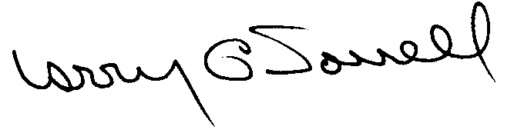
Larry G. Sorrell, Manager
Audit and Certification
INTRODUCTION
We conducted an examination of the internal procurement operating policies and procedures of the South Carolina Department of Education. Our on-site review was conducted April 2, 2001 through May 7, 2001 and was made under Section 11-35-1230(1) of the South Carolina Consolidated Procurement Code and Section 19-445.2020 of the accompanying regulations.
The examination was directed principally to determine whether, in all material respects, the procurement system's internal controls were adequate and the procurement procedures, as outlined in the Internal Procurement Operating Procedures Manual, were in compliance with the South Carolina Consolidated Procurement Code and its ensuing regulations.
Additionally, our work was directed toward assisting the South Carolina Department of Education in promoting the underlying purposes and policies of the Code as outlined in Section 11-35-20, which include:

(1) to ensure the fair and equitable treatment of all persons who deal with the procurement system of this State

(2) to provide increased economy in state procurement activities and to maximize to the fullest extent practicable the purchasing values of funds of the State

(3) to provide safeguards for the maintenance of a procurement system of quality and integrity with clearly defined rules for ethical behavior on the part of all persons engaged in the public procurement process

BACKGROUND

Section 11-35-1210 of the South Carolina Consolidated Procurement Code states:

The (Budget and Control) Board may assign differential dollar limits below which individual governmental bodies may make direct procurements not under term contracts. The Office of General Services shall review the respective governmental body's internal procurement operation, shall verify in writing that it is consistent with the provisions of this code and the ensuing regulations, and recommend to the Board those dollar limits for the respective governmental body's procurement not under term contract.
On October 13, 1998, the Budget and Control Board granted the Department the following procurement certifications:

PROCUREMENT AREAS | CERTIFICATION LIMITS
Goods and Services |  | $25,000 per commitment
Consultant Services |  | $25,000 per commitment
Information Technology |  | $25,000 per commitment
Our audit was performed primarily to determine if recertification is warranted. No additional certification over the current limits was requested.
SCOPE
We conducted our examination in accordance with Generally Accepted Auditing Standards as they apply to compliance audits. Our examination encompassed a detailed analysis of the internal procurement operating procedures of the South Carolina Department of Education and its related policies and procedures manual to the extent we deemed necessary to formulate an opinion on the adequacy of the system to properly handle procurement transactions.
We selected a judgmental sample for the period July 1, 1998 through March 31, 2001 of procurement transactions for compliance testing and performed other audit procedures that we considered necessary to formulate this opinion. Specifically the scope of our audit included, but was not limited to, a review of the following:

(1) All sole source, emergency and trade-in sale procurements for the period April 1, 1998 through March 31, 2001

(2) Procurement transactions for the audit period as follows:
a) One hundred and two judgmentally selected procurement transactions exceeding $1,500
- A block sample of five hundred numerical purchase orders
- Additional sample of nine informal solicitations

(3) One major construction contract and three professional services contracts reviewed for compliance with the Manual for Planning and Execution of State Permanent Improvements

(4) Minority Business Enterprise Plan and reports

(5) Approval of the most recent Information Technology Plan

(6) Internal procurement procedures manual

(7) Surplus property procedures

(8) File documentation and evidence of competition
SUMMARY OF AUDIT FINDINGS
Our audit of the procurement system of the South Carolina Department of Education, hereinafter referred to as the Department, produced the following findings and recommendations.
PAGE
I. Sole Source Procurements
A. Inappropriate Sole Source Procurements 7
Eleven sole source procurements were inappropriate.
B. Drug-Free Workplace Certification 8
The Drug-Free Workplace Certifications were obtained after the start
of sixteen contracts.
II. General Procurement Exceptions
A. Procurements Without Competition 8
Four procurements had no evidence of competition.
- Improper Award Method 8
An award was not made in accordance with the source selection method.
C. Determinations Not Prepared 9
Justifications were not prepared as required by the Code.
RESULTS OF EXAMINATION
I. Sole Source Procurements
We examined the quarterly reports of sole source and emergency procurements for the audit period. This review was performed to determine the appropriateness of the procurement actions taken and the accuracy of the reports submitted to the Office of General Services as required by Section 11-35-2440 of the Code.
A. Inappropriate Sole Source Procurements
The following eleven sole source procurements were inappropriate.
Item | PO | Date | Amount | Description
1 | P44657 | 7/13/98 | $ 3,000 | News clipping service
2 | P70088 | 1/07/00 | 2,300 | News clipping service
3 | P40396 | 4/07/98 | 4,250 | Develop program for contribution solicitation
4 | P41706 | 5/12/98 | 3,000 | Develop mathematics questions
5 | P44300 | 6/19/99 | 2,759 | Accident insurance
6 | P44604 | 7/10/98 | 49,600 | Consultant
7 | P47628 | 9/03/98 | 36,000 | Public relations consultant
8 | P50131 | 10/27/98 | 197,534 | Consultant to develop task assessments
9 | P53437 | 1/21/99 | 2,000 | Art instructor
10 | P64553 | 9/02/99 | 5,000 | Integrate programs into middle schools
11 | P65653 | 9/27/99 | 155,137 | Field test task assessments

Items 1 and 2 were noted in our previous audit. The remaining items were justified as the best source or uniquely qualified. The terms best source and uniquely qualified are not synonymous with the definition of a sole source. In many of these cases, an employment contract would have been more appropriate than a consultant contract.
Section 11-35-1560 of the Code requires that sole source procurements only apply when there is one source for the required supply, service, or construction items. In cases of reasonable doubt, competition must be solicited.
We recommend that procurements, which do not meet the definition of a sole source, be competed in accordance with the Code.

B. Drug-Free Workplace Certification
We noted sixteen of the fifty sole source procurements greater than $50,000 where the Department did not obtain the required certification from the vendors stating that they were in compliance with the South Carolina Drug-Free Workplace Act per Section 44-107-30 of the South Carolina Code of Laws. The Department requested and received the certifications after we brought the items to their attention.
We recommend the Department obtain the drug-free workplace certification on all sole source procurements greater than $50,000 prior to the start of the contract or services being rendered.

II. General Procurement Exceptions
A. Procurements Without Competition
The following four procurements were not supported by solicitations of competition, sole source or emergency procurement determinations, term contract references or correctly classified as exempt items.
PO | Date | Amount | Description
C71110 | 9/01/00 | $12,020 | Hazardous spill clean up
P60028 | 6/17/99 | 13,354 | Printers and accessories
P60132 | 6/21/99 | 26,563 | Sheet music
P65104 | 9/14/99 | 10,924 | Sheet music
The Department incorrectly believed that competition on C71110 was not required because the Department of Health and Environmental Control was involved. The file on P60028 noted the price was fair and reasonable, however written solicitations of request for quotation plus advertisement applied to the procurement. The procurements for the sheet music on purchase orders P60132 and P65104 was incorrectly considered exempt as copyrighted materials.
We recommend the Department comply with the competitive requirements of the Code when the potential value exceeds $1,500.
B. Improper Award Method
Quotation Q44 was issued for internet access for the Governor’s School for the Arts and Humanities (SCGSAH). The specifications were very broad and subjective. For example, one of the specifications stated, in part, “Once accessed, this service should provide information resources to meet the artistic and academic needs of the SCGSAH students.” The award was based on the vendor that offered the most access to the different publications, i.e. the best offeror. Section 11-35-1550 (2) (d) requires that the award be made to the lowest responsive and responsible bidder. Based on the specifications and the award method, the solicitation should have been processed as a request for proposal or a best value bid.
We recommend the Department solicit and award contracts in accordance with the appropriate procurement method defined in the Code.
- Determinations Not Prepared
The Department did not prepare the written determination per Section 11-35-1530(1) on request for proposal RFP10. We noted the same exception in our last audit. The multi-term determination as required by Section 11-35-2030(2) for the three-year contract on quotation Q43 was not prepared.
We recommend the Department prepare the applicable determinations in accordance with the Code.
CERTIFICATION RECOMMENDATIONS
As enumerated in our transmittal letter, corrective action based on the recommendations described in this report, we believe, will in all material respects place the South Carolina Department of Education in compliance with the Consolidated Procurement Code and ensuing regulations.
Under the authority described in Section 11-35-1210 of the Procurement Code, subject to this corrective action, we will recommend the Department be recertified to make direct agency procurements for three years up to the limits as follows:
PROCUREMENT AREAS | RECOMMENDED CERTIFICATION LIMITS
Goods and Services | *$25,000
Consultant Services | *$25,000
Information Technology | *$25,000
* Total potential purchase commitment whether single year or multi-term contracts are used.

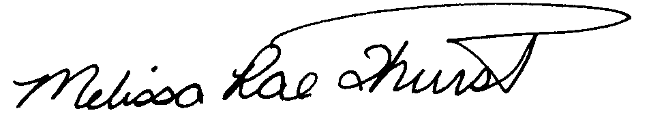
Melissa Rae Thurstin
Senior Auditor

Larry G. Sorrell, Manager
Audit and Certification

STATE OF SOUTH CAROLINA
State Budget and Control Board
OFFICE OF GENERAL SERVICES
JIM HODGES, CHAIRMAN  GOVERNOR  GRADY L. PATTERSON, JR.  STATE TREASURER  JAMES A. LANDER  COMPTROLLER GENERAL |  | HUGH K. LEATHERMAN, SR.  CHAIRMAN, SENATE FINANCE COMMITTEE  ROBERT W. HARRELL, JR.  CHAIRMAN, WAYS AND MEANS COMMITTEE  FRANK FUSCO  EXECUTIVE DIRECTOR
GEORGE N. DORN, JR.
DIRECTOR

MATERIALS MANAGEMENT OFFICE
1201 MAIN STREET, SUITE 600
COLUMBIA, SOUTH CAROLINA 29201
(803) 737-0600
Fax (803) 737-0639

R. VOIGHT SHEALY
MATERIALS MANAGEMENT OFFICER

July 12, 2001

Mr. R. Voight Shealy

Materials Management Officer
Materials Management Office
1201 Main Street, Suite 600
Columbia, South Carolina 29201

Dear Voight:

We have reviewed the response from the South Carolina Department of Education to our audit report for the period of April 1, 1998 – March 31, 2001. Also we have followed the Department’s corrective action during and subsequent to our fieldwork. We are satisfied that the Department has corrected the problem areas and the internal controls over the procurement system are adequate.

Therefore, we recommend the Budget and Control Board grant the South Carolina Department of Education, the certification limits noted in our report for a period of three years.

Sincerely,

Larry G. Sorrell, Manager
Audit and Certification

LGS/jl
Total Copies Printed 25
Unit Cost .24
Total Cost $6.00

