STATE OF SOUTH CAROLINA
State Budget and Control Board
OFFICE OF GENERAL SERVICES
JIM HODGES, CHAIRMAN  GOVERNOR  GRADY L. PATTERSON, JR.  STATE TREASURER  JAMES A. LANDER  COMPTROLLER GENERAL |  |  | HUGH K. LEATHERMAN, SR.  CHAIRMAN, SENATE FINANCE COMMITTEE  ROBERT W. HARRELL, JR.  CHAIRMAN, WAYS AND MEANS COMMITTEE  RICK KELLY  EXECUTIVE DIRECTOR
GEORGE N. DORN, JR.
DIRECTOR

MATERIALS MANAGEMENT OFFICE
1201 MAIN STREET, SUITE 600
COLUMBIA, SOUTH CAROLINA 29201
(803) 737-0600
Fax (803) 737-0639

R. VOIGHT SHEALY
MATERIALS MANAGEMENT OFFICER

April 17, 2001

Mr. George N. Dorn, Jr., Director
Office of General Services
1201 Main Street, Suite 420
Columbia, South Carolina 29201

Dear George:

I have attached the South Carolina School for the Deaf and Blind’s procurement audit report and recommendations made by the Office of Audit and Certification. I concur and recommend the Budget and Control Board grant the School a three-year certification as noted in the audit report.

Sincerely,
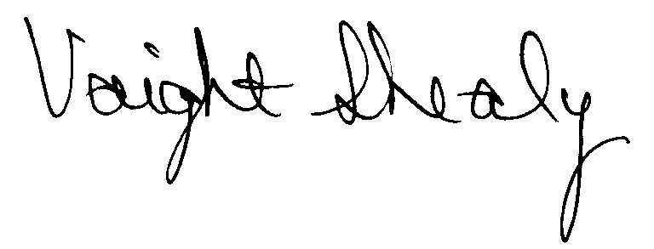

R. Voight Shealy
Materials Management Officer

/jl
SOUTH CAROLINA SCHOOL FOR THE DEAF AND THE BLIND
PROCUREMENT AUDIT REPORT

JANUARY 1, 1998 - DECEMBER 31, 2000

TABLE OF CONTENTS
PAGE

Transmittal Letter 1

Scope 3
Results of Examination 4
Certification Recommendation 7
School Response 8
Follow-up Letter 9

STATE OF SOUTH CAROLINA
State Budget and Control Board
OFFICE OF GENERAL SERVICES
JIM HODGES, CHAIRMAN  GOVERNOR  GRADY L. PATTERSON, JR.  STATE TREASURER  JAMES A. LANDER  COMPTROLLER GENERAL |  |  | HUGH K. LEATHERMAN, SR.  CHAIRMAN, SENATE FINANCE COMMITTEE  ROBERT W. HARRELL, JR.  CHAIRMAN, WAYS AND MEANS COMMITTEE  RICK KELLY  EXECUTIVE DIRECTOR
GEORGE N. DORN, JR.
DIRECTOR

MATERIALS MANAGEMENT OFFICE
1201 MAIN STREET, SUITE 600
COLUMBIA, SOUTH CAROLINA 29201
(803) 737-0600
Fax (803) 737-0639

R. VOIGHT SHEALY
MATERIALS MANAGEMENT OFFICER

July 30, 2026

Mr. R. Voight Shealy
Materials Management Officer
Office of General Services
1201 Main Street, Suite 600
Columbia, South Carolina 29201

Dear Voight:
We have examined the procurement policies and procedures of the South Carolina School for the Deaf and the Blind for the period January 1, 1998 through December 31, 2000. As part of our examination, we studied and evaluated the system of internal control over procurement transactions to the extent we considered necessary.
The evaluation was to establish a basis for reliance upon the system of internal control to assure adherence to the Consolidated Procurement Code, State regulations, and the procurement policy of the School. Additionally, the evaluation was used in determining the nature, timing and extent of other auditing procedures necessary for developing an opinion on the adequacy, efficiency and effectiveness of the procurement system.
The administration of the South Carolina School for the Deaf and the Blind is responsible for establishing and maintaining a system of internal control over procurement transactions. In fulfilling this responsibility, estimates and judgments by management are required to assess the expected benefits and related costs of control procedures. The objectives of a system are to
provide management with reasonable, but not absolute, assurance of the integrity of the procurement process, that affected assets are safeguarded against loss from unauthorized use or disposition and that transactions are executed in accordance with management's authorization and are recorded properly.
Because of inherent limitations in any system of internal control, errors or irregularities may occur and not be detected. Also, projection of any evaluation of the system to future periods is subject to the risk that procedures may become inadequate because of changes in conditions or that the degree of compliance with the procedures may deteriorate.
Our study and evaluation of the system of internal control over procurement transactions, as well as our overall examination of procurement policies and procedures, were conducted with professional care. However, because of the nature of audit testing, they would not necessarily disclose all weaknesses in the system.
The examination did, however, disclose several conditions enumerated in this report which we believe need correction or improvement.
Corrective action based on the recommendations described in these findings will in all material respects place the South Carolina School for the Deaf and the Blind in compliance with the Consolidated Procurement Code and ensuing regulations.

Sincerely,
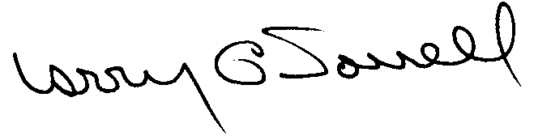

Larry G. Sorrell, Manager
Audit and Certification
SCOPE
We conducted our examination in accordance with Generally Accepted Auditing Standards as they apply to compliance audits. Our examination encompassed a detailed analysis of the internal procurement operating procedures of the South Carolina School for the Deaf and the Blind and its related policies and procedures manual to the extent we deemed necessary to formulate an opinion on the adequacy of the system to properly handle procurement transactions.
We selected judgemental samples from the period July 1, 1998 through December 31, 2000 of procurement transactions for compliance testing and performed other audit procedures we considered necessary to formulate this opinion. Specifically, the scope of our audit included, but was not limited to, a review of the following:
(1) All sole source, emergency and trade-in sale procurements for the period January 1, 1998 through December 31, 2000

(2) Procurement transactions from the period July 1, 1998 through
December 31, 2000 as follows:
- Sixty-six payment transactions greater than $1,500 each reviewed for
competition and compliance to the Code
- A block sample of five hundred purchase orders reviewed for
order splitting and favored vendors

- Four construction contracts and three professional services contracts for compliance with the Manual for Planning and Execution of State Permanent Improvements
- Minority Business Enterprise Plan and reports
- Information technology plans
- Internal procurement procedures manual
- Surplus property procedures
- File documentation and evidence of competition
RESULTS OF EXAMINATION
The Office of Audit and Certification performed an examination of the internal procurement policies and procedures and related manual of South Carolina School for the Deaf and the Blind, hereinafter referred to as the School, for the period January 1, 1998 through December 31, 2000. Our on-site review was conducted February 5, 2001 through February 9, 2001 and was made under the authority described in Section 11-35-1230(1) of the South Carolina Consolidated Procurement Code and Regulation 19-445.2020.
On May 12, 1998, the Budget and Control Board granted the School the following certification:
PROCUREMENT AREAS | CERTIFICATION LIMITS
Goods and Services | $ 25,000 per commitment
Information Technology | $ 25,000 per commitment
Consultant Services | $ 25,000 per commitment

Our audit was performed primarily to determine if recertification is warranted. Since our previous audit in 1998, the School has maintained what we consider to be a professional and efficient procurement system. We did note the following items which should be addressed by management.
No Evidence of Compliance
Two procurements had no evidence of compliance with competitive requirements of the Code.
PO | Amount | Description
551 | $ 2,281 | Charter transportation
1012 | 3,000 | Used paper folding machine

Section 11-35-1550 of the Code defines the level of competition for procurements from $1,500.01 to $5,000. The School could not provide documentation to support the solicitation of competitions.
We recommend the School make procurements in accordance with the Code and document the compliance in the file.

Unauthorized Procurement
Purchase order 38 was issued to a local political subdivision on 7/1/98 for $49,500 for fire protection service for the fiscal year ending 6/30/99. The School did not consider the procurement subject to the Code. The procurement should have been declared a sole source. Since the total value exceeded the School’s procurement authority of $25,000, the procurement is unauthorized as defined in Regulation 19-445.2015.
We recommend the School request ratification of the unauthorized procurement from the Materials Management Officer per Regulation 19-445.2015. Future procurements for this type of service should be procured in accordance with the Code.
Blanket Purchase Agreements
The following releases against the blanket purchase agreement exceeded the $400 call limit thus making each unauthorized.
Voucher | PO | Amount | Description
969 | 438 | $1,154 | Refrigerator/ice machine repairs
3353 | 276 | 458 | Photo services
2084 | 279 | 560 | Copying services

Regulation 19-445.2015 defines an unauthorized procurement as an act obligating the State in a contract by any person without the requisite authority to do so by an appointment or delegation. Since the caller did not have the authority to exceed the $400 limit, these procurements are unauthorized.
We recommend that ratification be requested for these items from the ratifying authority at the School and that the requirements of the blanket purchase agreements be adhered to in the future.
Emergency Procurement
Purchase order 950 was issued to repair the diesel engine on a bus for $8,080 and written quotes were solicited. Additional repairs of $5,847 were needed to complete the repair and the purchase order was amended to include the $5,847. The School did not address compliance to the Code for the additional repairs by justifying as an emergency procurement, which was an acceptable method.
We recommend the School comply with the Code when repairs exceed the original procurement amount.
Standard Equipment Lease
The School rented a construction trailer for a 12-month period on purchase order 632 for $4,260. The value of the trailer was $21,231. However, the standard equipment agreement as required by Regulation 19-445.2152(B) was not prepared
We recommend the School prepare a standard equipment agreement as required in the regulation.
CERTIFICATION RECOMMENDATION
As enumerated in our transmittal letter, corrective action based on the recommendations described in this report, we believe, will in all material respects place the South Carolina School for the Deaf and the Blind in compliance with the Consolidated Procurement Code and ensuing regulations.
Under the authority described in Section 11-35-1210 of the Procurement Code, subject to this corrective action, we will recommend the South Carolina School for the Deaf and the Blind be recertified to make direct School procurements for three years up to the limit as follows.
PROCUREMENT AREAS | RECOMMENDED CERTIFICATION LIMITS
Goods and Services | *$ 25,000 per commitment
Information Technology | *$ 25,000 per commitment
Consultant Services | *$ 25,000 per commitment
*The total potential purchase commitment whether single year or multi-term contracts are used.

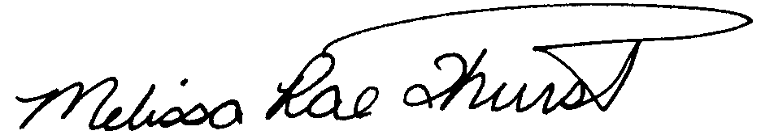
Melissa Rae Thurstin
Senior Auditor

Larry G. Sorrell, Manager

Audit and Certification

STATE OF SOUTH CAROLINA
State Budget and Control Board
OFFICE OF GENERAL SERVICES
JIM HODGES, CHAIRMAN  GOVERNOR  GRADY L. PATTERSON, JR.  STATE TREASURER  JAMES A. LANDER  COMPTROLLER GENERAL |  |  | HUGH K. LEATHERMAN, SR.  CHAIRMAN, SENATE FINANCE COMMITTEE  ROBERT W. HARRELL, JR.  CHAIRMAN, WAYS AND MEANS COMMITTEE  RICK KELLY  EXECUTIVE DIRECTOR
GEORGE N. DORN, JR.
DIRECTOR

MATERIALS MANAGEMENT OFFICE
1201 MAIN STREET, SUITE 600
COLUMBIA, SOUTH CAROLINA 29201
(803) 737-0600
Fax (803) 737-0639

R. VOIGHT SHEALY
MATERIALS MANAGEMENT OFFICER

April 17, 2001

Mr. R. Voight Shealy

Materials Management Officer
Materials Management Office
1201 Main Street, Suite 600
Columbia, South Carolina 29201

Dear Voight:

We have reviewed the response from the South Carolina School for the Deaf and Blind to our audit report for the period of January 1, 1998 – December 31, 2000. Also we have followed the School’s corrective action during and subsequent to our fieldwork. We are satisfied that the School has corrected the problem areas and the internal controls over the procurement system are adequate.

Therefore, we recommend the Budget and Control Board grant South Carolina School for the Deaf and Blind the certification limits noted in our report for a period of three years.

Sincerely,
Larry G. Sorrell, Manager
Audit and Certification

LGS/jl
Total Copies Printed 25
Unit Cost .20
Total Cost $5.00

