STATE OF SOUTH CAROLINA
State Budget and Control Board
OFFICE OF GENERAL SERVICES
JIM HODGES, CHAIRMAN  GOVERNOR  GRADY L. PATTERSON, JR.  STATE TREASURER  JAMES A. LANDER  COMPTROLLER GENERAL |  |  | HUGH K. LEATHERMAN, SR.  CHAIRMAN, SENATE FINANCE COMMITTEE  ROBERT W. HARRELL, JR.  CHAIRMAN, WAYS AND MEANS COMMITTEE  RICK KELLY  EXECUTIVE DIRECTOR
GEORGE N. DORN, JR.
DIRECTOR

MATERIALS MANAGEMENT OFFICE
1201 MAIN STREET, SUITE 600
COLUMBIA, SOUTH CAROLINA 29201
(803) 737-0600
Fax (803) 737-0639

R. VOIGHT SHEALY
MATERIALS MANAGEMENT OFFICER

April 2, 2001

Mr. George N. Dorn, Jr., Director
Office of General Services
1201 Main Street, Suite 420
Columbia, South Carolina 29201

Dear George:

I have attached the South Carolina Office of the Comptroller General’s procurement audit report and recommendations made by the Office of Audit and Certification. I concur and recommend the Budget and Control Board grant the Office a three-year certification as noted in the audit report.

Sincerely,
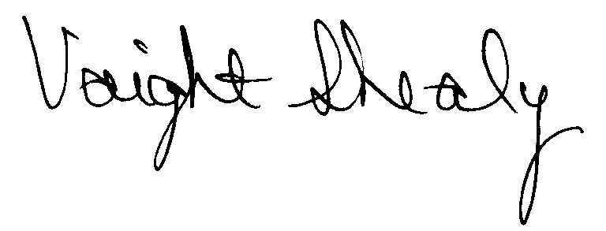
R. Voight Shealy
Materials Management Officer

/jl
SOUTH CAROLINA OFFICE OF THE COMPTROLLER GENERAL
PROCUREMENT AUDIT REPORT

APRIL 1, 1998 - DECEMBER 31, 2000
TABLE OF CONTENTS
PAGE
Transmittal Letter 1
Scope 3
Results of Examination 4
Certification Recommendations 5

STATE OF SOUTH CAROLINA
State Budget and Control Board
OFFICE OF GENERAL SERVICES
JIM HODGES, CHAIRMAN  GOVERNOR  GRADY L. PATTERSON, JR.  STATE TREASURER  JAMES A. LANDER  COMPTROLLER GENERAL |  |  | HUGH K. LEATHERMAN, SR.  CHAIRMAN, SENATE FINANCE COMMITTEE  ROBERT W. HARRELL, JR.  CHAIRMAN, WAYS AND MEANS COMMITTEE  RICK KELLY  EXECUTIVE DIRECTOR
GEORGE N. DORN, JR.
DIRECTOR

MATERIALS MANAGEMENT OFFICE
1201 MAIN STREET, SUITE 600
COLUMBIA, SOUTH CAROLINA 29201
(803) 737-0600
Fax (803) 737-0639

R. VOIGHT SHEALY
MATERIALS MANAGEMENT OFFICER

March 29, 2001

Mr. R. Voight Shealy
Materials Management Officer
Office of General Services
1201 Main Street, Suite 600
Columbia, South Carolina 29201
Dear Voight:
We have examined the procurement policies and procedures of the South Carolina Office of the Comptroller General for the period April 1, 1998 through December 31, 2000. As part of our examination, we studied and evaluated the system of internal control over procurement transactions to the extent we considered necessary.
The evaluation was to establish a basis for reliance upon the system of internal control to assure adherence to the Consolidated Procurement Code, State regulations, and the Office’s procurement policy. Additionally, the evaluation was used in determining the nature, timing and extent of other auditing procedures necessary for developing an opinion on the adequacy, efficiency and effectiveness of the procurement system.
The administration of the South Carolina Office of the Comptroller General is responsible for establishing and maintaining a system of internal control over procurement transactions. In fulfilling this responsibility, estimates and judgments by management are required to assess the expected benefits and related costs of control procedures. The objectives of a system are to
provide management with reasonable, but not absolute, assurance of the integrity of the procurement process, that affected assets are safeguarded against loss from unauthorized use or disposition and that transactions are executed in accordance with management's authorization and are recorded properly.
Because of inherent limitations in any system of internal control, errors or irregularities may occur and not be detected. Also, projection of any evaluation of the system to future periods is subject to the risk that procedures may become inadequate because of changes in conditions or that the degree of compliance with the procedures may deteriorate.
Our study and evaluation of the system of internal control over procurement transactions, as well as our overall examination of procurement policies and procedures, were conducted with professional care. However, because of the nature of audit testing, they would not necessarily disclose all weaknesses in the system.

Sincerely,
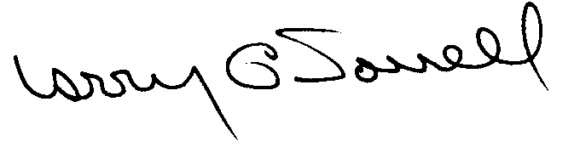
Larry G. Sorrell, Manager
Audit and Certification
SCOPE
We conducted our examination in accordance with Generally Accepted Auditing Standards as they apply to compliance audits. Our examination encompassed a detailed analysis of the internal procurement operating procedures of the South Carolina Office of the Comptroller General and its related policies and procedures manual to the extent we deemed necessary to formulate an opinion on the adequacy of the system to properly handle procurement transactions.
We selected judgmental samples for the period July 1, 1998 through December 31, 2000 of procurement transactions for compliance testing and performed other audit procedures that we considered necessary to formulate this opinion. Specifically, the scope of our audit included, but was not limited to, a review of the following:

(1) All sole source, emergency, and trade-in sale procurements for the period April 1, 1998 through December 31, 2000

(2) Procurement transactions for the period July 1, 1998 through December 31, 2000 as follows:
a) Ten payments greater than $1,500 each reviewed for competition and compliance to the Code
- Purchase orders issued from July 1, 2000 through December 31, 2000
- Procurement card transactions for the months of May and July of 2000

(3) Surplus property procedures

(4) Minority Business Enterprise Plans and reports

- Information technology plans and approvals

- File documentation and evidence of competition

- Internal procurement procedures manual

RESULTS OF EXAMINATION
We conducted an examination of the internal procurement operating policies and procedures of the South Carolina Office of the Comptroller General. Our on-site review was conducted March 21 - 23, 2001, and was made under Section 11-35-1230(1) of the South Carolina Consolidated Procurement Code and Section 19-445.2020 of the accompanying regulations. The audit was performed primarily because the three-year certification, as shown below, granted by the Budget and Control Board will expire on May 12, 2001.
PROCUREMENT AREAS | CERTIFICATION LIMITS
Goods and Services | $10,000
Information Technology | $10,000
The Office did not request any increases in certification.
We noted no material exceptions.
CERTIFICATION RECOMMENDATIONS
Under the authority described in Section 11-35-1210 of the Consolidated Procurement Code we recommend the South Carolina Office of the Comptroller General be recertified to make direct agency procurements for three years up to the limits as follows:
PROCUREMENT AREAS | RECOMMENDED CERTIFICATION LIMITS
Goods and Services | *$10,000 per commitment
Information Technology | *$10,000 per commitment
*The total potential purchase commitment whether single year or multi-term contracts are used.

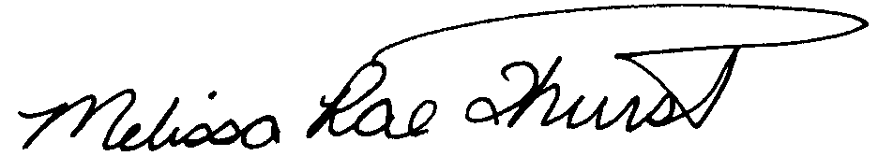 Melissa Rae Thurstin
Senior Auditor

Larry G. Sorrell, Manager
Audit and Certification

Total Copies Printed 25
Unit Cost .15
Total Cost $3.75

