STATE OF SOUTH CAROLINA

State Budget and Control Board

PROCUREMENT SERVICES DIVISION
JIM HODGES, CHAIRMAN  GOVERNOR  GRADY L. PATTERSON, JR.  STATE TREASURER  JAMES A. LANDER  COMPTROLLER GENERAL |  | HUGH K. LEATHERMAN, SR.  CHAIRMAN, SENATE FINANCE COMMITTEE  ROBERT W. HARRELL, JR.  CHAIRMAN, WAYS AND MEANS COMMITTEE  FRANK W. FUSCO  EXECUTIVE DIRECTOR
DELBERT H. SINGLETON, JR.
DIVISION DIRECTOR
(803) 734-2320

MATERIALS MANAGEMENT OFFICE
1201 MAIN STREET, SUITE 600
COLUMBIA, SOUTH CAROLINA 29201
(803) 737-0600
Fax (803) 737-0639

R. VOIGHT SHEALY
MATERIALS MANAGEMENT OFFICER

January 10, 2002

Mr. Delbert H. Singleton Jr.
Director
Procurement Services Division
6th Floor-Wade Hampton Building
Columbia, South Carolina 29201

Dear Delbert:

I have attached Coastal Carolina University’s procurement audit report and recommendations made by the Office of Audit and Certification. I concur and recommend the Budget and Control Board grant the University a three-year certification as noted in the audit report.

Sincerely,

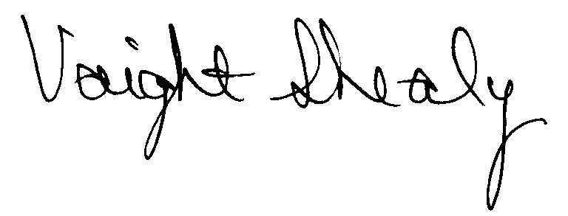

R. Voight Shealy
Materials Management Officer

/jl

COASTAL CAROLINA UNIVERSITY
PROCUREMENT AUDIT REPORT
OCTOBER 1, 1998 - SEPTEMBER 30, 2001
TABLE OF CONTENTS
PAGE
Transmittal Letter 1
Introduction 3
Scope 4
Summary of Audit Exceptions 5
Certification Recommendations 6
College Response 7
Follow-up Letter 8

STATE OF SOUTH CAROLINA

State Budget and Control Board

PROCUREMENT SERVICES DIVISION
JIM HODGES, CHAIRMAN  GOVERNOR  GRADY L. PATTERSON, JR.  STATE TREASURER  JAMES A. LANDER  COMPTROLLER GENERAL |  |  | HUGH K. LEATHERMAN, SR.  CHAIRMAN, SENATE FINANCE COMMITTEE  ROBERT W. HARRELL, JR.  CHAIRMAN, WAYS AND MEANS COMMITTEE  FRANK W. FUSCO  EXECUTIVE DIRECTOR
DELBERT H. SINGLETON, JR.
DIVISION DIRECTOR
(803) 734-2320

MATERIALS MANAGEMENT OFFICE
1201 MAIN STREET, SUITE 600
COLUMBIA, SOUTH CAROLINA 29201
(803) 737-0600
Fax (803) 737-0639

R. VOIGHT SHEALY
MATERIALS MANAGEMENT OFFICER

July 29, 2026
Mr. R. Voight Shealy
Materials Management Officer
Office of General Services
1201 Main Street, Suite 600
Columbia, South Carolina 29201
Dear Voight:
We have examined the procurement policies and procedures of Coastal Carolina University for the period October 1, 1998 through September 30, 2001. As part of our examination, we studied and evaluated the system of internal control over procurement transactions to the extent we considered necessary.
The evaluation was to establish a basis for reliance upon the system of internal control to assure adherence to the South Carolina Consolidated Procurement Code, State regulations and the University’s procurement policy. Additionally, the evaluation was used in determining the nature, timing and extent of other auditing procedures necessary for developing an opinion on the adequacy, efficiency and effectiveness of the procurement system.
The administration of Coastal Carolina University is responsible for establishing and maintaining a system of internal control over procurement transactions. In fulfilling this responsibility, estimates and judgments by management are required to assess the expected benefits and related costs of control procedures. The objectives of a system are to provide management with reasonable, but not absolute, assurances of the integrity of the procurement process, that affected assets are safeguarded against loss from unauthorized use or disposition and that transactions are executed in accordance with management's authorization and are recorded properly.
Because of inherent limitations in any system of internal control, errors or irregularities may occur and not be detected. Also, projection of any evaluation of the system to future periods is subject to the risk that procedures may become inadequate because of changes in conditions or that the degree of compliance with the procedures may deteriorate.
Our study and evaluation of the system of internal control over procurement transactions, as well as our overall examination of procurement policies and procedures, were conducted with professional care. However, because of the nature of audit testing, they would not necessarily disclose all weaknesses in the system.
The examination did, however, disclose conditions enumerated in this report that we believe need correction or improvement.
Corrective action based on the recommendations described in these findings will in all material respects place Coastal Carolina University in compliance with the Consolidated Procurement Code and ensuing regulations.

Sincerely,
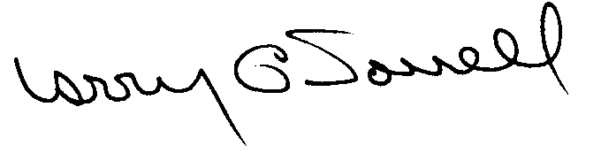
Larry G. Sorrell, Manager
Audit and Certification

INTRODUCTION
The Office of Audit and Certification performed an examination of the internal procurement operating policies and procedures and related manual of Coastal Carolina University, hereinafter referred to as the University, for the period October 1, 1998 through September 30, 2001.
Our on-site review was conducted October 15, 2001 through November 16, 2001, and was made under the authority as described in Section 11-35-1230(1) of the South Carolina Consolidated Procurement Code. On May 11, 1999, the Budget and Control Board granted Coastal Carolina University the following procurement certifications.
Procurement Areas | Certification Limits
Goods and Services | $50,000 per commitment
Consultant Services | $25,000 per commitment
Information Technology | $50,000 per commitment
Construction Services | $25,000 per commitment

The audit was performed primarily to determine if recertification is warranted. Additionally, Coastal Carolina University requested the following increased certification limits.
Procurement Areas | Certification Limits
Goods and Services | $100,000 per commitment
Consultant Services | $ 25,000 per commitment
Information Technology | $ 50,000 per commitment
Construction Contract Award | $ 25,000 per commitment
Construction Contract Change Order | $ 25,000 per change order
A/E Contract Amendment | $ 5,000 per amendment

SCOPE
We conducted our examination in accordance with Generally Accepted Auditing Standards as they apply to compliance audits. Our examination encompassed a detailed analysis of the internal procurement operating procedures of Coastal Carolina University and its related policies and procedures manual to the extent we deemed necessary to formulate an opinion on the adequacy of the system to properly handle procurement transactions.
We selected a judgmental sample for the period July 1, 1999 through September 30, 2001, of procurement transactions for compliance testing and performed other audit procedures that we considered necessary to formulate this opinion. Specifically, the scope of our audit included, but was not limited to, a review of the following:

(1) All sole source, emergency and trade-in sale procurements for the period October 1, 1998, through September 30, 2001

(2) Procurement transactions for the period July 1, 1999 to September 30, 2001 as follows:
a) Ninety-six judgmentally selected payments each exceeding $1,500 including two procurement card payments
b) A block sample of five hundred sequential purchase orders including five formal quotations

(3) Three construction contracts reviewed for compliance with the Manual for Planning and Execution of State Permanent Improvements

(4) Surplus property disposition procedures

(5) Minority Business Enterprise Plans and reports

(6) Internal procurement procedures manual review

(7) Real Property Management Office approvals of leases

(8) Blanket purchase order files

- Information Technology Plans for the audit period

(10) File documentation and evidence of competition
SUMMARY OF AUDIT FINDINGS

Overpayments
We noted two overpayments during our review. On check 113813, the vendor was paid sales tax when sales tax was not applicable. On check 133567, the vendor billed a higher unit price than was quoted and listed on the purchase order. The Accounting Department did not question these overpayments because the total payments did not exceed the values of the purchase orders.
We recommend that invoices be reconciled to the purchase orders to avoid overpayments. We also recommend refunds be requested for the overpayments.

CERTIFICATION RECOMMENDATIONS
As enumerated in our transmittal letter, corrective action based on the recommendations described in this report, we believe, will in all material respects place Coastal Carolina University in compliance with the South Carolina Consolidated Procurement Code and ensuing regulations.
Under the authority described in Section 11-35-1210 of the Procurement Code and subject to this corrective action, we will recommend the University be recertified to make direct agency procurements for three years up to the limits as follows:
Procurement Areas | Certification Limits
Goods and Services | *$100,000 per commitment
Consultant Services | *$ 25,000 per commitment
Information Technology | *$ 50,000 per commitment
Construction Contract Award | $ 25,000 per commitment
Construction Contract Change Order | $ 25,000 per change order
A/E Contract Amendment | $ 5,000 per amendment
*Total potential purchase commitment whether single year or multi-term contracts are used.

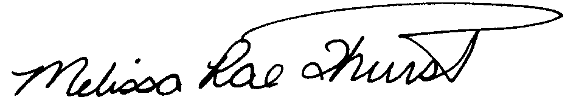
Melissa Rae Thurstin
Senior Auditor

Larry G. Sorrell, Manager
Audit and Certification

STATE OF SOUTH CAROLINA

State Budget and Control Board

PROCUREMENT SERVICES DIVISION
JIM HODGES, CHAIRMAN  GOVERNOR  GRADY L. PATTERSON, JR.  STATE TREASURER  JAMES A. LANDER  COMPTROLLER GENERAL |  | HUGH K. LEATHERMAN, SR.  CHAIRMAN, SENATE FINANCE COMMITTEE  ROBERT W. HARRELL, JR.  CHAIRMAN, WAYS AND MEANS COMMITTEE  FRANK W. FUSCO  EXECUTIVE DIRECTOR
DELBERT H. SINGLETON, JR.
DIVISION DIRECTOR
(803) 734-2320

MATERIALS MANAGEMENT OFFICE
1201 MAIN STREET, SUITE 600
COLUMBIA, SOUTH CAROLINA 29201
(803) 737-0600
Fax (803) 737-0639

R. VOIGHT SHEALY
MATERIALS MANAGEMENT OFFICER

January 11, 2002

Mr. R. Voight Shealy

Materials Management Officer
Materials Management Office

1201 Main Street, Suite 600
Columbia, South Carolina 29201

Dear Voight:

We have reviewed the response from the Coastal Carolina University to our audit report for the period of July 1, 1998 – June 30, 2001. Also we have followed the University’s corrective action during and subsequent to our fieldwork. We are satisfied that the University has corrected the problem areas and the internal controls over the procurement system are adequate.

Therefore, we recommend the Budget and Control Board grant the Coastal Carolina University the certification limits noted in our report for a period of three years.

Sincerely,

Larry G. Sorrell, Manager
Audit and Certification

LGS/jl
Total Copies Printed 25
Unit Cost .18
Total Cost $4.50

