STATE OF SOUTH CAROLINA

State Budget and Control Board

OFFICE OF GENERAL SERVICES
JIM HODGES, CHAIRMAN  GOVERNOR  GRADY L. PATTERSON, JR.  STATE TREASURER  JAMES A. LANDER  COMPTROLLER GENERAL |  | HUGH K. LEATHERMAN, SR.  CHAIRMAN, SENATE FINANCE COMMITTEE  ROBERT W. HARRELL, JR.  CHAIRMAN, WAYS AND MEANS COMMITTEE  FRANK FUSCO  EXECUTIVE DIRECTOR
GEORGE N. DORN, JR.
DIRECTOR

MATERIALS MANAGEMENT OFFICE
1201 MAIN STREET, SUITE 600
COLUMBIA, SOUTH CAROLINA 29201
(803) 737-0600
Fax (803) 737-0639

R. VOIGHT SHEALY
MATERIALS MANAGEMENT OFFICER

October 2, 2001

Mr. George N. Dorn, Jr., Director
Office of General Services
1201 Main Street, Suite 420
Columbia, South Carolina 29201

Dear George:

I have attached the audit report for the South Carolina Department of Agriculture. Since we are not recommending any certification above the basic $5,000 allowed by the Code, no action is required by the Budget and Control Board. Therefore, I recommend that the report be presented to the Budget and Control Board as information.

Sincerely,
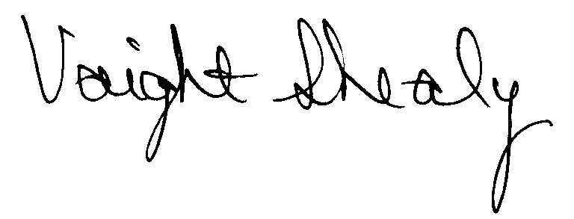
R. Voight Shealy
Materials Management Officer

/jl

SOUTH CAROLINA DEPARTMENT OF AGRICULTURE

PROCUREMENT AUDIT REPORT

JULY 1, 1999 - MARCH 31, 2001

TABLE OF CONTENTS

PAGE
Transmittal Letter 1
Introduction 3
Scope 4
Results of Examination 5

Conclusion 7

Department Response 8

Follow-up Letter 9

STATE OF SOUTH CAROLINA

State Budget and Control Board

OFFICE OF GENERAL SERVICES
JIM HODGES, CHAIRMAN  GOVERNOR  GRADY L. PATTERSON, JR.  STATE TREASURER  JAMES A. LANDER  COMPTROLLER GENERAL |  | HUGH K. LEATHERMAN, SR.  CHAIRMAN, SENATE FINANCE COMMITTEE  ROBERT W. HARRELL, JR.  CHAIRMAN, WAYS AND MEANS COMMITTEE  FRANK FUSCO  EXECUTIVE DIRECTOR
GEORGE N. DORN, JR.
DIRECTOR

MATERIALS MANAGEMENT OFFICE
1201 MAIN STREET, SUITE 600
COLUMBIA, SOUTH CAROLINA 29201
(803) 737-0600
Fax (803) 737-0639

R. VOIGHT SHEALY
MATERIALS MANAGEMENT OFFICER

August 13, 2001

Mr. R. Voight Shealy
Materials Management Officer
Office of General Services
1201 Main Street, Suite 600
Columbia, South Carolina 29201
Dear Voight:
We have examined the procurement policies and procedures of the South Carolina Department of Agriculture for the period July 1, 1999 through March 31, 2001. As part of our examination, we studied and evaluated the system of internal control over procurement transactions to the extent we considered necessary.
The evaluation was to establish a basis for reliance upon the system of internal control to assure adherence to the Consolidated Procurement Code and State regulations, and the Department’s procurement policy. Additionally, the evaluation was used in determining the nature, timing and extent of other auditing procedures necessary for developing an opinion on the adequacy, efficiency and effectiveness of the procurement system.
The administration of the South Carolina Department of Agriculture is responsible for establishing and maintaining a system of internal control over procurement transactions. In

fulfilling this responsibility, estimates, and judgments by management are required to assess the expected benefits and related costs of control procedures. The objectives of a system are to provide management with reasonable, but not absolute, assurance of the integrity of the procurement process, that affected assets are safeguarded against loss from unauthorized use or disposition and that transactions are executed in accordance with management's authorization and are recorded properly.
Because of inherent limitations in any system of internal control, errors or irregularities may occur and not be detected. Also, projection of any evaluation of the system to future periods is subject to the risk that procedures may become inadequate because of changes in conditions or that the degree of compliance with the procedures may deteriorate.
Our study and evaluation of the system of internal control over procurement transactions, as well as our overall examination of procurement policies and procedures, were conducted with professional care. However, because of the nature of audit testing, they would not necessarily disclose all weaknesses in the system.
The examination did, however, disclose conditions enumerated in this report which we believe need correction or improvement. Corrective action based on the recommendations described in these findings will in all material respects place the South Carolina Department of Agriculture in compliance with the Consolidated Procurement Code and ensuing regulations.

Sincerely,
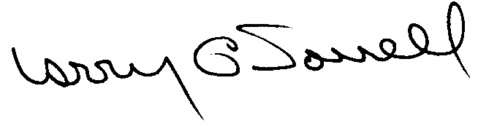

Larry G. Sorrell, Manager
Audit and Certification

INTRODUCTION
We conducted an examination of the internal procurement operating policies and procedures of the South Carolina Department of Agriculture. Our on-site review was conducted May 9 through 21, 2001 and was made under Section 11-35-1230(1) of the South Carolina Consolidated Procurement Code and Section 19-445.2020 of the accompanying regulations.
The examination was directed principally to determine whether, in all material respects, the procurement system's internal controls were adequate and the procurement procedures, as outlined in the Internal Procurement Operating Procedures Manual, were in compliance with the South Carolina Consolidated Procurement Code and its ensuing regulations.
Additionally, our work was directed toward assisting the Department in promoting the underlying purposes and policies of the Code as outlined in Section 11-35-20, which includes:

(1) to ensure the fair and equitable treatment of all persons who deal with the procurement system of this State

(2) to provide increased economy in state procurement activities and to maximize to the fullest extent practicable the purchasing values of funds of the State

(3) to provide safeguards for the maintenance of a procurement system of quality and integrity with clearly defined rules for ethical behavior on the part of all persons engaged in the public procurement process

SCOPE
We conducted our examination in accordance with Generally Accepted Auditing Standards as they apply to compliance audits. Our examination encompassed a detailed analysis of the internal procurement operating procedures of the South Carolina Department of Agriculture and its related policies and procedures manual to the extent we deemed necessary to formulate an opinion on the adequacy of the system to properly handle procurement transactions.
We selected a judgmental sample for the period July 1, 1999 through March 31, 2001 of procurement transactions for compliance testing and performed other audit procedures that we considered necessary to formulate this opinion. Specifically, the scope of our audit included, but was not limited to, a review of the following:

(1) All sole source, emergency and trade-in sale procurements for the period July 1, 1999 through March 31, 2001

(2) Procurement transactions for the period July 1, 1999 through March 31, 2001 as follows:
a) Thirty-three payments each exceeding $1,500
b) A block sample of two hundred fifty seven purchase orders

(3) Minority Business Enterprise Plans and reports

- Information technology plan

- File documentation for evidence of competition

(6) Internal procurement procedures manual

(7) Surplus property procedures

RESULTS OF EXAMINATION
Since our previous audit in 1997, the Department has maintained what we consider to be a professional, efficient procurement system. We did note, however, the following items that should be addressed by management.

Inadequate Competition
The following procurements for the rental of a forklift should have combined and competition solicited based on the total potential value of the rental.
PO | Date | Amount
3433 | 6/26/00 | $ 439
PO | Date | Amount
3505 | 7/06/00 | 325
1198 | 7/12/00 | 325
PO | Date | Amount
1460 | 7/24/00 | 325
1461 | 7/24/00 | 325
1655 | 8/2/00 | 325
 | Total | $2,067
We recommend that procurements with a potential value of $1,500 be procured in accordance with Section 11-35-1510.
Trade-in Sale Not Reported
One trade-in sale was not reported to the Materials Management Office. The trade in was a crane on purchase order 1977 dated 9/8/99. Section 11-35-3830 of the Code requires the quarterly reporting of trade in sales.
We recommend the Department adhere to the reporting requirements of the Code for trade in sales.
Procedures Manual
We reviewed the most recent Internal Procurement Procedures Manual for compliance to the Code. We noted several items that need to be added or changed. A detailed listing of the needed revisions was given to the Procurement Office.
We recommend the manual be revised and submitted to the Materials Management Office for approval per Regulation 19-445.2005.

CONCLUSION
As enumerated in our transmittal letter, corrective action based on the recommendations described in this report, we believe, will in all material respects place the South Carolina Department of Agriculture in compliance with the Consolidated Procurement Code and ensuing regulations.
Under the authority described in Section 11-35-1210 of the Procurement Code, subject to this corrective action, we will recommend the South Carolina Department of Agriculture be allowed to continue procuring goods and services, consultant services, construction and information technology up to the basic level of $5,000 as allowed by the South Carolina Consolidated Procurement Code and accompanying regulations.

David E. Rawl, CPPB
Senior Auditor

Larry G. Sorrell, Manager
Audit and Certification

STATE OF SOUTH CAROLINA

State Budget and Control Board

OFFICE OF GENERAL SERVICES
JIM HODGES, CHAIRMAN  GOVERNOR  GRADY L. PATTERSON, JR.  STATE TREASURER  JAMES A. LANDER  COMPTROLLER GENERAL |  | HUGH K. LEATHERMAN, SR.  CHAIRMAN, SENATE FINANCE COMMITTEE  ROBERT W. HARRELL, JR.  CHAIRMAN, WAYS AND MEANS COMMITTEE  FRANK FUSCO  EXECUTIVE DIRECTOR
GEORGE N. DORN, JR.
DIRECTOR

MATERIALS MANAGEMENT OFFICE
1201 MAIN STREET, SUITE 600
COLUMBIA, SOUTH CAROLINA 29201
(803) 737-0600
Fax (803) 737-0639

R. VOIGHT SHEALY
MATERIALS MANAGEMENT OFFICER

October 2, 2001

Mr. R. Voight Shealy
Materials Management Officer
Materials Management Office
1201 Main Street, Suite 600
Columbia, South Carolina 29201

Dear Voight:

We have reviewed the South Carolina Department of Agriculture’s response to our audit report for July 1, 1999 – March 31, 2001. Also, we have followed the Department’s corrective action during and subsequent to our field work. We are satisfied that the Department has corrected the problem areas and the internal controls over the procurement system are adequate.

Additional certification was not requested. Therefore, we recommend the Department be allowed to continue procuring all goods and services, construction services, information technology and consulting services up to the basic level as outlined in the Code.

Sincerely,
Larry G. Sorrell, Manager
Audit and Certification

LGS/jl

Total Copies Printed 25
Unit Cost - . .20
Total Cost - $5.00

