 | State of South Carolina  AWARD POSTING NOTICE | Solicitation Number  Procurement Officer  Date  Phone  E-Mail Address  Address | : PEBA0202018RFP  : David H. Quiat  : 1/19/2021  : 803-737-0562  : dquiat@mmo.sc.gov  : 1201 Main St., Suite 600  Columbia, SC 29201  Chris Manos

DESCRIPTION: Benefits Administration System

USING GOVERNMENTAL UNIT: South Carolina Public Employee Benefit Authority

In accordance with The South Carolina Consolidated Procurement Code, 11-35-1520 (10), the Posting Date for the referenced solicitation is scheduled for January 25, 2021.

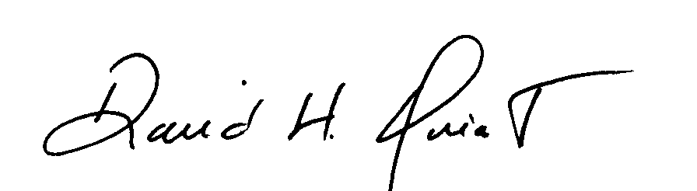
David H. Quiat
Procurement Manager

