STATE OF SOUTH CAROLINA
State Budget and Control Board
OFFICE OF GENERAL SERVICES
JIM HODGES, CHAIRMAN  GOVERNOR  GRADY L. PATTERSON, JR.  STATE TREASURER  JAMES A. LANDER  COMPTROLLER GENERAL |  | JOHN DRUMMOND  CHAIRMAN, SENATE FINANCE COMMITTEE  ROBERT W. HARRELL, JR.  CHAIRMAN, WAYS AND MEANS COMMITTEE  RICK KELLY  EXECUTIVE DIRECTOR
ROBERT W. McCLAM
DIRECTOR

MATERIALS MANAGEMENT OFFICE
1201 MAIN STREET, SUITE 600
COLUMBIA, SOUTH CAROLINA 29201
(803) 737-0600
Fax (803) 737-0639

R. VOIGHT SHEALY
ASSISTANT DIRECTOR

January 5, 2001

Mr. George Dorn, Director
Office of General Services
1201 Main Street, Suite 420

Columbia, South Carolina 29201

Dear George:

I have attached Lander University’s procurement audit report and recommendations made by the Office of Audit and Certification. I concur and recommend the Budget and Control Board grant the University a three-year certification as noted in the audit report.

Sincerely,
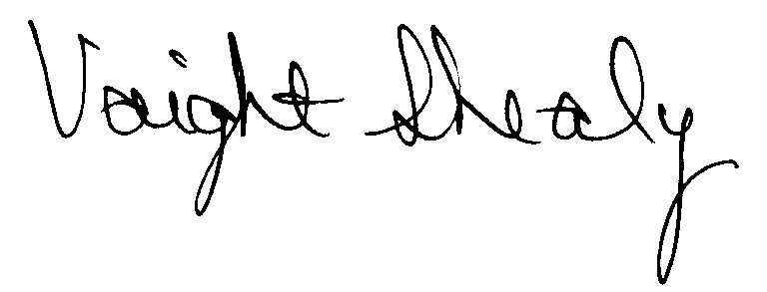
R. Voight Shealy
Materials Management Officer

/jl

LANDER UNIVERSITY

PROCUREMENT AUDIT REPORT

JULY 1, 1997 - JUNE 30, 2000

TABLE OF CONTENTS
PAGE

Transmittal Letter 1

Scope 3

Results of Examination 4

Certification Recommendations 7

University Response 8

Follow-up Letter 9

I

STATE OF SOUTH CAROLINA
State Budget and Control Board
OFFICE OF GENERAL SERVICES
JIM HODGES, CHAIRMAN  GOVERNOR  GRADY L. PATTERSON, JR.  STATE TREASURER  JAMES A. LANDER  COMPTROLLER GENERAL |  | JOHN DRUMMOND  CHAIRMAN, SENATE FINANCE COMMITTEE  ROBERT W. HARRELL, JR.  CHAIRMAN, WAYS AND MEANS COMMITTEE  RICK KELLY  EXECUTIVE DIRECTOR
ROBERT W. McCLAM
DIRECTOR

MATERIALS MANAGEMENT OFFICE
1201 MAIN STREET, SUITE 600
COLUMBIA, SOUTH CAROLINA 29201
(803) 737-0600
Fax (803) 737-0639

R. VOIGHT SHEALY
ASSISTANT DIRECTOR

November 10, 2000

Mr. R.Voight Shealy
Materials Management Officer
Office of General Services
1201 Main Street, Suite 600
Columbia, South Carolina 29201
Dear Voight:
We have examined the procurement policies and procedures of Lander University for the period July 1, 1997 through June 30, 2000. As part of our examination, we studied and evaluated the system of internal control over procurement transactions to the extent we considered necessary.
The evaluation was to establish a basis for reliance upon the system of internal control to assure adherence to the Consolidated Procurement Code, State regulations and the University’s procurement policy. Additionally, the evaluation was used in determining the nature, timing and extent of other auditing procedures necessary for developing an opinion on the adequacy, efficiency and effectiveness of the procurement system.
The administration of the University is responsible for establishing and maintaining a system of internal control over procurement transactions. In fulfilling this responsibility, estimates and judgments by management are required to assess the expected benefits and related costs of control procedures. The objectives of a system are to provide management with reasonable, but
not absolute, assurances of the integrity of the procurement process, that affected assets are safeguarded against loss from unauthorized use or disposition and that transactions are executed in accordance with management's authorization and are recorded properly.
Because of inherent limitations in any system of internal control, errors or irregularities may occur and not be detected. Also, projection of any evaluation of the system to future periods is subject to the risk that procedures may become inadequate because of changes in conditions or that the degree of compliance with the procedures may deteriorate.
Our study and evaluation of the system of internal control over procurement transactions, as well as our overall examination of procurement policies and procedures, were conducted with professional care. However, because of the nature of audit testing, they would not necessarily disclose all weaknesses in the system.
The examination did, however, disclose conditions enumerated in this report that we believe need correction or improvement.
Corrective action based on the recommendations described in these findings will in all material respects place Lander University in compliance with the South Carolina Consolidated Procurement Code and ensuing regulations.
Sincerely,
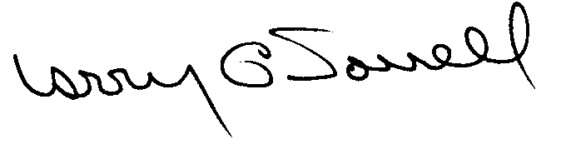
Larry G. Sorrell, Manager
Audit and Certification

SCOPE
We conducted our examination in accordance with Generally Accepted Auditing Standards as they apply to compliance audits. Our examination encompassed a detailed analysis of the internal procurement operating procedures of Lander University and its related policies and procedures manual to the extent we deemed necessary to formulate an opinion on the adequacy of the system to properly handle procurement transactions.
We selected a judgmental sample from the period July 1, 1998 through June 30, 2000 of procurement transactions for compliance testing and performed other audit procedures that we considered necessary to formulate this opinion. Specifically, the scope of our audit included, but was not limited to, a review of the following:

(1) All sole source, emergency and trade-in sale procurements for the period July 1, 1997 - June 30, 2000

(2) Procurement transactions for the period July 1, 1998 to June 30, 2000 as follows:
- Ninety-one payment transactions greater than $1,500 each reviewed for competition and compliance to the Code
- A block sample of five hundred numerical purchase orders reviewed for order splitting and favored vendors

(3) One construction contract and three professional services contracts for compliance with the Manual of Planning and Execution of State Permanent Improvements

(4) Minority Business Enterprise Plans and reports for the audit period

(5) Information technology plans for the audit period

(6) Internal procurement procedures manual

- Blanket purchase order files and credit card purchasing procedures

- File documentation and evidence of competition

- Surplus property procedures
RESULTS OF EXAMINATION
The Office of Audit and Certification performed an examination of the internal procurement operating policies and procedures and related manual of Lander University for the period July 1, 1997 through June 30, 2000.
Our on-site reviewed was conducted September 25, 2000 through October 11, 2000 and was made under the authority as described in Section 11-35-1230 (1) of the South Carolina Consolidated Procurement Code.
On February 10, 1998, the Budget and Control Board granted Lander University the following procurement certifications:
PROCUREMENT AREAS | CERTIFICATION LIMITS
Goods and Services | $50,000 per commitment
Consultant Services | $50,000 per commitment
Information Technology | $50,000 per commitment
Construction Services | $30,000 per commitment

The audit was performed primarily because the three-year certification granted the University by the Budget and Control Board is to expire February 10, 2001. Additionally, the University requested increased re-certification limits as follows:

PROCUREMENT AREAS | RECOMMENDED CERTIFICATION LIMITS
Goods and Services | $50,000 per commitment
Consultant Services | $50,000 per commitment
Information Technology | $50,000 per commitment
Construction Services | $50,000 per commitment
Construction Contract Change Order | $25,000 per change order
Architect/Engineer Contract Amendment | $10,000 per amendment

Since our previous audit in 1997, Lander University has maintained what we consider to be a professional, efficient procurement system. We did note, however, the following points that should be addressed by management.

Unauthorized Procurement
The University exceeded its $50,000 procurement certification authority on the following multi-term contract.
Sealed Bid Number | Description | Annual Contract | Total Potential
A0011/VWS | Printing | $11,000 | $55,000
The solicitation allowed for a one-year contract with up to four additional one-year extensions. The procurement certification limit of $50,000 for printing applies to the total commitment of a contract, whether single year or multi-term contract.
Regulation 19-445.2015 defines an unauthorized procurement as an act obligating the State in a contract by any person without the requisite authority to do so by appointment or delegation. Since the University exceeded its delegated procurement authority, the contract is unauthorized.
We recommend the University consider the total potential contract value on multi-year contracts. Furthermore, the University must request ratification for the procurement from the Materials Management Officer in accordance with Regulation 19-445.2015.

Inappropriate Price Changes on Two Contracts
Quotation Q109 for chairs was awarded to the low bidder on purchase order 2197 for $199.50 per chair. After receiving the purchase order, the vendor realized the quoted price was below cost. The University allowed the vendor to increase the unit cost of the chairs to $229.21. Since the quotes were opened and all prices exposed, the increase should not have been allowed. The vendor should have supplied the chairs at the quoted price or been allowed to withdraw the quote. If the vendor chose to withdraw his quote, the next low responsive and responsible bidder should have been awarded the contract.
Purchase order 131216 was issued for several computer-related items and the vendor’s faxed quotation stated the prices were good for thirty days. The University issued the purchase order three days before the expiration date of the quote. One item quoted was a tape cartridge for $85. The vendor substituted and billed a more expensive tape cartridge at $95. The University amended the purchase order to reflect the increase in price. The vendor should have requested authorization to substitute the item or provided the item initially quoted.
We recommend the University not allow vendors to change their quoted prices. If the items have been discontinued then authorization from Procurement Services should be obtained prior to shipment.

Sole Source Reporting Errors
The following three sole source procurements were incorrectly reported.
PO Number | Date | Description | $ Amount Reported | $ Actually Spent
002465 | 6/30/98 | Telephone system labor, services and materials | $10,000 | 0
131482 | 7/01/99 | Telephone system labor, services and materials | 10,000 | 0
038851 | 9/15/97 | Labor and materials for heating/cooling system science building | 10,000 | 17,364

The first two items were blanket purchase orders established at the beginning of the fiscal year for materials, labor and repair services for the University’s telephone system. The purchase order amounts of $10,000 each were reported to the Materials Management Office (MMO). Payment records showed no activity against either order during the year. At the end of each year, the purchase orders were cancelled but the sole source reports were never amended removing the purchase orders. The third item was a blanket order for materials and labor for the heating/cooling unit in the science building. A total of $17,364 was charged against the purchase order during the period.
We recommend Procurement Services establish procedures concerning the review of blanket purchase order charges to ensure the reported totals are accurate.

The following sole source transaction was exempt and should not have been reported.
PO  Number | Date | Description | Amount
132395 | 11/29/99 | Software maintenance | $4,250
Software maintenance and licenses are exempt from the Code after such software has been competitively bid.
We recommend that exempt items not be reported as a sole source.
CERTIFICATION RECOMMENDATIONS
As enumerated in our transmittal letter, corrective action based on the recommendations described in this report, we believe, will in all material respects places Lander University in compliance with the South Carolina Consolidated Procurement Code and ensuing regulations. Corrective action should be accomplished by December 31, 2000.
Under the authority described in section 11-35-1210 of the Procurement Code, subject to this corrective action, we will recommend Lander University recertification to make agency procurements for three years up the limits as follow.

PROCUREMENT AREAS | RECOMMENDED CERTIFICATION LIMITS
Goods and Services | *$50,000 per commitment
Consultant Services | *$50,000 per commitment
Information Technology | *$50,000 per commitment
Construction Services | *$50,000 per commitment
Construction Contract Change Order | $25,000 per change order
Architect/Engineer Contract Amendment | $10,000 per amendment
* Total potential purchase commitment whether single year or multi-term contracts are used.

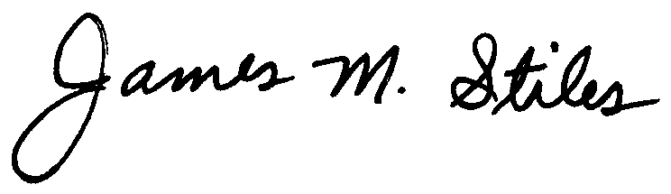
James M. Stiles, CPPB

Audit Manager

Larry G. Sorrell, Manager
Audit and Certification
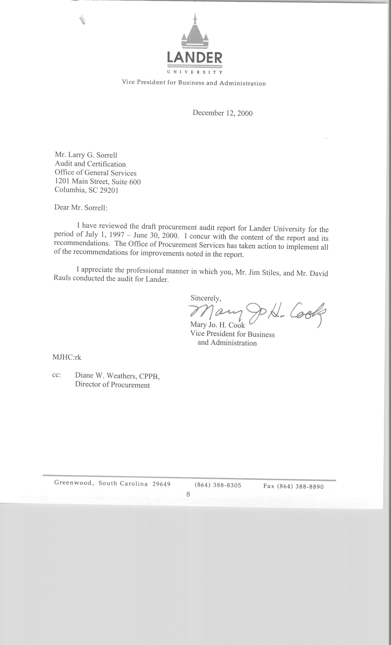
STATE OF SOUTH CAROLINA
State Budget and Control Board
OFFICE OF GENERAL SERVICES
JIM HODGES, CHAIRMAN  GOVERNOR  GRADY L. PATTERSON, JR.  STATE TREASURER  JAMES A. LANDER  COMPTROLLER GENERAL |  | JOHN DRUMMOND  CHAIRMAN, SENATE FINANCE COMMITTEE  ROBERT W. HARRELL, JR.  CHAIRMAN, WAYS AND MEANS COMMITTEE  RICK KELLY  EXECUTIVE DIRECTOR
ROBERT W. McCLAM
DIRECTOR

MATERIALS MANAGEMENT OFFICE
1201 MAIN STREET, SUITE 600
COLUMBIA, SOUTH CAROLINA 29201
(803) 737-0600
Fax (803) 737-0639

R. VOIGHT SHEALY
ASSISTANT DIRECTOR

January 5, 2001

Mr. R. Voight Shealy

Materials Management Officer
Materials Management Office
1201 Main Street, Suite 600
Columbia, South Carolina 29201

Dear Voight:

We have reviewed the response from Lander University to our audit report for the period of July 1, 1997 – June 30, 2000. Also we have followed the University’s corrective action during and subsequent to our fieldwork. We are satisfied that the University has corrected the problem areas and the internal controls over the procurement system are adequate.

Therefore, we recommend the Budget and Control Board grant Lander University the certification limits noted in our report for a period of three years.

Sincerely,

Larry G. Sorrell, Manager
Audit and Certification

LGS/jl
Total Copies Printed 25
Unit Cost .20
Total Cost $5.00

