STATE OF SOUTH CAROLINA
State Budget and Control Board
OFFICE OF GENERAL SERVICES
JIM HODGES, CHAIRMAN  GOVERNOR  GRADY L. PATTERSON, JR.  STATE TREASURER  JAMES A. LANDER  COMPTROLLER GENERAL |  |  | HUGH K. LEATHERMAN, SR.  CHAIRMAN, SENATE FINANCE COMMITTEE  ROBERT W. HARRELL, JR.  CHAIRMAN, WAYS AND MEANS COMMITTEE  RICK KELLY  EXECUTIVE DIRECTOR
GEORGE N. DORN, JR.
DIRECTOR

MATERIALS MANAGEMENT OFFICE
1201 MAIN STREET, SUITE 600
COLUMBIA, SOUTH CAROLINA 29201
(803) 737-0600
Fax (803) 737-0639

R. VOIGHT SHEALY
MATERIALS MANAGEMENT OFFICER

March 9, 2001

Mr. George Dorn, Director
Office of General Services
1201 Main Street, Suite 420
Columbia, South Carolina 29201

Dear George:

I have attached Francis Marion University’s procurement audit report and recommendations made by the Office of Audit and Certification. I concur and recommend the Budget and Control Board grant the University a three-year certification as noted in the audit report.

Sincerely,
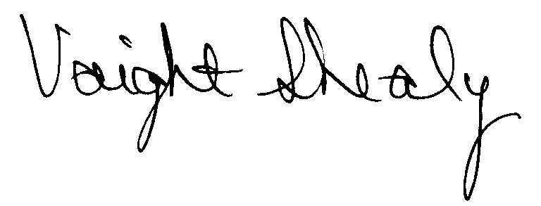
R. Voight Shealy
Materials Management Officer

/jl
FRANCIS MARION UNIVERSITY
PROCUREMENT AUDIT REPORT

JULY 1, 1997 - DECEMBER 31, 2000

TABLE OF CONTENTS
PAGE
Transmittal Letter 1
Introduction 3
Background 4
Scope 5
Summary of Audit Findings 6
Results of Examination 7
Certification Recommendation 10
University Response 11
Follow-up Letter 12

STATE OF SOUTH CAROLINA
State Budget and Control Board
OFFICE OF GENERAL SERVICES
JIM HODGES, CHAIRMAN  GOVERNOR  GRADY L. PATTERSON, JR.  STATE TREASURER  JAMES A. LANDER  COMPTROLLER GENERAL |  |  | HUGH K. LEATHERMAN, SR.  CHAIRMAN, SENATE FINANCE COMMITTEE  ROBERT W. HARRELL, JR.  CHAIRMAN, WAYS AND MEANS COMMITTEE  RICK KELLY  EXECUTIVE DIRECTOR
GEORGE N. DORN, JR.
DIRECTOR

MATERIALS MANAGEMENT OFFICE
1201 MAIN STREET, SUITE 600
COLUMBIA, SOUTH CAROLINA 29201
(803) 737-0600
Fax (803) 737-0639

R. VOIGHT SHEALY
MATERIALS MANAGEMENT OFFICER

February 15, 2001

Mr. R. Voight Shealy

Materials Management Officer
Office of General Services
1201 Main Street, Suite 600
Columbia, South Carolina 29201
Dear Voight:
We have examined the procurement policies and procedures of Francis Marion University for the period July 1, 1997 through December 31, 2000. As part of our examination, we studied and evaluated the system of internal control over procurement transactions to the extent we considered necessary.
The evaluation was to establish a basis for reliance upon the system of internal control to assure adherence to the Consolidated Procurement Code, State regulations and the University’s procurement policy. Additionally, the evaluation was used in determining the nature, timing and extent of other auditing procedures necessary for developing an opinion on the adequacy, efficiency and effectiveness of the procurement system.
The administration of Francis Marion University is responsible for establishing and maintaining a system of internal control over procurement transactions. In fulfilling this responsibility, estimates and judgments by management are required to assess the expected benefits and related costs of control procedures. The objectives of a system are to provide management with reasonable, but not absolute,
assurance of the integrity of the procurement process,
that affected assets are safeguarded against loss from unauthorized use or disposition and that transactions are executed in accordance with management's authorization and are recorded properly.
Because of inherent limitations in any system of internal control, errors or irregularities may occur and not be detected. Also, projection of any evaluation of the system to future periods is subject to the risk that procedures may become inadequate because of changes in conditions or that the degree of compliance with the procedures may deteriorate.
Our study and evaluation of the system of internal control over procurement transactions, as well as our overall examination of procurement policies and procedures, were conducted with professional care. However, because of the nature of audit testing, they would not necessarily disclose all weaknesses in the system.
The examination did, however, disclose conditions enumerated in this report which we believe need correction or improvement.
Corrective action based on the recommendations described in these findings will in all material respects place Francis Marion University in compliance with the Consolidated Procurement Code and ensuing regulations.

Sincerely,
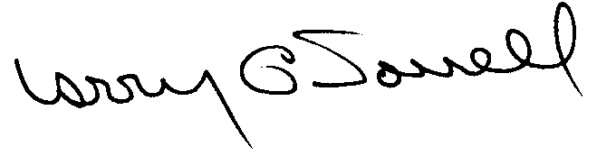
Larry G. Sorrell, Manager
Audit and Certification
INTRODUCTION
We conducted an examination of the internal procurement operating policies and procedures of Francis Marion University. Our review was conducted December 18, 2000 through January 30, 2001, and was made under Section 11-35-1230(1) of the South Carolina Consolidated Procurement Code and Section 19-445.2020 of the accompanying regulations.
The examination was directed principally to determine whether, in all material respects, the procurement system's internal controls were adequate and the procurement procedures, as outlined in the Internal Procurement Operating Procedures Manual, were in compliance with the South Carolina Consolidated Procurement Code and its ensuing regulations.
Additionally, our work was directed toward assisting the University in promoting the underlying purposes and policies of the Code as outlined in Section 11-35-20, which include:

- to ensure the fair and equitable treatment of all persons who deal with the procurement system of this State

- to provide increased economy in state procurement activities and to maximize to the fullest extent practicable the purchasing values of funds of the State

- to provide safeguards for the maintenance of a procurement system of quality and integrity with clearly defined rules for ethical behavior on the part of all persons engaged in the public procurement process

BACKGROUND
Section 11-35-1210 of the South Carolina Consolidated Procurement Code states:

The (Budget and Control) Board may assign differential dollar limits below which individual governmental bodies may make direct procurements not under term contracts. The Office of General Services shall review the respective governmental body's internal procurement operation, shall verify in writing that it is consistent with the provisions of this code and the ensuing regulations, and recommend to the Board those dollar limits for the respective governmental body's procurement not under term contract.
On April 14, 1998 and then amended June 29, 1999, the Budget and Control Board granted the University the following procurement certifications:

PROCUREMENT AREAS |  | CERTIFICATION LIMITS
Goods and Services | $ 100,000 per commitment
Consultant Services | $ 10,000 per commitment
Information Technology | $ 100,000 per commitment
Construction Services | $ 100,000 per commitment
Construction Contract Change Order | $ 25,000 per change order
Architect/Engineer Contract Amendment | $ 25,000 per amendment
Our audit was performed primarily to determine if recertification is warranted. No additional certification was requested.
SCOPE
We conducted our examination in accordance with Generally Accepted Auditing Standards as they apply to compliance audits. Our examination encompassed a detailed analysis of the internal procurement operating procedures of Francis Marion University and its related policies and procedures manual to the extent we deemed necessary to formulate an opinion on the adequacy of the system to properly handle procurement transactions.
We selected judgmental samples for the period July 1, 1997 through December 31, 2000, of procurement transactions for compliance testing and performed other audit procedures that we considered necessary to formulate this opinion. Specifically, the scope of our audit included, but was not limited to, a review of the following:

- All sole source, emergency and trade-in sale procurements for the period July 1, 1997 through September 30, 2000

- Procurement transactions for the period July 1, 1997 through December 31, 2000 as follows:
a) Seventy-nine payment transactions greater than $1,500 each reviewed for competition and compliance to the Code
b) A block sample of four hundred fifty seven purchase orders filed by Departments for order splitting and favored vendors
c) Additional sample of five sealed bids

- Five construction contracts and two professional service contracts for compliance with the Manual for Planning and Execution of State Permanent Improvements

- Minority Business Enterprise Plans and reports for the audit period

- Information technology plans for the audit period

- Internal procurement procedures manual

- File documentation and evidence of competition

- Surplus property procedures
SUMMARY OF AUDIT FINDINGS
Our audit of the procurement system of Francis Marion University, hereinafter referred to as the University, produced the following findings and recommendations.
PAGE
I. Procurements Not Supported by Competition 7
Three procurements were not supported by solicitations of competition, sole source or emergency procurement determinations.
II. Request For Proposal Solicitations 7
We could not determine full Code compliance on two request for proposal solicitations.
III. Trade In Sale Procurements 8
Three trade in sales were not approved for trade in by the Materials Management Office. One was not reported to the Materials Management Office.
IV. Multi-term Contracts 8
Two multi-term procurements were not supported by written determinations.
V. Inappropriate Sole Source 9
The procurement of decorative kits was inappropriate as a sole source.

RESULTS OF EXAMINATION

I. Procurements Not Supported by Competition
We noted three procurements that were not supported by solicitations of competition, sole source or emergency procurement determinations.
Reference | Description | Amount
PO 2412 | Annual computer maintenance agreement | $2,874
PO 2413 | Annual maintenance agreement on printers and tape backup unit | 6,974
Check 24384 | Monthly lease payment for phone system | 2,947
Purchase orders 2412 and 2413 were issued to the same vendor. Sole sources may have been the most appropriate procurement method. The payment on check 24384 was not sent through the Procurement Office. The payment on check 24384 represented the monthly lease payment for a twelve month lease with a value of $35,364. The person responsible for approving the lease did not have procurement authority thus making the procurement unauthorized as defined in Regulation 19-445.2015. Ratification of the unauthorized must be submitted to the President or his designee in accordance with Regulation 19-445.2015.
We recommend the University comply with the competition requirements of the Code.
II. Request For Proposal Solicitations
We could not determine full compliance to the Code on two request for proposal (RFP) solicitations. RFP solicitation 1597 was awarded for $26,809 to procure outdoor advertising. The solicitation did not include vendor protest rights and the posting location of the award. We did not find nor could the University provide the bid tabulation. The written determination required by Section 11-35-1530 (1) to solicit as a RFP was not prepared until after the proposal had been issued. The determination should have been prepared when the University first considered the RFP method.
RFP solicitation 1433 was awarded for $29,650 to procure recruiting/admission software. The solicitation file did not include a complete copy of the RFP. Therefore we could not verify that the solicitation included vendor protest rights and the posting location of the award. We also could not locate the written determination to solicit as a RFP.
We recommend the University comply with the Code for RFP solicitations.
III. Trade In Sale Procurements
We noted three trade in sale procurements that were not approved for trade in by the Materials Management Office.
PO | Description | Original Unit Purchase Price
16435 | Printer | $5,996
955 | Offset press | 13,563
955 | Swing away color head | 5,650
Regulation 19-445.2150 (G) states in part,

Governmental bodies may trade in personal property, whose original unit purchase price did not exceed $5,000, the trade in value of which must be applied to the purchase of new items. When the original unit purchase price exceeds $5,000, the governmental body shall refer the matter to the Materials Management Officer, the ITMO, or the designee of either, for disposition.
Further, the printer on PO 16435 was not reported to the Materials Management Office as required by Section 11-35-3830 (3).
We recommend the University comply with the trade in sale procedures of the Code and regulations. An amended report must be filed to add PO 16435.
IV. Multi-term Contracts
We reviewed two multi term procurements that were not supported by a written determination which justifies the use of multi-term solicitations.
Solicitation | Description | Amount
IFB 1606 | Pest control service-5 year contract | $6,192 per year
IFB 1596 | Elevator maintenance contract-5 year contract | 11,400 per year
Section 11-35-2030 (2) requires a written determination be prepared for any contract that exceeds one year.
We recommend the University comply with the Code for multi-term solicitations.

V. Inappropriate Sole Source
The University procured decorative kits as a sole source on PO 16596 for $1,633. The kit is a prepackaged assortment of balloons, murals, hand clappers, popcorn megaphones, and other items for use in pep rallies and other type events. Since other companies offer similar kits, we do not believe a sole source procurement was appropriate.
We recommend competition be solicited in the future.

CERTIFICATION RECOMMENDATIONS
As enumerated in our transmittal letter, corrective action based on the recommendations described in this report will in all material respects place Francis Marion University in compliance with the Consolidated Procurement Code and ensuing Regulations.
Under the authority described in Section 11-35-1210 of the Procurement Code, subject to this corrective action, we will recommend Francis Marion University be recertified to make direct agency procurements for three years up to the following limits.
PROCUREMENT AREAS |  | RECOMMENDED CERTIFICATION LIMITS
Goods and Services | *$100,000 per commitment
Consultant Services | *$ 10,000 per commitment
Information Technology | *$100,000 per commitment
Construction Contract Award | $100,000 per commitment
Construction Contract Change Order | $ 25,000 per change order
Architect/Engineering Contract Amendment | $ 25,000 per amendment

*The total potential purchase commitment whether single year or multi-term contracts are used.
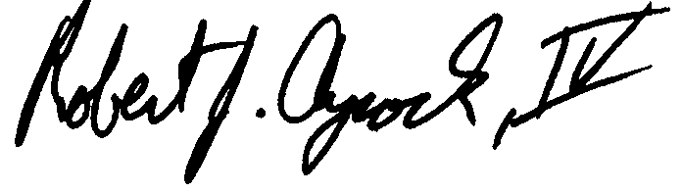

Robert J. Aycock, IV

Audit Manager
Larry G. Sorrell, Manager
Audit and Certification
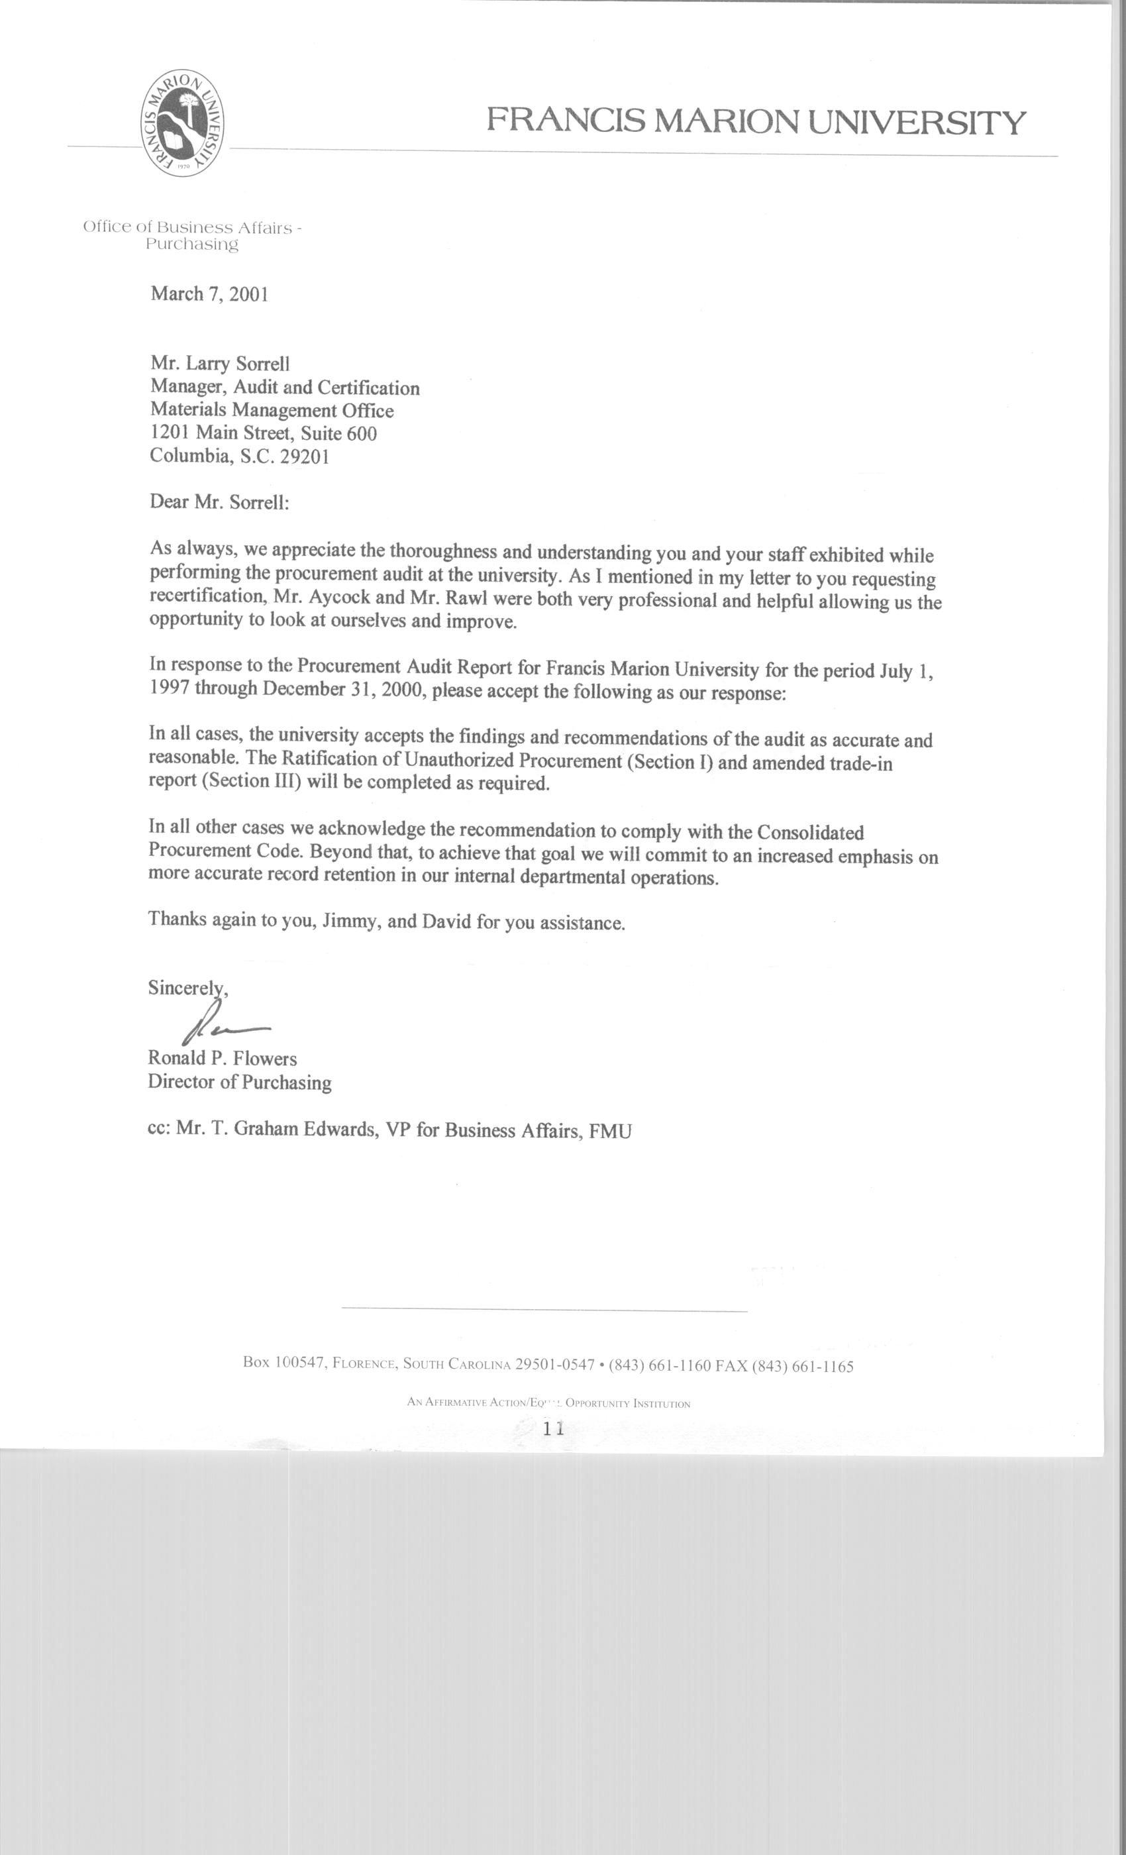

STATE OF SOUTH CAROLINA
State Budget and Control Board
OFFICE OF GENERAL SERVICES
JIM HODGES, CHAIRMAN  GOVERNOR  GRADY L. PATTERSON, JR.  STATE TREASURER  JAMES A. LANDER  COMPTROLLER GENERAL |  |  | HUGH K. LEATHERMAN, SR.  CHAIRMAN, SENATE FINANCE COMMITTEE  ROBERT W. HARRELL, JR.  CHAIRMAN, WAYS AND MEANS COMMITTEE  RICK KELLY  EXECUTIVE DIRECTOR
GEORGE N. DORN, JR.
DIRECTOR

MATERIALS MANAGEMENT OFFICE
1201 MAIN STREET, SUITE 600
COLUMBIA, SOUTH CAROLINA 29201
(803) 737-0600
Fax (803) 737-0639

R. VOIGHT SHEALY
MATERIALS MANAGEMENT OFFICER

March 9, 2001

Mr. R. Voight Shealy

Materials Management Officer
Materials Management Office
1201 Main Street, Suite 600

Columbia, South Carolina 29201

Dear Voight:

We have reviewed the response from Francis Marion University to our audit report for the period of July 1, 1997 – December 31, 2000. Also we have followed the University’s corrective action during and subsequent to our fieldwork. We are satisfied that the University has corrected the problem areas and the internal controls over the procurement system are adequate.

Therefore, we recommend the Budget and Control Board grant Francis Marion University the certification limits noted in our report for a period of three years.

Sincerely,

Larry G. Sorrell, Manager
Audit and Certification

LGS/jl
Total Copies Printed 25
Unit Cost .24
Total Cost $6.00

