STATE OF SOUTH CAROLINA
State Budget and Control Board
OFFICE OF GENERAL SERVICES
JIM HODGES, CHAIRMAN  GOVERNOR  GRADY L. PATTERSON, JR.  STATE TREASURER  JAMES A. LANDER  COMPTROLLER GENERAL |  | JOHN DRUMMOND  CHAIRMAN, SENATE FINANCE COMMITTEE  ROBERT W. HARRELL, JR.  CHAIRMAN, WAYS AND MEANS COMMITTEE  RICK KELLY  EXECUTIVE DIRECTOR
GEORGE N. DORN, JR.
DIRECTOR

MATERIALS MANAGEMENT OFFICE
1201 MAIN STREET, SUITE 600
COLUMBIA, SOUTH CAROLINA 29201
(803) 737-0600
Fax (803) 737-0639

R. VOIGHT SHEALY
MATERIALS MANAGEMENT OFFICER

January 12, 2001

Mr. George N. Dorn, Jr. Director
Office of General Services
1201 Main Street, Suite 420
Columbia, South Carolina 29201

Dear George:

I have attached the South Carolina Department of Alcohol and Other Drug Abuse Services procurement audit report and recommendations made by the Office of Audit and Certification. I concur and recommend the Budget and Control Board grant the Department a three-year certification as noted in the audit report.

Sincerely,
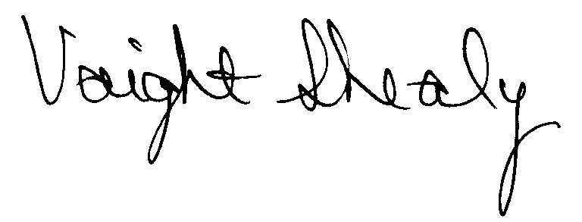
R. Voight Shealy
Materials Management Officer

/jl
South Carolina Department of
Alcohol and Other Drug Abuse SERVICES
PROCUREMENT AUDIT REPORT

JULY 1, 1997 - SEPTEMBER 30, 2000
.
TABLE OF CONTENTS

PAGE

Transmittal Letter 1
Introduction 3
Scope 4
Results of Examination 5

Certification Recommendations . 8

Department Response 9

Follow-up Letter 10

STATE OF SOUTH CAROLINA
State Budget and Control Board
OFFICE OF GENERAL SERVICES
JIM HODGES, CHAIRMAN  GOVERNOR  GRADY L. PATTERSON, JR.  STATE TREASURER  JAMES A. LANDER  COMPTROLLER GENERAL |  | JOHN DRUMMOND  CHAIRMAN, SENATE FINANCE COMMITTEE  ROBERT W. HARRELL, JR.  CHAIRMAN, WAYS AND MEANS COMMITTEE  RICK KELLY  EXECUTIVE DIRECTOR
GEORGE N. DORN, JR.
DIRECTOR

MATERIALS MANAGEMENT OFFICE
1201 MAIN STREET, SUITE 600
COLUMBIA, SOUTH CAROLINA 29201
(803) 737-0600
Fax (803) 737-0639

R. VOIGHT SHEALY
MATERIALS MANAGEMENT OFFICER

December 11, 2000
Mr. R. Voight Shealy
Materials Management Officer
Office of General Services
1201 Main Street, Suite 600
Columbia, South Carolina 29201

Dear Voight:
We have examined the procurement policies and procedures of the South Carolina Department of Alcohol and Other Drug Abuse Services for the period July 1, 1997 through September 30, 2000. As part of our examination, we studied and evaluated the system of internal control over procurement transactions to the extent we considered necessary.
The evaluation was to establish a basis for reliance upon the system of internal control to assure adherence to the Consolidated Procurement Code, State regulations and Department’s procurement policy. Additionally, the evaluation was used in determining the nature, timing and extent of other auditing procedures necessary for developing an opinion on the adequacy, efficiency and effectiveness of the procurement system.
The administration of the South Carolina Department of Alcohol and Other Drug Abuse Services is responsible for establishing and maintaining a system of internal control over procurement transactions. In fulfilling this responsibility, estimates and judgments by
management are required to assess the expected benefits and related costs of control procedures. The objectives of a system are to provide management with reasonable, but not absolute, assurance of the integrity of the procurement process, that affected assets are safeguarded against loss from unauthorized use or disposition and that transactions are executed in accordance with management's authorization and are recorded properly.
Because of inherent limitations in any system of internal control, errors or irregularities may occur and not be detected. Also, projection of any evaluation of the system to future periods is subject to the risk that procedures may become inadequate because of changes in conditions or that the degree of compliance with the procedures may deteriorate.
Our study and evaluation of the system of internal control over procurement transactions, as well as our overall examination of procurement policies and procedures, were conducted with professional care. However, because of the nature of audit testing, they would not necessarily disclose all weaknesses in the system.
The examination did, however, disclose conditions enumerated in this report which we believe need correction or improvement.
Corrective action based on the recommendations described in these findings will in all material respects place the South Carolina Department of Alcohol and Other Drug Abuse Services in compliance with the Consolidated Procurement Code and ensuing regulations.
Sincerely,
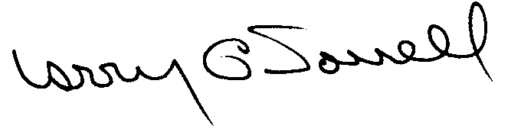
Larry G. Sorrell, Manager
Audit and Certification
INTRODUCTION
We conducted an examination of the internal procurement operating policies and procedures of the South Carolina Department of Alcohol and Other Drug Abuse Services. Our review was made under Section 11-35-1230(1) of the South Carolina Consolidated Procurement Code and Section 19-445.2020 of the accompanying regulations.
The examination was directed principally to determine whether, in all material respects, the procurement system's internal controls were adequate and the procurement procedures were in compliance with the South Carolina Consolidated Procurement Code and its ensuing regulations.
Additionally our work was directed toward assisting the Department in promoting the underlying purposes and policies of the Code as outlined in Section 11-35-20, which include:

- to ensure the fair and equitable treatment of all persons who deal with the procurement system of the State

- to provide increased economy in state procurement activities and to maximize to the fullest extent practicable the purchasing values of funds of the State

(3) to provide safeguards for the maintenance of a procurement system of quality and integrity with clearly defined rules for ethical behavior on the part of all persons engaged in the public procurement process
SCOPE
We conducted our examination in accordance with Generally Accepted Auditing Standards as they apply to compliance audits. Our examination encompassed a detailed analysis of the internal procurement operating procedures of the South Carolina Department of Alcohol and Other Drug Abuse Services, hereinafter referred to as the Department, and its related policies to the extent we deemed necessary to formulate an opinion on the adequacy of the system to properly handle procurement transactions.
We selected judgmental samples for the period July 1, 1998 through September 30, 2000 of procurement transactions for compliance testing and performed other audit procedures that we considered necessary to formulate this opinion. Specifically, the scope of our audit included, but was not limited to, a review of the following:

- All sole source, emergency and trade-in sale procurements for the period July 1, 1997 through September 30, 2000

(2) Procurement transactions from the period July 1, 1998 through, September 30, 2000 as follows:
- Forty-two payment transactions greater than $1,500 each reviewed for competition and compliance to the Code
- A block sample of five hundred numerical purchase orders reviewed for order splitting and favored vendors

(3) Minority Business Enterprise Plans and reports for the audit period
(4) Information technology plans for the audit period
(5) Internal Procurement Operating Procedures Manual
- Surplus Property procedures
- Blanket purchase order files
- File documentation and evidence of competition

RESULTS OF EXAMINATION
Our on-site review was conducted October 23, 2000 through November 3, 2000, and was made under the authority as described in Section 11-35-1230(1) of the South Carolina Consolidated Procurement Code. The examination was directed principally to determine whether, in all material respects, the procurement system's internal controls were adequate and the procurement procedures, as outlined in the Internal Procurement Operating Procedures Manual, were in compliance with the South Carolina Consolidated Procurement Code and its ensuing regulations.
The Department requested to continue the following current certification limits that the Board granted on February 10, 1998:

PROCUREMENT AREAS | CERTIFICATION LIMITS
Goods and Services | $25,000
Consultant Services | $25,000
Information Technology | $25,000

Since our previous audit in July 1997, the Department has maintained what we consider to be a professional, efficient procurement system. We did note, however, the following minor points that should be addressed by management.

Misapplied Exemption Resulted in an Unauthorized Procurement
The Department issued contract SA-99-TIL for $83,352 for a consultant to evaluate a program. The Department treated the contract as exempt for grant-specified services. The exemption passed on 3/22/94 by the Budget and Control Board states,
In accordance with Code Section 11-35-710, exempted procurements made by a requesting agency for the purchase of grant-specified and approved major equipment, subcontracts, and consultants the agency determines to be essential to the successful completion of the grant-funded project if those procurements are made in accordance with procedures approved by the Office of General Services on an agency-by-agency basis.

The Department has not submitted nor has the Office of General Services approved procedures for grant specified services. Therefore, the exemption did not apply. The contract is unauthorized since it exceeded the Department’s certification level of $25,000 for Consultants.
We recommend the Department submit grant-specified procurement procedures to the Office of General Services for approval. Furthermore, the Department must request ratification for the unauthorized procurement from the Materials Management Officer pursuant to Regulation 19-445.2015.

Responses Not Time and Date Stamped

The Department is not time and date stamping responses to request for quotations that are received prior to the openings. The time and date stamp machine is a secure instrument that requires a key to change the settings. Additionally, request for quotation 99-01 contained two responses that were received after the due date and the Department included these responses in the tabulation. Neither vendor was the low bidder and did not receive the award.
We recommend that all responses to request for quotations be time and date stamped to show through an independent means that the tabulated information was received prior to the openings. This procedure helps protect the Department and the procurement officer conducting the openings. Responses that are received after the due date should be rejected in accordance with Regulation 19-445.2070(H).
Sole Source Reporting Error
The following eight transactions should not have been reported as sole source procurements since they were exempt.
PO | Date | Description | Amount
980026 | 07/01/97 | Software license/ maintenance | $3,381
990079 | 07/21/98 | Software license/ maintenance | 4,173
990071 | 07/27/98 | Software license/ maintenance | 2,460
000032 | 07/15/99 | Software license/ maintenance | 4,551
000033 | 07/15/99 | Software license/ maintenance | 2,460
980402 | 02/20/98 | Printed manuals | 3,420
990215 | 09/16/98 | Books | 4,156
990318 | 10/30/98 | Annual software maintenance | 7,200
Renewals of software licenses and maintenance are exempt from the Code after initial software procurements have been competitively bid. Manuals and books are exempt.
Additionally, the following changes to two sole source procurements were not reported.
PO | Date | Description | Amount Reported | Overreported | Reason
752 | 4/28/00 | Training consultant | $2,350 | $2,350 | PO canceled
51 | 7/01/00 | Training consultant | $7,444 | 632 | PO reduced
We recommend changes to sole source purchase orders be reported as they occur. Amended reports should be submitted to correct the reports.

CERTIFICATION RECOMMENDATIONS
As enumerated in our transmittal letter, corrective action based on the recommendations described in this report, we believe, will in all material respects places the Department of Alcohol and Other Drug Abuse Services in compliance with the South Carolina Consolidated Procurement Code and ensuing regulations.
Under the authority described in section 11-35-1210 of the Procurement Code, and subject to this corrective action, we will recommend the Department be re-certified to make direct agency procurements for three years up to the limits as follows:

PROCUREMENT AREAS | RECOMMENDED CERTIFICATION LIMITS
Goods and Services | *$25,000
Consultant Services | *$25,000
Information Technology | *$25,000

* Total potential purchase commitment whether single year or multi-term contracts are used.

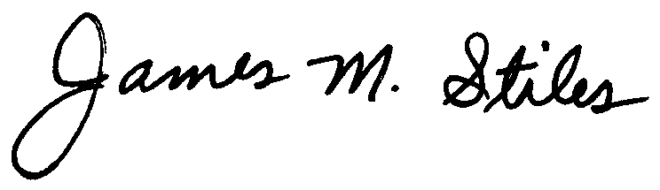

James M. Stiles, CPPB

Audit Manager

Larry G. Sorrell, Manager
Audit and Certification
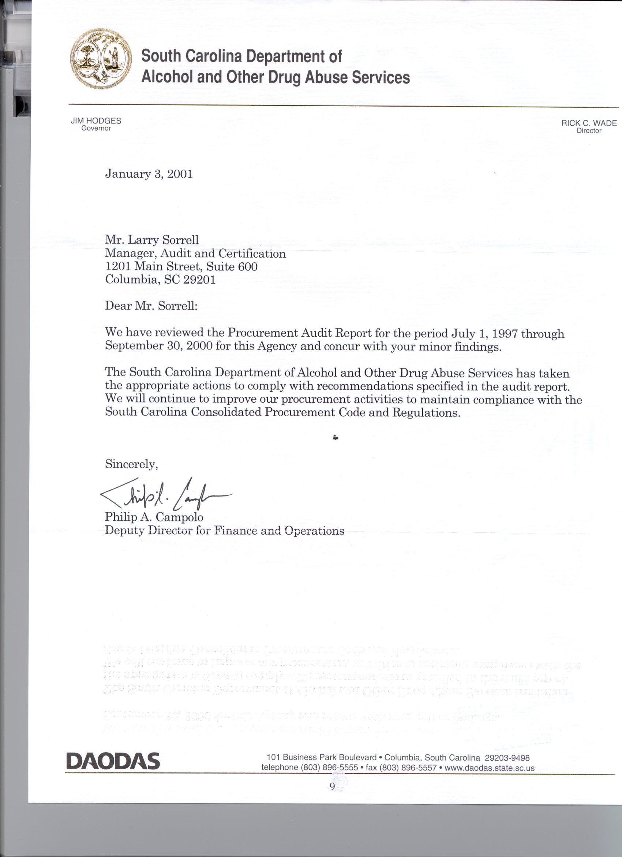
STATE OF SOUTH CAROLINA
State Budget and Control Board
OFFICE OF GENERAL SERVICES
JIM HODGES, CHAIRMAN  GOVERNOR  GRADY L. PATTERSON, JR.  STATE TREASURER  JAMES A. LANDER  COMPTROLLER GENERAL |  | JOHN DRUMMOND  CHAIRMAN, SENATE FINANCE COMMITTEE  ROBERT W. HARRELL, JR.  CHAIRMAN, WAYS AND MEANS COMMITTEE  RICK KELLY  EXECUTIVE DIRECTOR
GEORGE N. DORN, JR.
DIRECTOR

MATERIALS MANAGEMENT OFFICE
1201 MAIN STREET, SUITE 600
COLUMBIA, SOUTH CAROLINA 29201
(803) 737-0600
Fax (803) 737-0639

R. VOIGHT SHEALY
MATERIALS MANAGEMENT OFFICER

January 12, 2001

Mr. R. Voight Shealy

Materials Management Officer
Materials Management Office
1201 Main Street, Suite 600
Columbia, South Carolina 29201

Dear Voight:

We have reviewed the response from the South Carolina Department of Alcohol and Other Drug Abuse Services to our audit report for the period of July 1, 1997 – September 30, 2000. Also we have followed the Department’s corrective action during and subsequent to our fieldwork. We are satisfied that the Department has corrected the problem areas and the internal controls over the procurement system are adequate.

Therefore, we recommend the Budget and Control Board grant the South Carolina Department of Alcohol and Other Drug Abuse Services the certification limits noted in our report for a period of three years.

Sincerely,

Larry G. Sorrell, Manager
Audit and Certification

LGS/jl
Total Copies Printed 25
Unit Cost .20
Total Cost $5.00

