STATE OF SOUTH CAROLINA
SOUTH CAROLINA PUBLIC EMPLOYEE BENEFIT AUTHORITY
202 ARBOR LAKE DRIVE
COLUMBIA, SOUTH CAROLINA 29223

Intent to Award
Posting Date: August 2, 2018

This is a statement of intent to award a contract and becomes the official statement of award effective 8:00 AM, local time, August 14, 2018, unless otherwise suspended or canceled. Contractor should not perform work on or incur any costs associated with the contract prior to the effective date of the contract. The State assumes no liability for the expenses incurred prior to the effective date of the contract.

Any actual bidder, offeror, contractor, or subcontractor who is aggrieved in connection with the intended award or award of a contract shall protest within ten (10) days of the date notification of award is posted in accordance with this code. A protest shall be in writing, shall set forth the grounds of the protest and the relief requested with enough particularity to give notice of the issues to be decided, and must be received by the appropriate Chief Procurement Officer within the time provided. [Section 11-35- 4210]
SAP
PROTEST - CPO – ITMO ADDRESS: Any protest must be addressed to the Chief Procurement Officer, Information Technology Management Office, and submitted in writing (a) by email to: protest-itmo@itmo.sc.gov, or (b) by post or delivery to 1201 Main Street, Suite 601, Columbia, SC 29201.

Solicitation: Data Conversion & Bridging Services (PEBA 0222018).

Issue Date: 3/22/2018

Opening Date: 5/22/2018

Awarded To: Icon Integration and Design, Inc.
9393 W. 110th St., Suite 500
Overland Park, KS 66210

Contract Term: August 14, 2018 through August 13, 2023.

Prior to commencement of work, the Contractor shall furnish the State with certificates of insurance coverage required by the Contract.

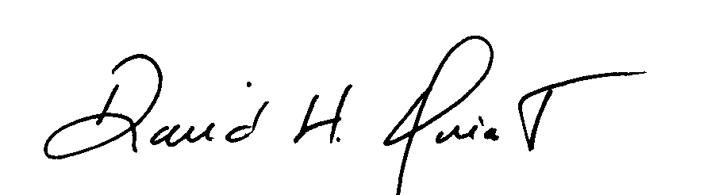
David H Quiat
Procurement Officer

