STATE OF SOUTH CAROLINA
SOUTH CAROLINA PUBLIC EMPLOYEE BENEFIT AUTHORITY
202 ARBOR LAKE DRIVE
COLUMBIA, SOUTH CAROLINA 29223

Intent to Award
Posting Date: January 13, 2017

This is a statement of intent to award a contract and becomes the official statement of award effective 8:00:00 AM local time, January 24, 2017, unless otherwise suspended or canceled. Contractor should not perform work on or incur any costs associated with the contract prior to the effective date of the contract. The State assumes no liability for the expenses incurred prior to the effective date of the contract.

Any actual bidder, offeror, contractor, or subcontractor who is aggrieved in connection with the intended award or award of a contract shall protest within ten (10) days of the date notification of award is posted in accordance with this code. A protest shall be in writing, shall set forth the grounds of the protest and the relief requested with enough particularity to give notice of the issues to be decided, and must be received by the appropriate Chief Procurement Officer within the time provided. [Section 11-35- 4210]
SAP
PROTEST - CPO ADDRESS - MMO: Any protest must be addressed to the Chief Procurement Officer, Information Technology Management Office, and submitted in writing (a) by email to protest-itmo@itmo.sc.gov, (b) by facsimile at 803-737-0102, or (c) by post or delivery to 1201 Main Street, Suite 601, Columbia, SC 29201.

Solicitation: Client Services Vendor to Facilitate and Support Program Activities.

Issue Date: 9/16/2016

Opening Date: 11/16/2016

Awarded To: Linea Solutions, Inc.
2701 Ocean Park Blvd, Suite 251
Santa Monica, CA 90405

Maximum Contract Term: January 24, 2017 through January 23, 2024.
Total Potential Value: $9,000,000.00

Note: The total potential value of the contract is estimated and may be adjusted as needed, but will not exceed the total potential value of the contract in the amount of nine million dollars ($9,000,000.00).

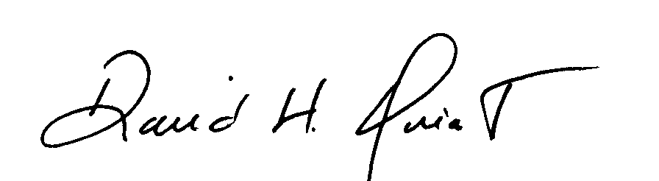
David H Quiat, CPPB
Procurement Officer

